Changing Leave Takes to PFML Codes

Effective August 1, 2020 employees are eligible to use supplemental benefits in addition to PFML payments from ESD during a PFML approved leave situation. The leave administrator will need to enter the supplemental leave for the employee based on the absence reason the employee entered for their absence request.

Listed below are the supplemental leave codes for ctcLink. Which leave type you use will depend on the supplemental leave your employee is using. These leave codes are administrative leave codes only, administrators will have to update employees leave forms accordingly. Please use query QHC_AB_ABSENCE_HISTORY to identify the Leave Types and Absence Reasons.

Absence Codes are (all codes are in the ctcLink folder)
011 | PFML-Family Leave
012 | PFML-Medical Leave

When an employee has been approved by ESD for PFML leave and they submit paid leave, the leave must be changed to one of the following by an Administrator since these codes are not available to the employee.

Supplemental Benefit Description | Leave Type | Earn Type | TRC Code
Supplemental Sick Leave | PFS T XXX | PFS | PFS
Supplemental Vacation Leave | PFV T XXX | PFV | PFV
Supplemental Personal Holiday | PFP T XXX | PFP | PFP
Supplemental Comp Time | PFC T XXX | PFC | PFC
Supplemental Personal Leave | PFL T XXX | PFL | PFL

*XXX = Company Code.

Please note:
These leave types will be excluded from the calculation of PFML premiums paid by the employee and employer and will not be reported to ESD.

Employees need to be monitored until they return to work and are no longer eligible for PFML

BEFORE PAYROLL RUNS EACH PAY PERIOD, GO INTO EACH ABSENCE EVENT AND CHANGE THE LEAVE TAKE

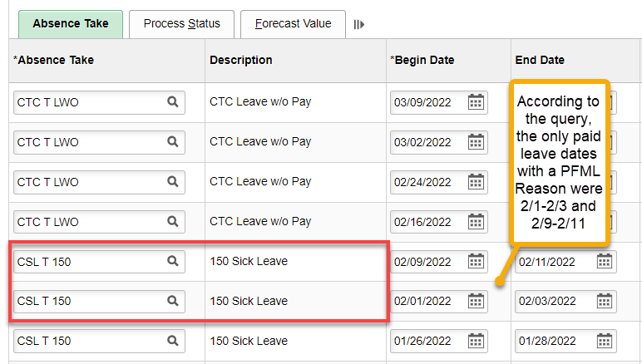
NOTE: when changing an Absence Take, the hours will be zeroed out if partial days. Be sure to check the Details of each Absence Take before changing the Absence Take Description.

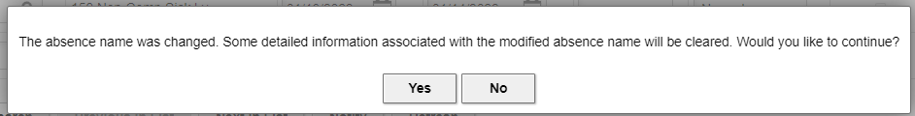

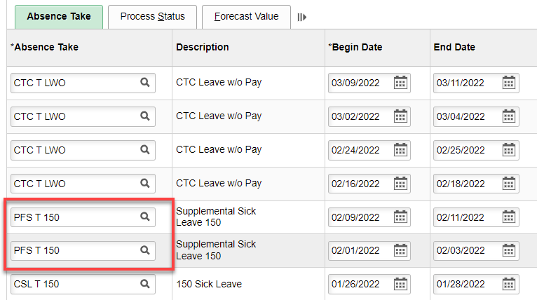

Save.

This will send what is needed to payroll.

That’s it!

