Leave Balances, Accruals, Takes and Adjustments (skip to the page 6 for an adjustment only)

Workforce Administrator>Absence Administration Tile

Note: there is a 90-day maximum retroactive processing period.

If termed on the current month, you can do the adjustment through On cycle process - Adjustment needs to be entered in the system before the current month accrual run.

If employee is termed/retired in previous month - run the off-cycle process to adjust the balance.

This documentation is for looking up and adjusting balances for a termed employee.

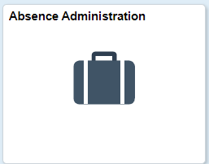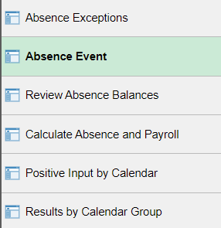

Check Absence Events (make sure all absence events are all in – email person or wait until absence management takes are done for the month). I like to wrap it all up when I’m terminating an employee so here is what I do:

Example of person retiring 9/30/21 (see screenshots below):
1. Find the current balances (Results by Calendar Group, Accumulators tab) (VAC 231.44; CSL 199)
2. Check Absence Events: delete future events past term date (click on minus sign to delete), click on Details hyperlink of other takes to see if they are Not Processed, Processing or Finalized.
3. Subtract any Leave Takes that have not been processed or finalized (All Finalized for this example).
4. Add accruals that have not been processed (check accrual rates by going to Results by Calendar Group and clicking on the previous month’s entitlement (in this case August ENT), click on the Supporting Elements Tab to see accruals. Keep in mind that if it is a month that personal holiday or personal leave hours accrue, or in the case of classified staff, leave accrual goes up because of length of service, you may have to account for those extra hours when adjusting leave. (8 hours CSL and 16 VAC).

Adjustments:
VAC: 231.44 – (absence takes not processed or finalized) + 16 (accrual) = 247.44
CSL: 199 – (absence takes not processed or finalized) + 8 (accrual) = 207

Here is the whole process:
1. Find the current balances (Results by Calendar Group, Accumulators tab) (in this case it’s SepB Take)

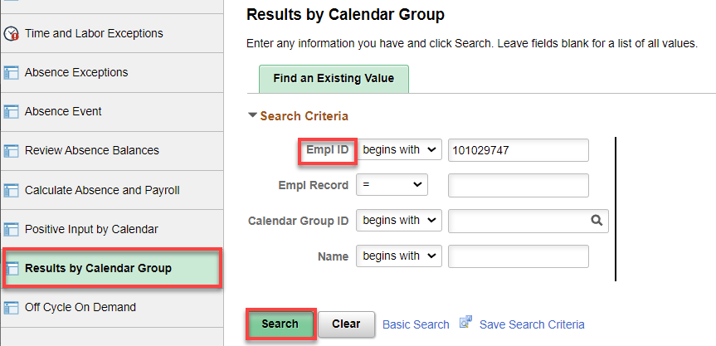

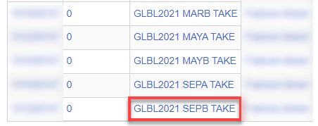

Check all balances and write them down (VAC 231.44; CSL 199)

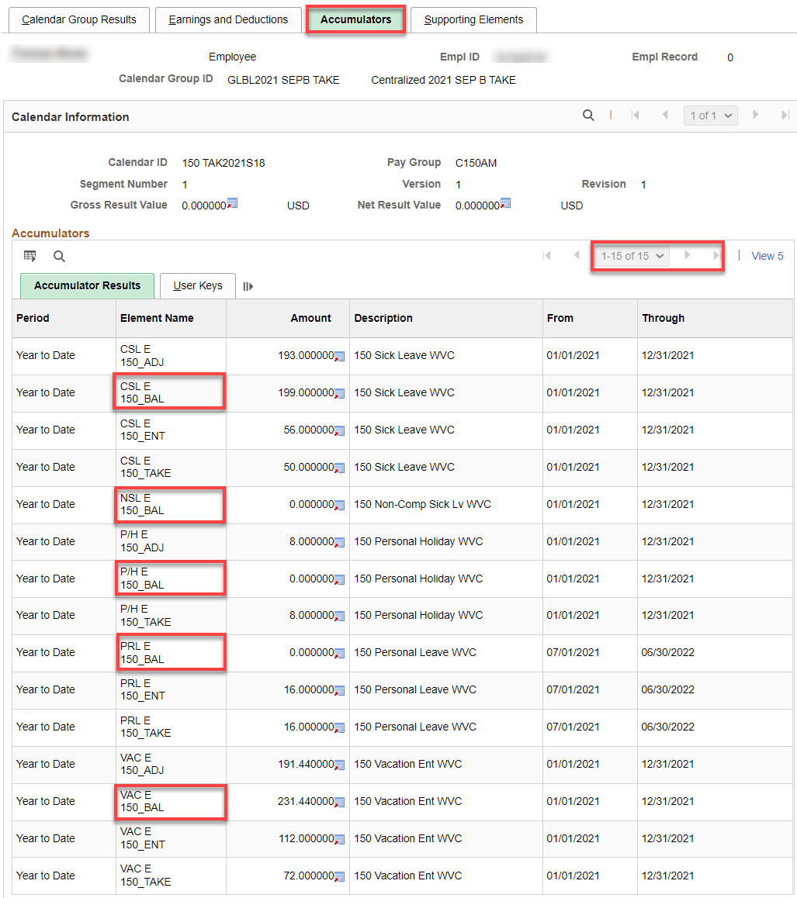

2. Check Absence Events: delete future events past term date (click on minus sign to delete), click on Details hyperlink of other takes to see if they are Not Processed, Processing or Finalized.

Click on Details

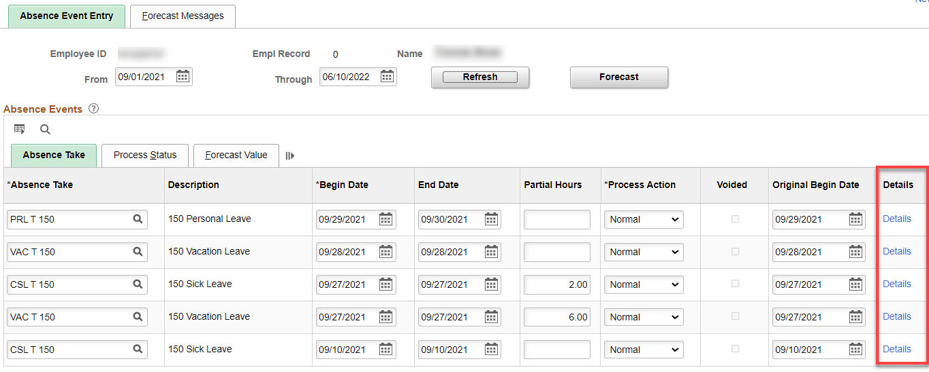

These three Absence Event examples show what the three different processes look like.

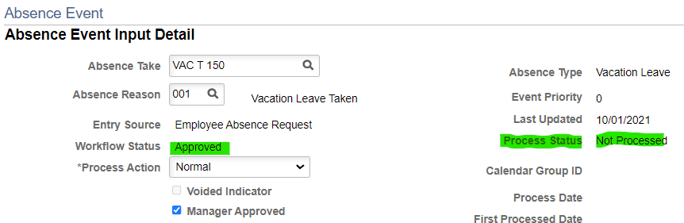

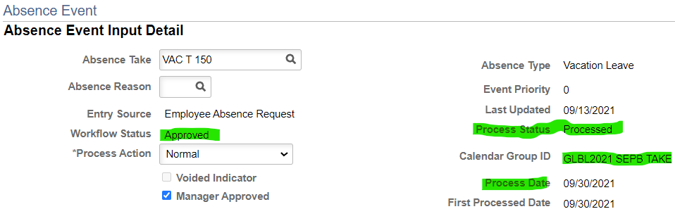

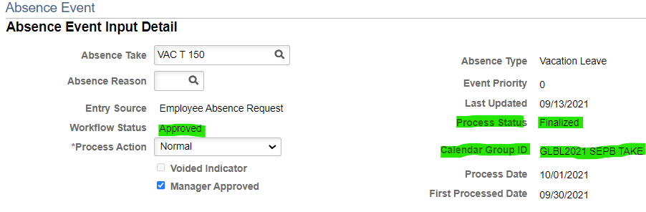
If the Absent Event Detail shows Approved and Processed, it means that the Leave Take is loaded but not finalized. If that’s the case, go to the Results by Calendar Group Accumulators tab for the Calendar Group ID SEPB Take (in this example), and it will show the correct/current leave balances (because it’s getting ready to finalize).

3. Subtract any Leave Takes that have not been processed or finalized (All Finalized in this example).

4. Add accruals that have not been processed (check accrual rates by going to Results by Calendar Group and clicking on the previous month’s entitlement (in this case August ENT), click on the Supporting Elements Tab to see accruals. Keep in mind that if it is a month that personal holiday or personal leave hours accrue, or in the case of classified staff, leave accrual goes up because of length of service, you may have to account for those extra hours when adjusting leave. (8 hours CSL and 16 VAC).

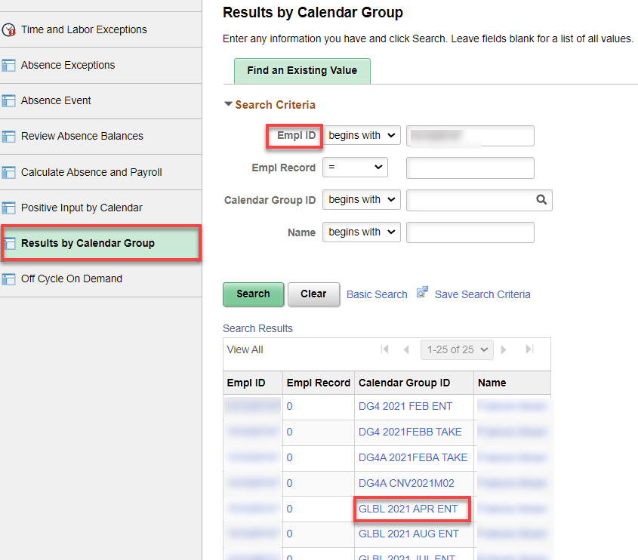

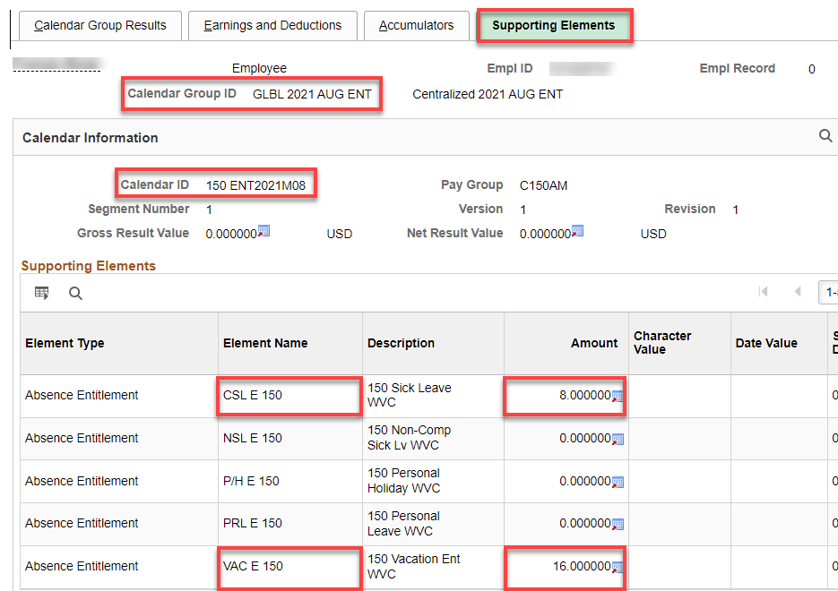

Adjusting Leave Balances: after doing the steps above OR waiting until leave takes and accruals have finished, adjust the balances to zero (Yes you can adjust balances even if the accruals have not happened yet).

Nav>Global Payroll & Absence Management>Payee Data>Adjust Balances>Absences

Search for the person, click on the correct month for the balance adjustment (in this example September ENT2021M09).

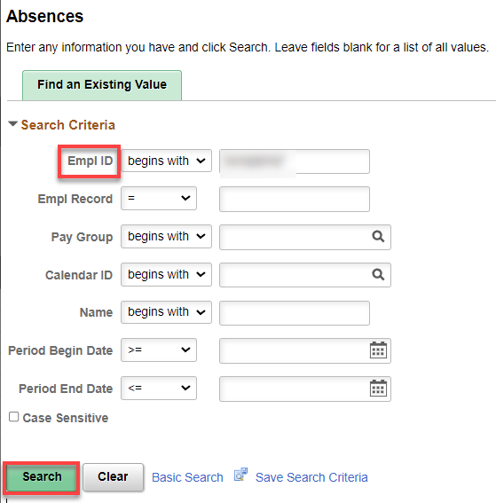

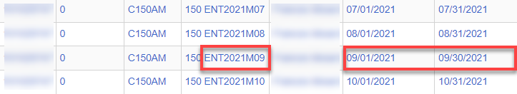

Add Adjustment Leave Code(s), as many rows as necessary, enter minus “-“ hours for subtracting hours and Begin and end Date (put in comments if you want). Save.

FOR TERMINATED EMPLOYES, THE END DATE HAS TO BE THE LAST WORKING DAY, NOT THE END OF THE MONTH (unless that is the last day worked) or the adjustment will not be made.

We still use the Entitlement Calendars*. Use the green highlighted codes for balance adjustments (transfer in/out, term, moving from one record to another, etc., orange for accrual adjustments (adding/subtracting P/H, PRL, vac, etc.), blue for adjustments to takes for Absence Balance Report, sick leave balances for sick leave buyout, etc.

*The January Entitlement Calendar cannot be used for P/H (Use 01A Take); the June Entitlement Calendar cannot be used for PRL (use July 01A Take).
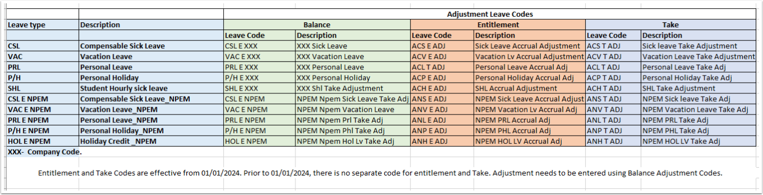
The following refers to the Absence Administration tile>Results by Calendar Group>Accumulator tab>Accumulator Results.

Using CSL, VAC, etc., will add the adjustment to the year to date Balance Accumulator but will not add/subtract the adjustment to the year to date Entitlement Accumulator nor will it adjust in the Review Absence Balance page (for administrators).

Using ACS, ACV, etc., will add the adjustment to the year to date Balance Accumulator and the Entitlement Accumulator Results and it will adjust the Review Absence Balance page (for administrators).
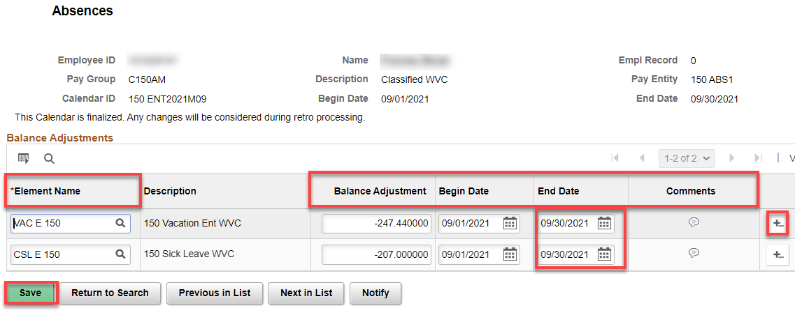

MAKE SURE ALL THIS INFO IS ON THE PAF SO PAYROLL CAN PAY OUT VACATION & SICK LEAVE, if applicable.

If termed on the current month, you can do the adjustment through On cycle process - Adjustment needs to be entered in the system before the current month accrual run.

If employee is termed/retired in previous month - run the off-cycle process to adjust the balance.

Choose the current month to subtract the hours (if not waiting until the leave take for the month, make sure to leave enough hours for any leave taken but not approved or adjusted from the balances).

After accruals and takes are done, all balances should be zero. I’ll check back to see…

If an Off-Cycle Absence Process needs to be ran, see Absence – Run Off-Cycle Absence Process documentation.

That’s it!

