If an Off-Cycle Absence Process needs to be ran

Add Absence Adjustment First
Nav>Global Payroll & Absence MGMT>Payee Data>Adjust Balances>Absences

Off Cycle On Demand
Nav>Workforce Administration>Absence Administration Tile – Off Cycle On Demand

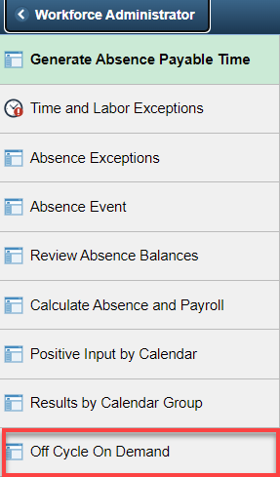

Add a New Value (each time—you cannot reuse a value), add Pay Group (C150AM for Classified, E150AM for Exempt, F150AM for Faculty), Target Period ID (the leave entitlement period the adjustment is being made), Off Cycle Group (Anything), Add.

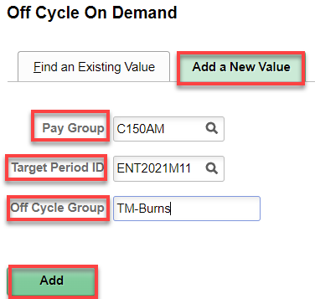

Click Create Request

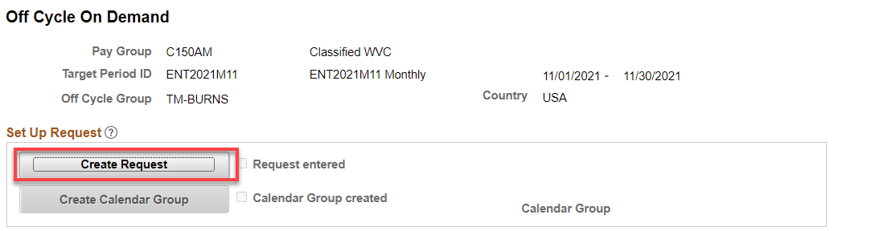

Click the down arrow on Calendars to Correct, enter the Empl ID, Empl Record (if other than 0), click Correction Details (if Correction Details is not “live”, hit tab or click Advances and then close it up, that might do it). TO ADD MORE THAN ONE EMPLOYEE, CLICK + (they should be in the same Pay Group and same processing month).

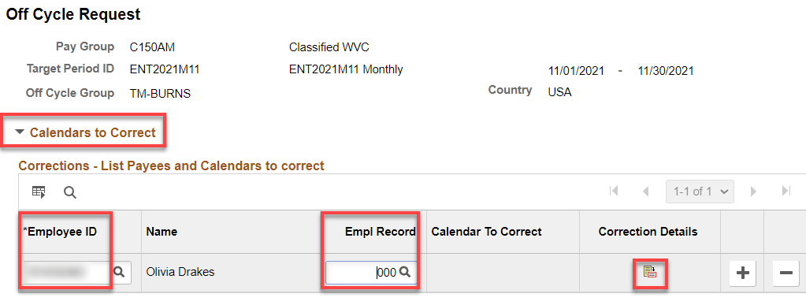

Click on Adjust Absence Balances

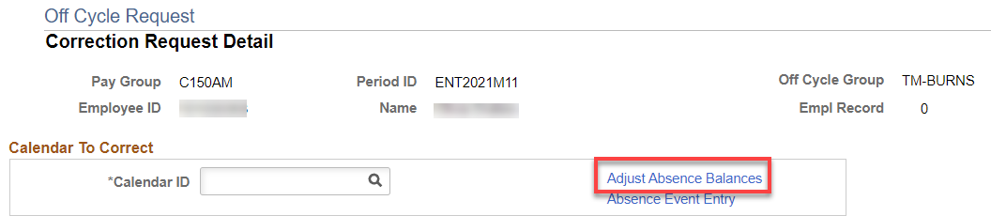

Click Search

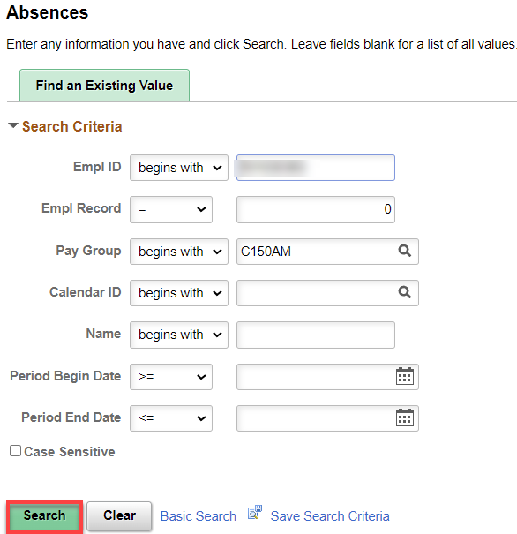

Choose the correct accrual period

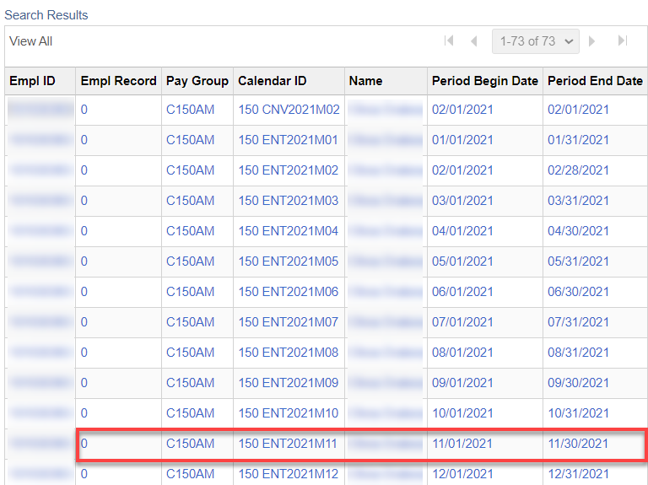

If this is correct, click OK. IF THIS IS A RERUN OF THE SAME PERSON, ADD THE AMOUNT THAT IS NEW FOR A NEW TOTAL ADJUSTMENT. Click OK

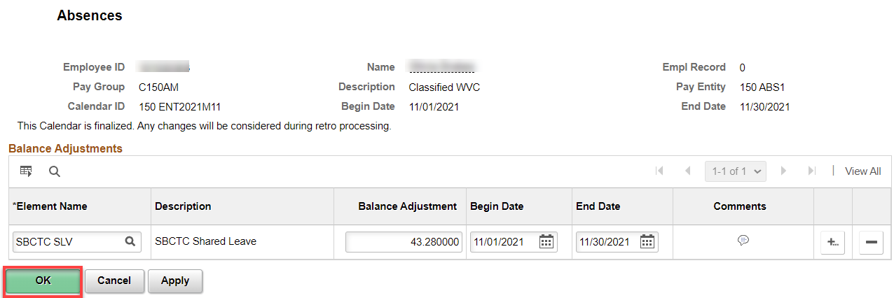

Click on Calendar ID search and find the correct accrual period.

The following screen shows. Click OK.

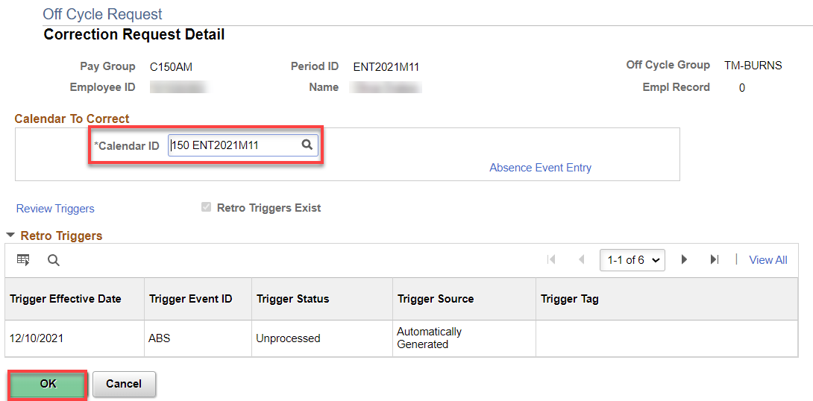

The screen below is the same as the screen above (toward the top), hit Apply and the OK.

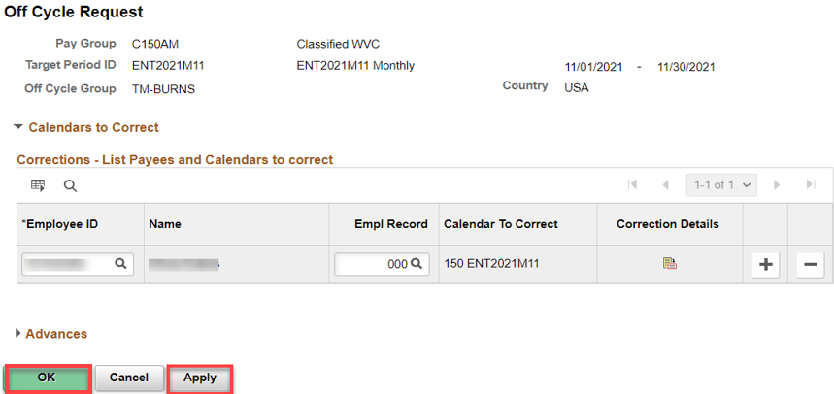

You will see that the Request Entered check box is checked. Click Create Calendar Group.

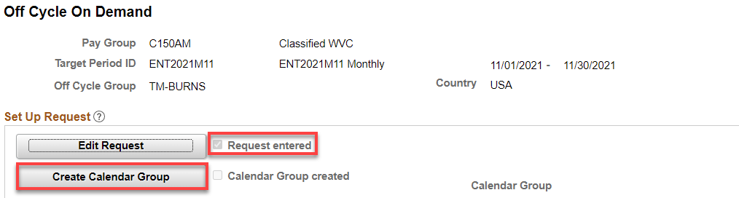

The Calendar Groups displays. Click Apply.

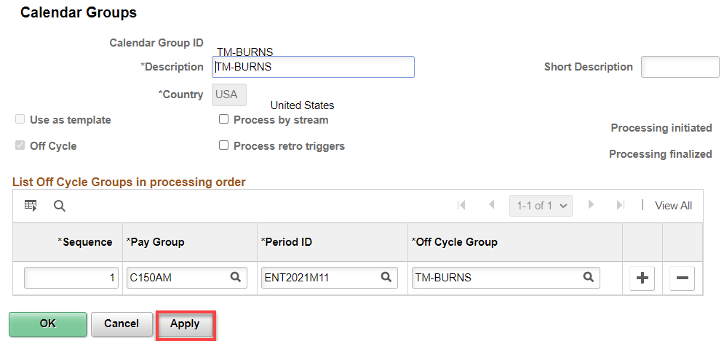

A Warning Message appears. Click OK.

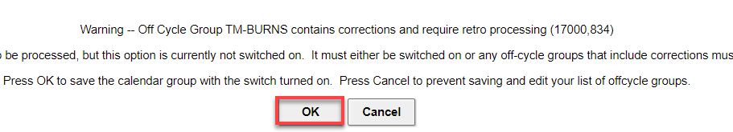

The Calendar Group page displays.
Notice the Process Retro Triggers is now checked.
Select the OK button.

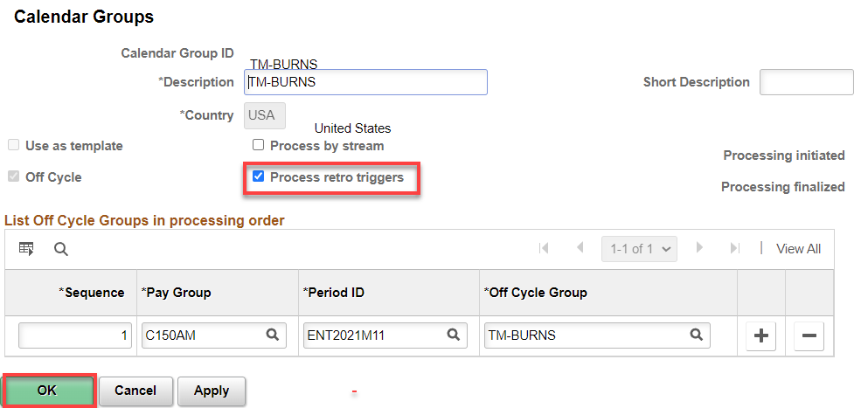

The Off Cycle On Demand page displays.
Notice the Calendar Group Created box is now checked.
Select the Calculate button.

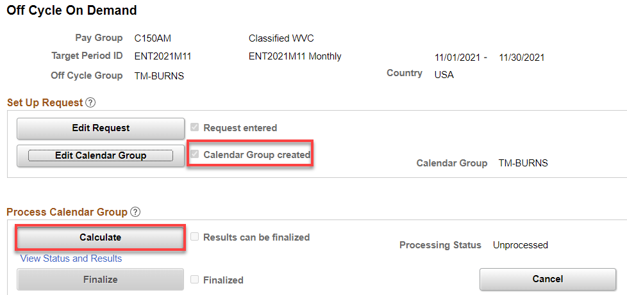

The Payee Status page displays.
Resolve any messages with Warnings or Errors.
Once you have corrected the warnings and/or errors you will have to Calculate again.
Select the Messages link. There should be 0 messages. There may be a messages that the next TAKE is suspended until this process is cancelled or finalized.
Select the Apply button and then the OK button again.

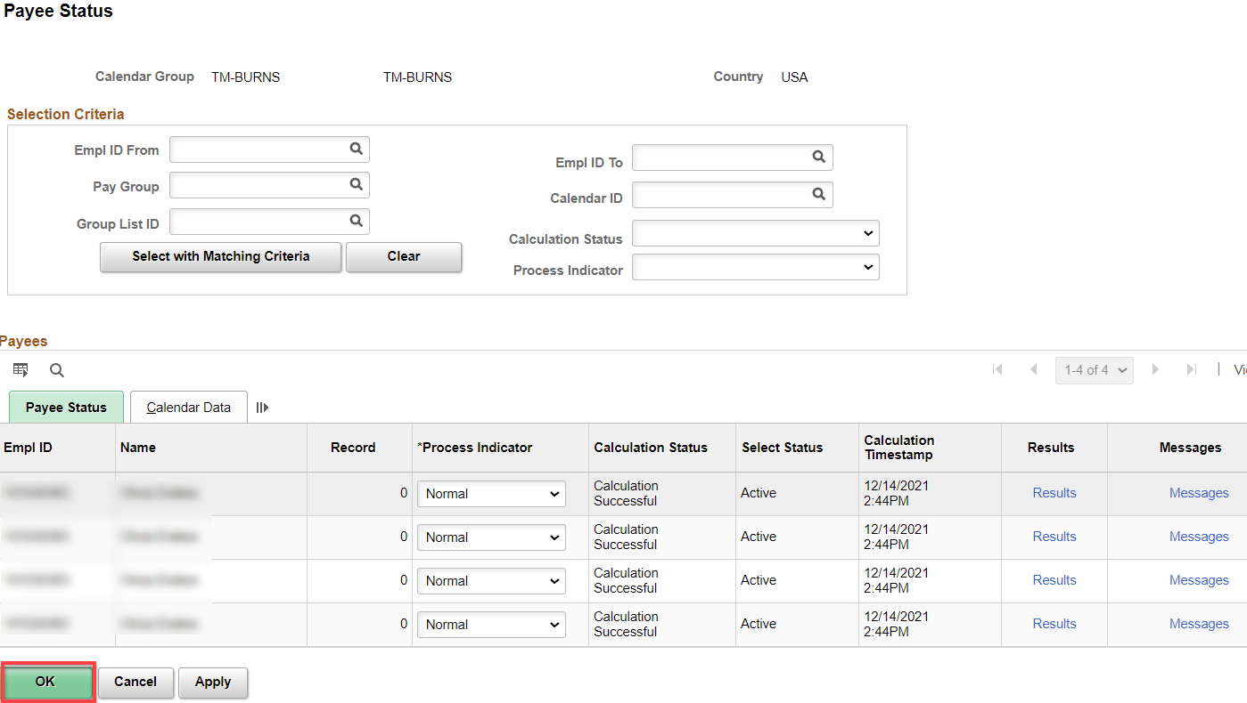

That returns to Off Cycle On Demand home screen.
Notice the Processing Status = Calculation Successful.

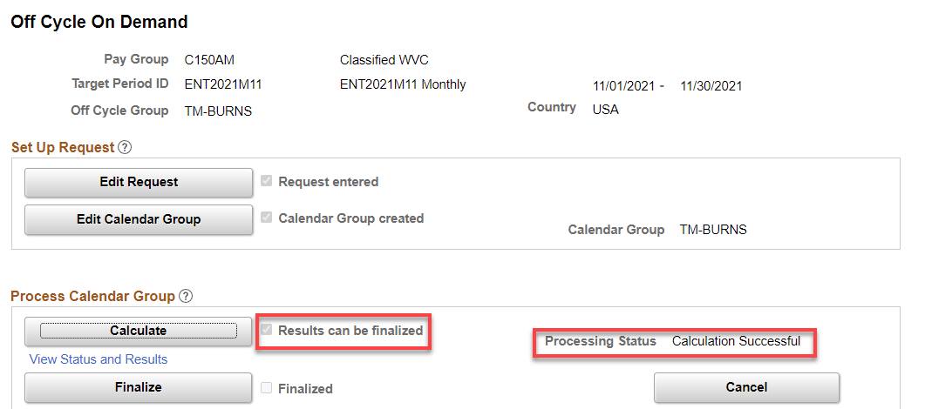

Before finalizing,
Validate the absence Balance in Results by Calendar Group Page for Off Cycle Calendar Group. Choose the Calendar Group ID used, Search.

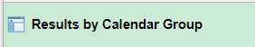

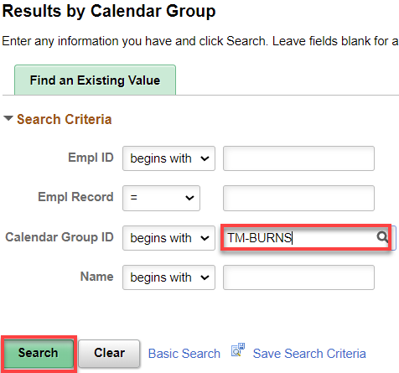

Select the Positive Input – Payroll link

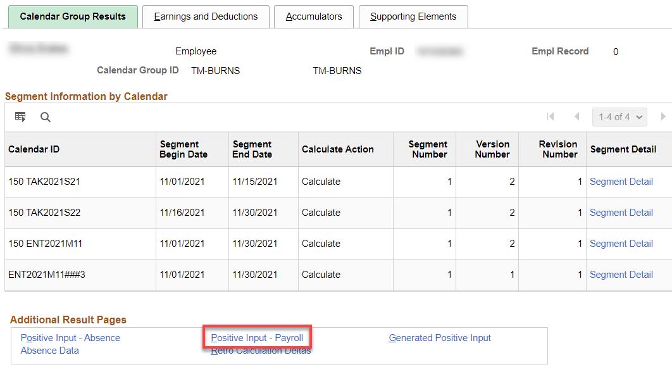

Positive Input Link – Absence tab: Go to page 3 (in this example, you can see the 43.28 hours of SBCTC SLV balance adjustment.

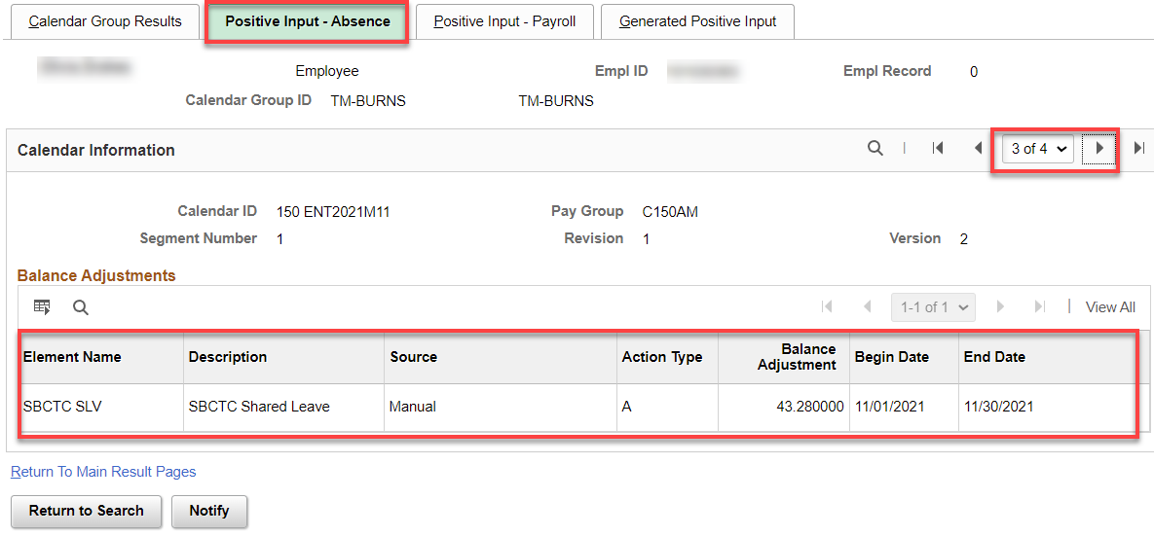

Return to Off Cycle On Demand page

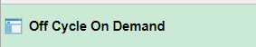

Put in the Off Cycle Group (in this case TM-Burns), Search.

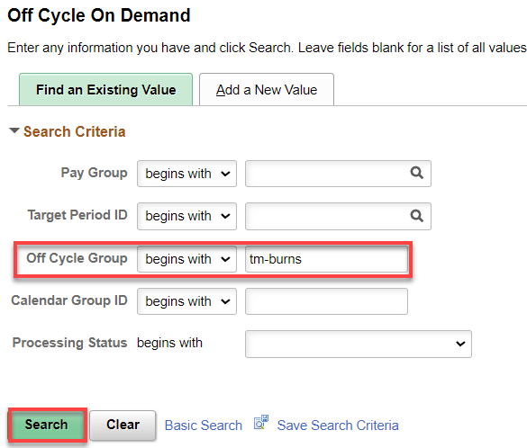

Click the Finalize button.

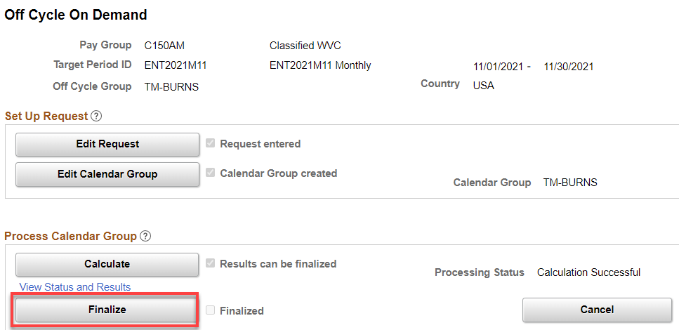

You should get this. Click OK.

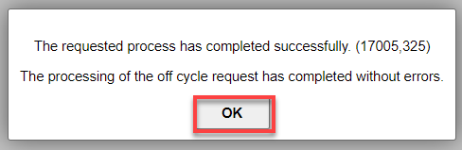

It should show Finalized. If not finalized, click the Calculate button again and that should do it.

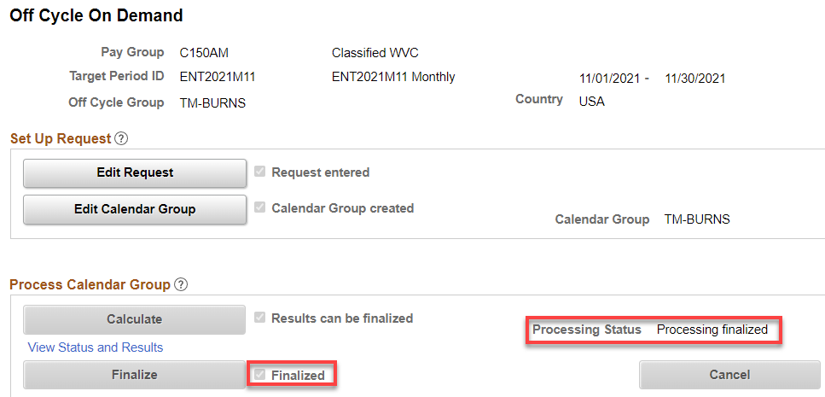

Wasn’t that fun!

