Long-Term Disability Benefits

Nav>Benefits>Enroll in Benefits>Disability Benefits

E-188 (SBCTC auto process) will continue to default employees who are without any OLTD plan selected into the 60% plans provided there is a retirement plan available for the process to logically select the correct OLTD Plan. College Admins must continue to manually key in:
- Employees who opt out of OLTD
- Employees who opt for 50% plan
- Any retirees who are not eligible for retirement plan and anyone else who has benefits and not retirement

There is NO AUTO-UPDATE from PEBB/PAY1 into ctcLink for LTD (as of 2/22).

If the employee-paid enrollment was automatically added and the effective dates are the same, you can use Correct History to decline or change to 50%.

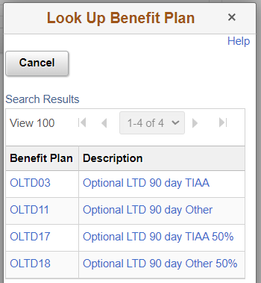
If you are enrolling or changing employee-paid LTD, you need to know what type of retirement they have (TIAA or Other), then click on the Benefit Plan Search Tool to find the coverage needed.

If you are changing coverage, the Benefit Plan will already tell you if the retirement plan is TIAA or Other.

Non-retirement-eligible employees will be “Other.”

SEE documentation: Benefits-LTD-Adding ABBRs for PT Faculty

Enrolling

If enrolling for the first time, add + a row in Plan Type, choose plan, add + a row in Coverage, enter Coverage, Deduction and Effective dates (use the same date for all), choose Benefit Plan and Save.

Note: you can effective date in the future, i.e., put in 3/1 even if it is currently 2/9 (according to the experts ).

Basic – add Plan Type, Coverage and Deduction Begin dates (both the same) and Election Date (Election Date can be different), add Benefit Plan, Save.

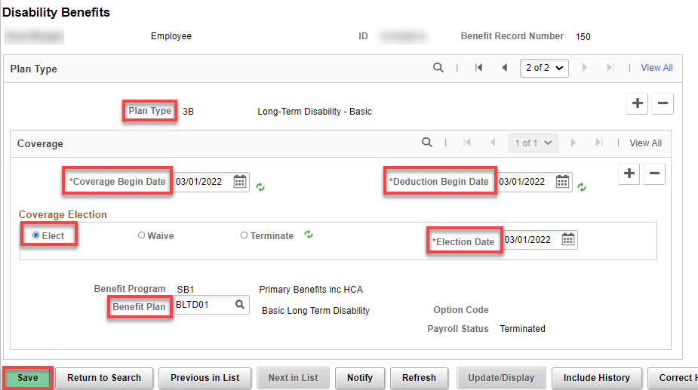
Employee Paid - Add a row (+), choose Plan Type (Optional), add Coverage and Deduction Begin dates (both the same-1st of the month after signature)) and Election Date (Election Date can be different), add Benefit Plan, if applicable, Save.

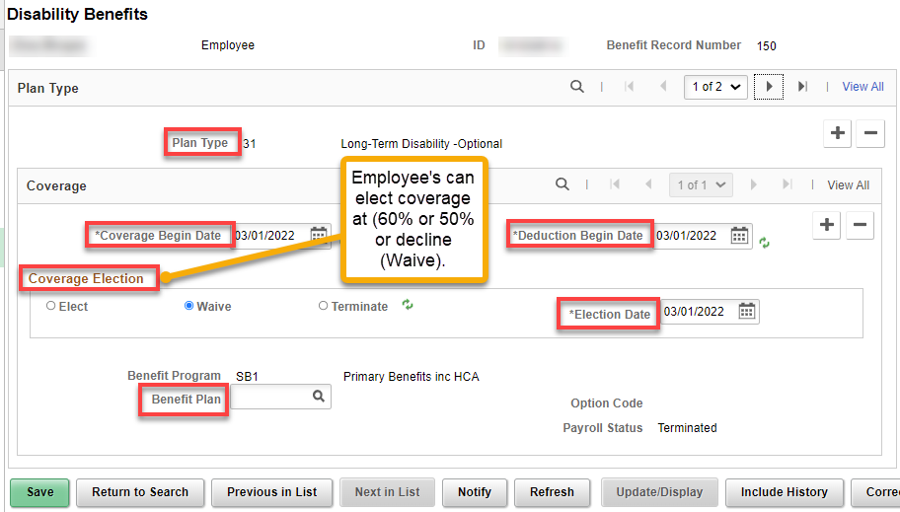

Changing

Add + a row in Coverage, enter Coverage and Deduction Begin dates (both the same) and Election Date (Election Date can be different), choose Benefit Plan and Save.

Note: you can effective date in the future, i.e., put in 3/1 even if it is currently 2/9 (according to the experts ).

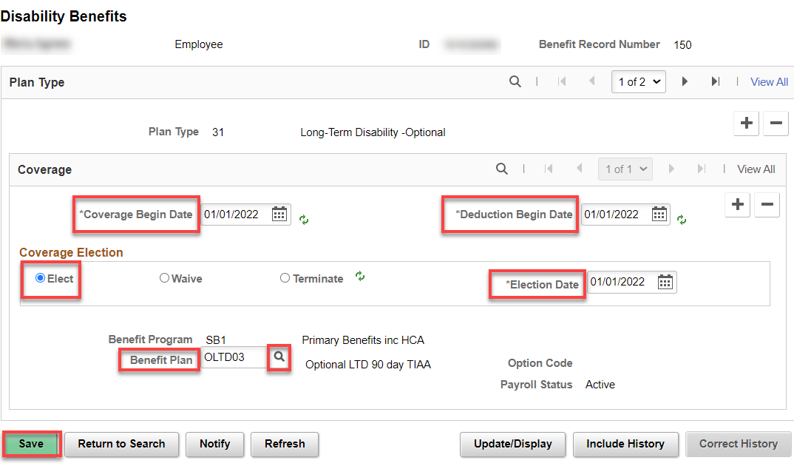

Declining/Waiving:

If an employee wants to decline employee-paid (optional) LTD coverage, just add + a row in Coverage and Deduction Begin dates (both the same) and Election Date (Election Date can be different), click on Waive (refresh) and Save.

Note: you can effective date in the future, i.e., put in 3/1 even if it is currently 2/9 (according to the experts ).

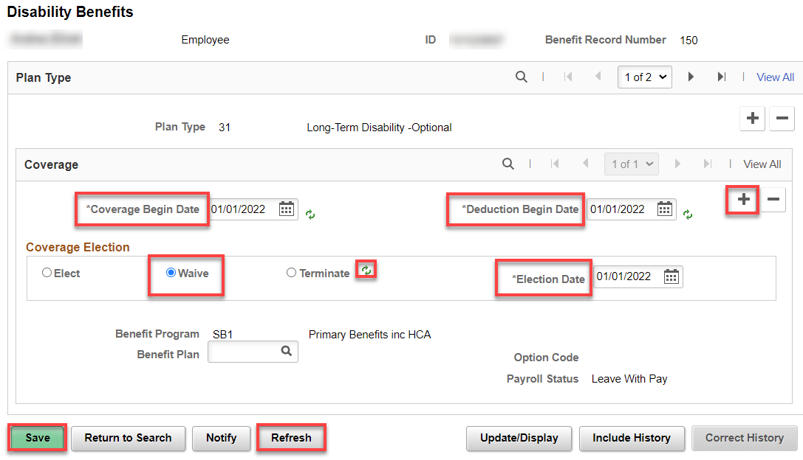

Terminating

Add + a row in Coverage, enter Coverage and Deduction Begin dates (both the same) and Election Date (Election Date can be different), select Termination, Refresh, Save.

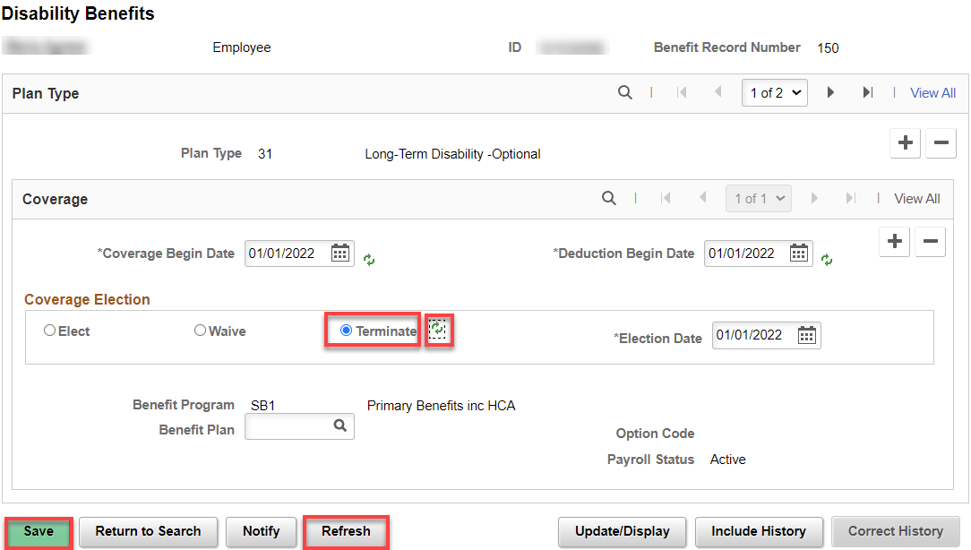

That’s it!

