LTD-Reviewing/Updating ABBRs for PT Faculty – The QRG is really good.

Nav>Workforce Administration tile>Benefits Admin tile>Review ABBRs

Reviewing Annual Benefit Base Rates (ABBRs) – I don’t see much of a need to review when you can see the ABBRs under Update

Nav>Workforce Administration tile>Benefits Admin tile>Enroll/Maintain benefits>Update ABBRs

Each PT faculty on benefits with employee-paid LTD must have their full-time equivalent salary put in each time there is a salary change. The full-time equivalent salary must be put on each job since we are not sure which job is being paid, PLUS, each job may have a different average annual salary.

The ABBRs are not needed for basic LTD or those PTF that decline (Waive) employee-paid LTD.

The best way I can think of to keep this function as simple as possible is to use the PT Faculty Benefits List (Excel spreadsheet) and put the ABBRs on only those PTF on benefits. The Salary Base Calculation Report only lists those PTF with employee paid (optional) LTD.

First, run the Salary Base Calculation Report (see QRG) or go to Nav>Benefits>CTC Custom>PTF LTD Report. The PDF will show three quarters back, including the current quarter. So, for instance, If I use a Calc Date of 1/20/22, the PDF results will be Winter 22, Fall 21 and summer 21. Add up the three wages to get the ABBR. Do the same for all jobs listed.

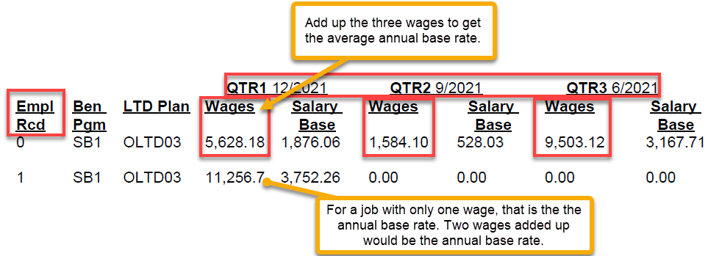

Go to Update ABBRs.

For each Empl Record, Add the Annual Benefits Base Rate Type (LTD), Effective Date, Annual Benefit Base Rate, Save.

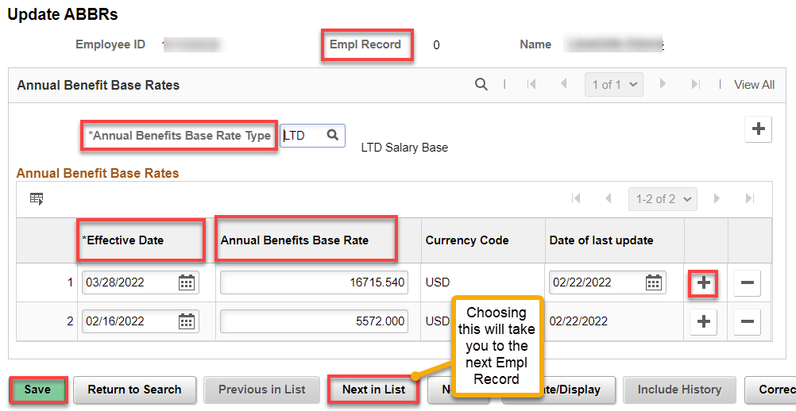

Next Empl Record.

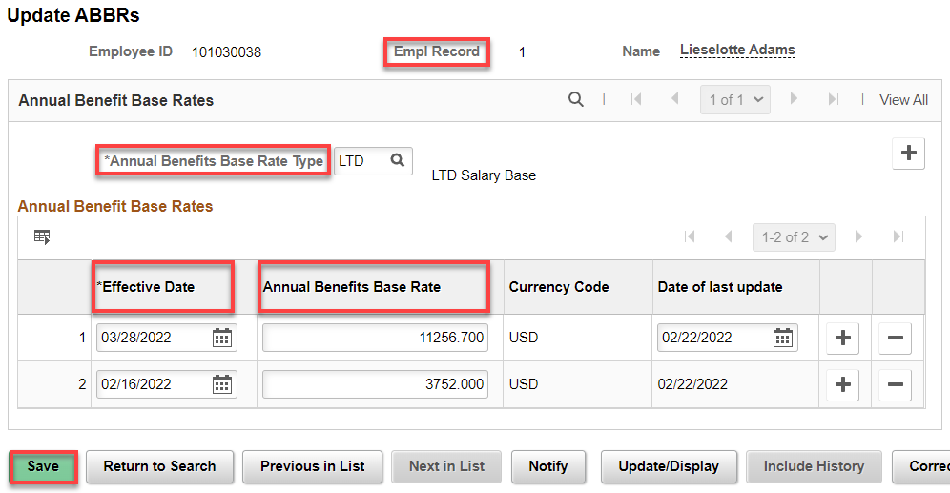

That’s it!

