Attach a Balloon Payment Calendar to an Employee

After Creating a Balloon Calendar (QRG is great), you can attach the Balloon Calendar Code to each FT Faculty with a balloon (you can have multiple Balloon Calendars).

Since WVC faculty are on a Short Work Break during the summer, I brought them back off Short Work Break and then updated salaries and balloon info (see FT Faculty Salary-Balloon Update f 09A documentation).

Job Data

Add + a row, Effective Date, Action and Reason

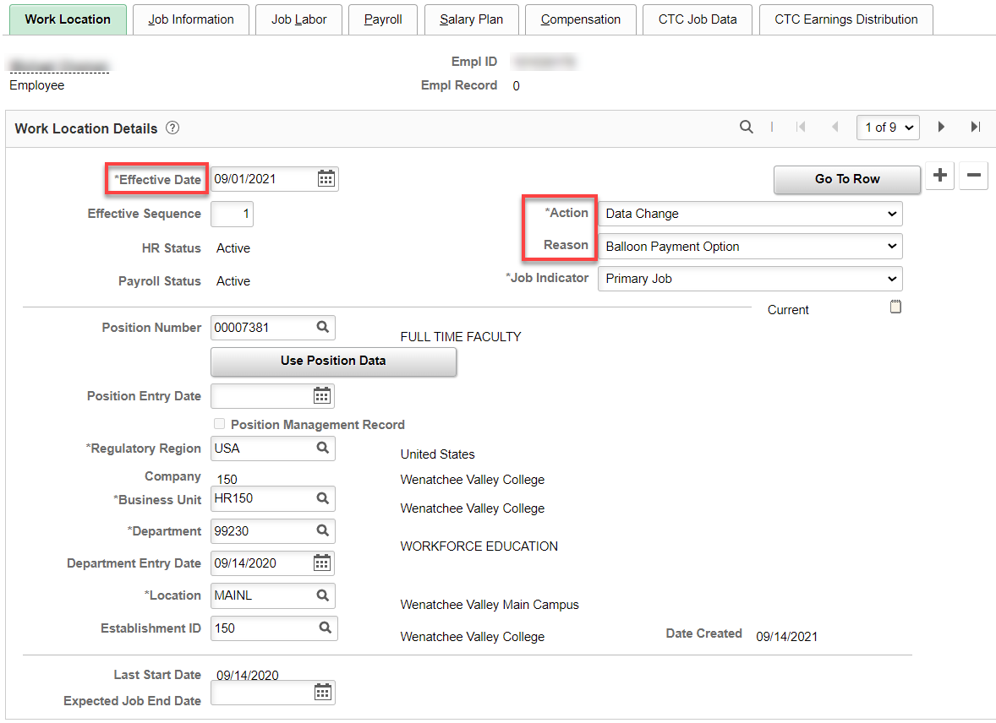

CTC Job Data

Add the Balloon Payment ID, Save

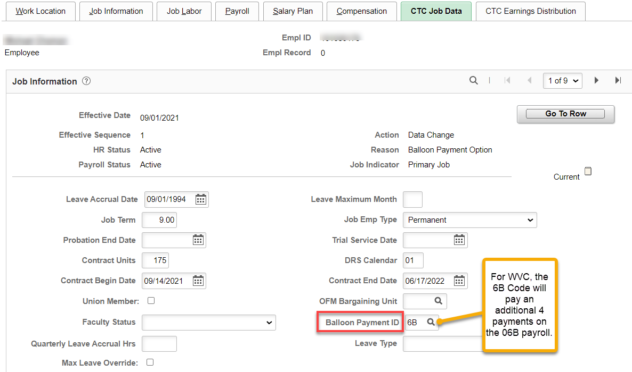

A warning message displays.
Review and select the OK button.

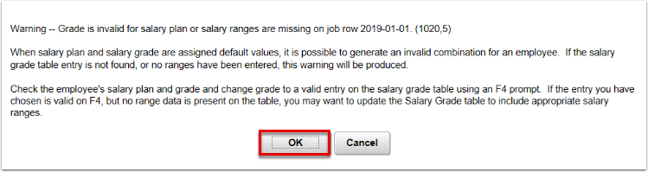

Loading Balloon Payments in Payroll (payroll does this)

That’s It!

