FT Faculty Salary and/or Balloon Update f 09A

Attach a Balloon Payment Calendar to an Employee

After Creating a Balloon Calendar (QRG is great), you can attach the Balloon Calendar Code to each FT Faculty with a balloon (you can have multiple Balloon Calendars).

Since WVC faculty are on a Short Work Break during the summer, I brought them back off Short Work Break and then updated salaries and balloon info.

Pay Rate Change (no Balloon)

Work Location tab: Add + a row, change Effective Date to 9/1, Action (Pay Rate Change), Reason (Other or Blank), change Effective Sequence if there is already a 9/1 Effective Date.

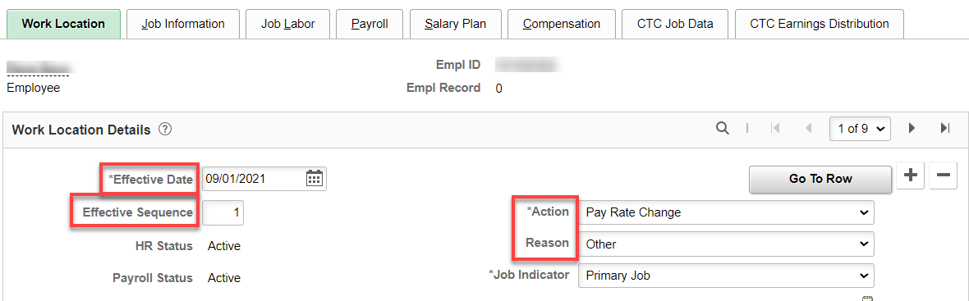

Compensation tab: change salary, frequency should be C20 with no balloon click Calculate Compensation, save.

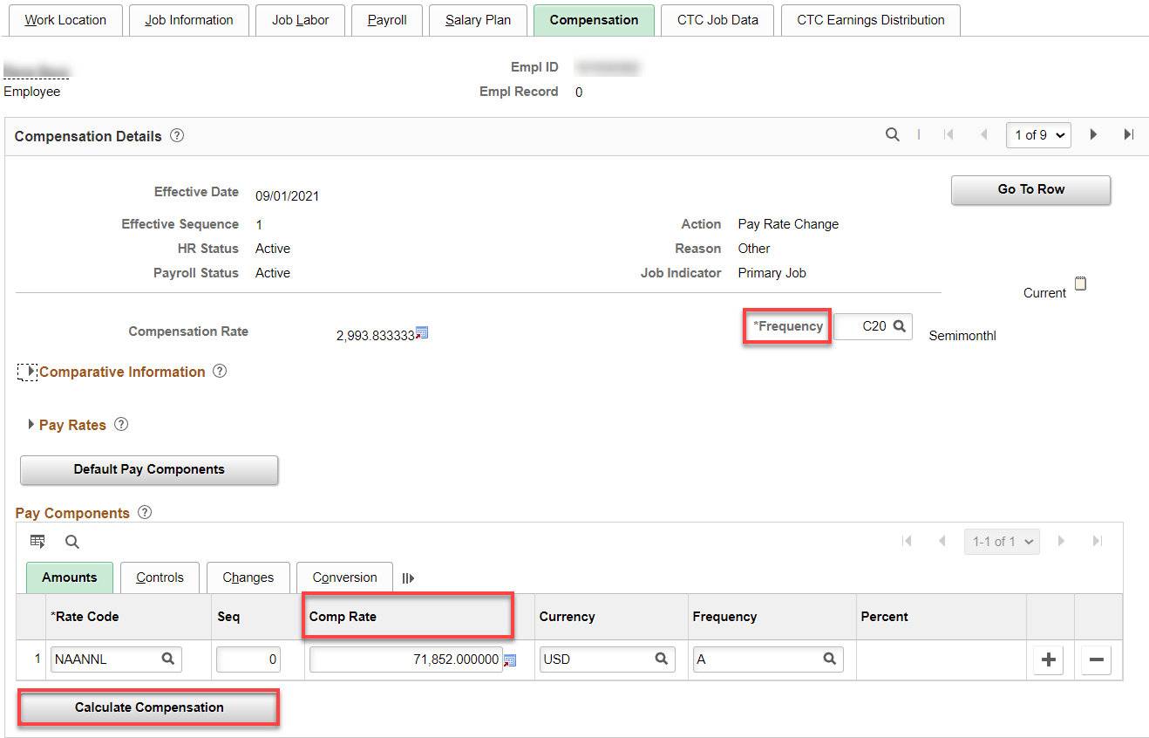

CTC Job Data tab: make sure Balloon Payment ID is blank for faculty with no balloon payment. Also check all other information like Job Emp Type, Job Term and Contract Units to be sure they are correct.

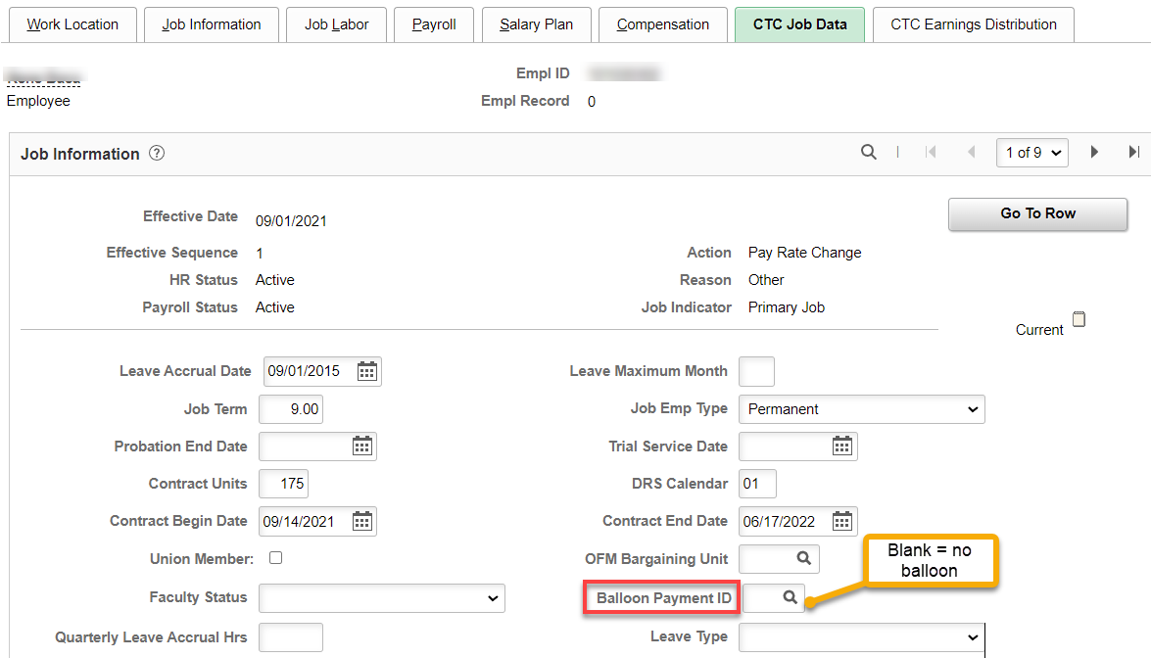

Pay Rate Change (with Balloon—or just adding balloon)

Work Location tab: Add + a row, change Effective Date to 9/1, Action (Data Change), Reason (Contract or Balloon Payment Option-doesn’t really matter), change Effective Sequence if there is already a 9/1 Effective Date.

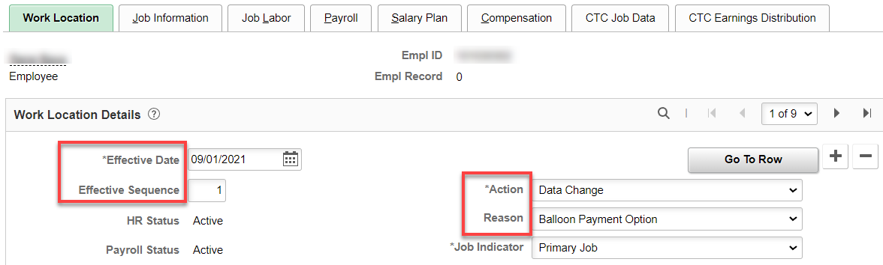

Compensation tab: update compensation, if applicable, Frequency should be S with Balloon, click Calculate Compensation.

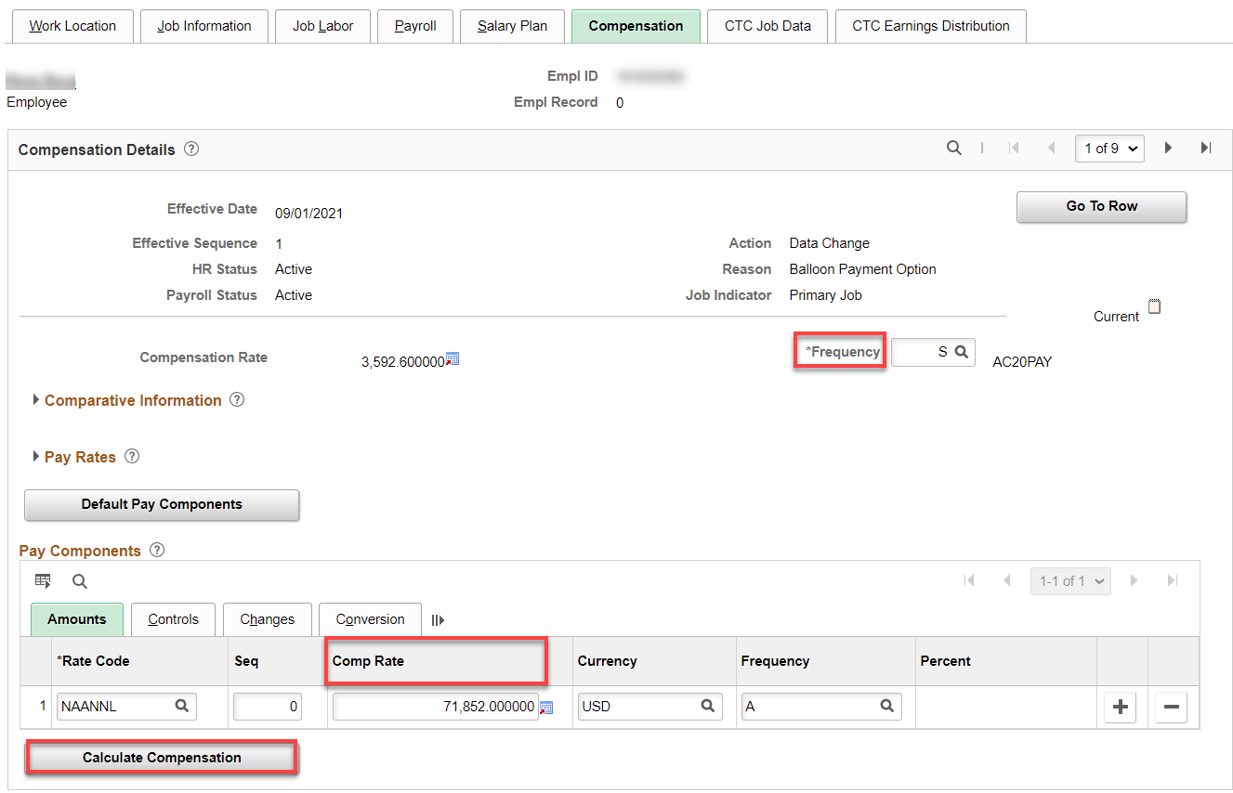

CTC Job Data tab: Contract Begin Date and Contract End Dates should be up-to-date with the return from Short Work Break, check that Contract Units, Job Term and other things look correct. Add Balloon Payment ID if they have a balloon.

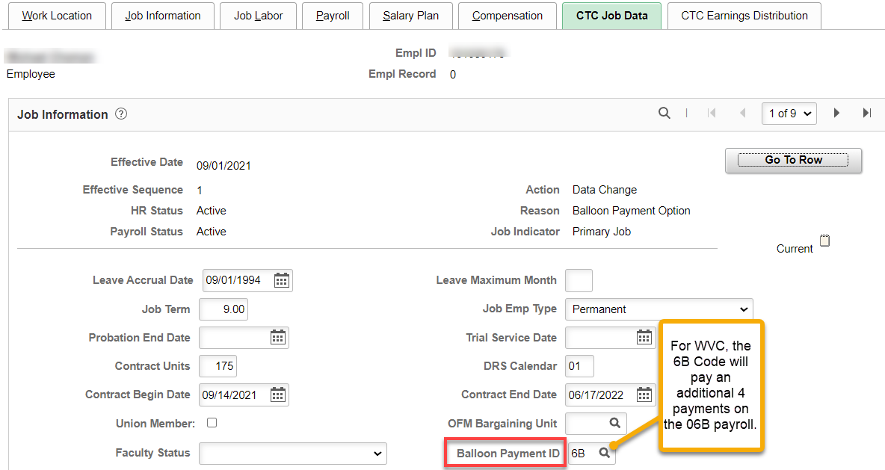

A warning message displays.
Review and select the OK button.

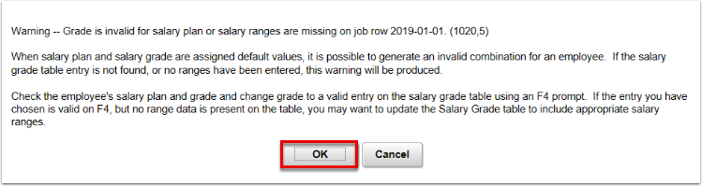

Loading Balloon Payments in Payroll (payroll does this)

That’s It!

