Cyclic Leave of Absence for Classified or Exempt

Putting on Leave of Absence: Add + a row, add Effective Date (for the person below, their last contract day was 6/15), Action (Leave of Absence), Reason (Cyclic Leave), Save.

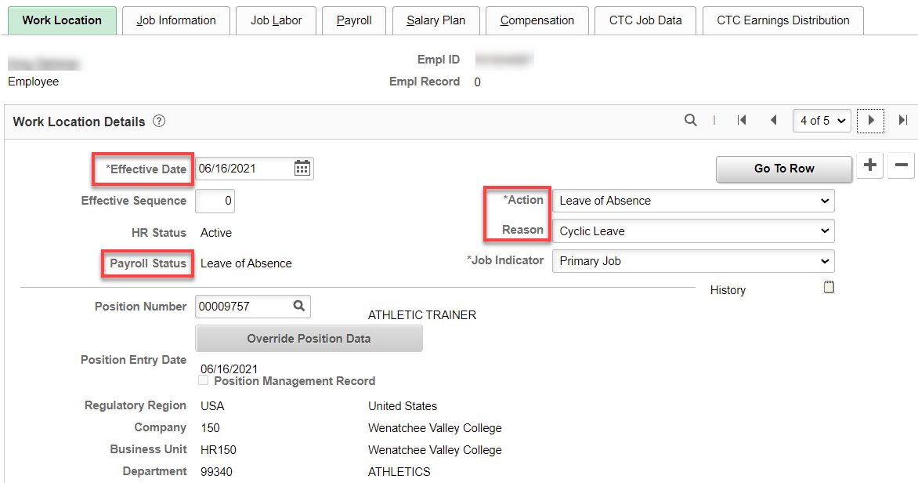

Taking Off Leave of Absence: Add + a row, Effective Date, Action (Return from Leave), Reason (Return from Leave) – (I’ve requested a Return from Cyclic Leave Reason be added), Save.

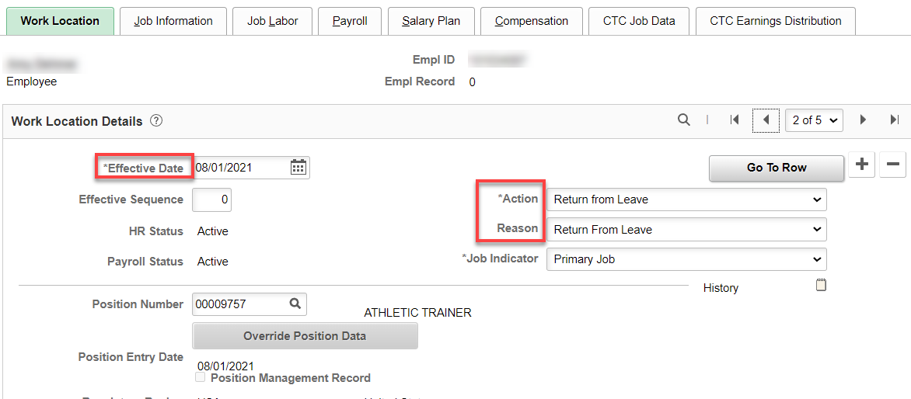

For classified staff, ctcLink will automatically prorate the salary based on the return from leave effective date. For Compensation for Exempt, see Compensation for Exempt on Cyclic Contracts documentation.
That’s it!

