Putting FTF on Paid or Unpaid Sabbatical

Paid Sabbatical
Job Data
Work Location tab: Add + a row, change Effective Date to 9/1 (or whatever the beginning of the pay period for the quarter), Action (Paid Leave of Absence), Reason (Paid Sabbatical Leave), change Effective Sequence if there is already a 9/1 Effective Date.

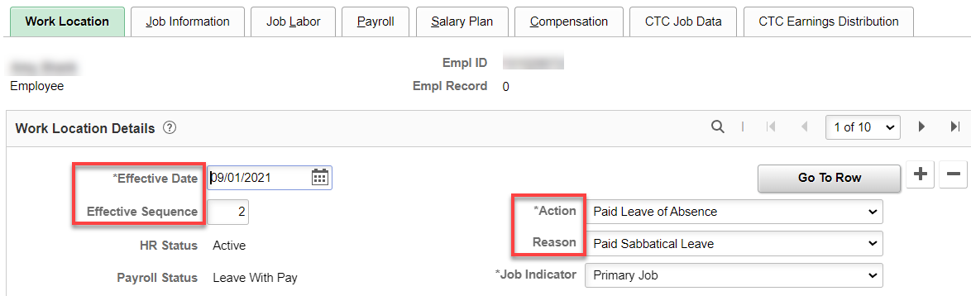

Job Information tab: for WVC, paid sabbaticals are 90% of full time, therefore, change the FTE to .90 (FTE has a direct impact on leave accrual and number of ours worked during payroll timeframe – which, in this case, doesn’t really matter since they don’t accrue leave and are not working).

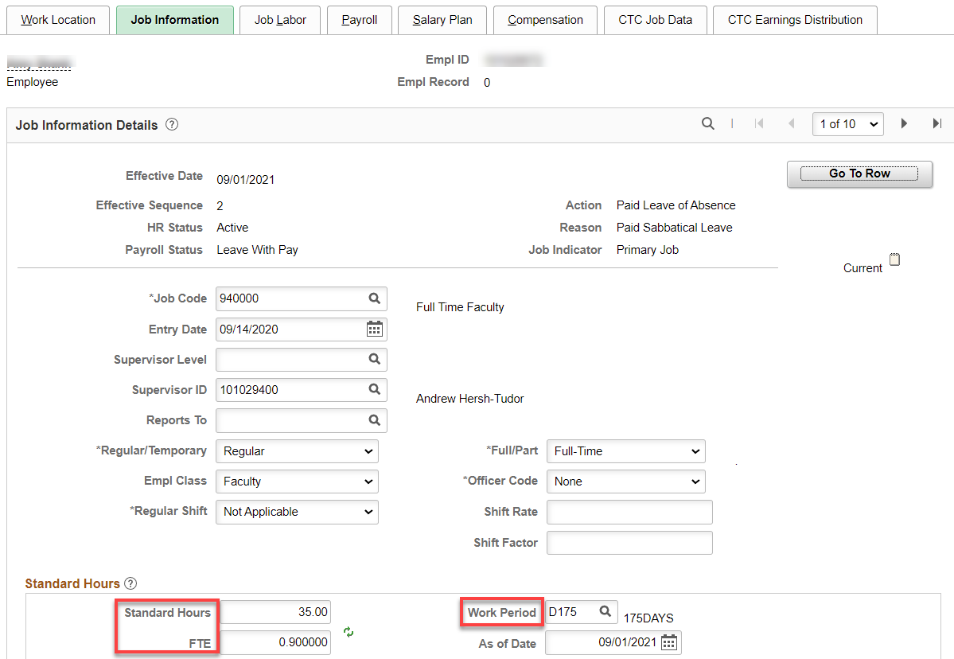

Payroll tab: At WVC, faculty do not accrue leave during a sabbatical. Change Absence System to Other (don’t forget to change back at the end of the sabbatical.

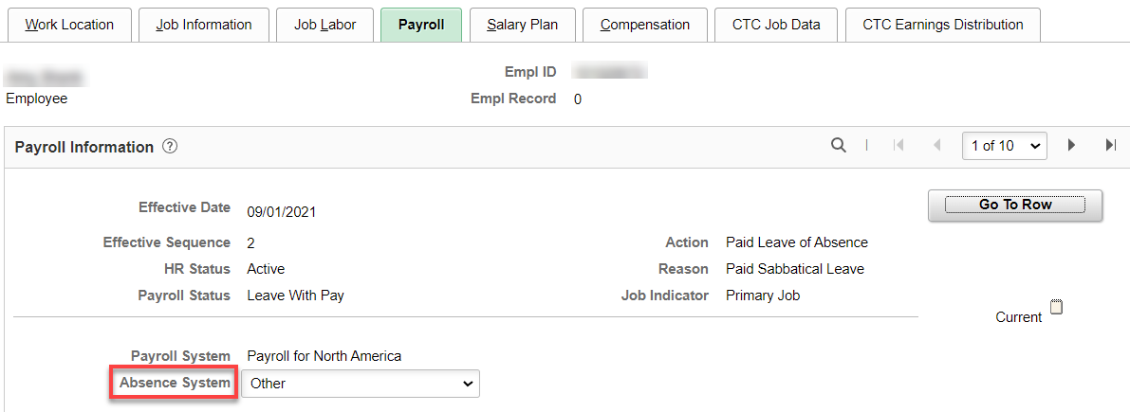

Compensation tab: at WVC, we pay 90% of the FT salary for sabbatical, therefore, change salary for the sabbatical period. If the sabbatical is for the whole academic year, frequency should be C20 with no balloon or S with a balloon (if less than an academic year, put prorated salary for the sabbatical period and the number of pay periods (Frequency) – no balloon is offered for less than a full academic year, click Calculate Compensation, save.

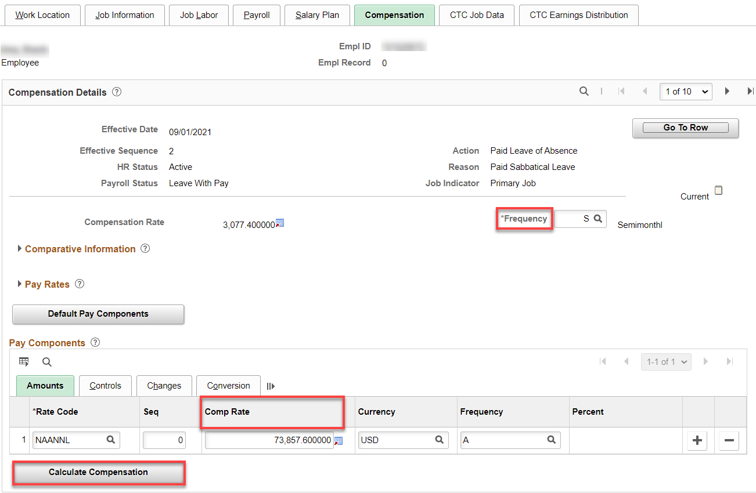

Non-Paid Sabbatical

Job Data

Work Location tab: Add + a row, change Effective Date to 9/1 (or whatever the beginning of the pay period for the quarter), Action (Leave of Absence), Reason (Sabbatical Leave), change Effective Sequence if there is already a 9/1 Effective Date.

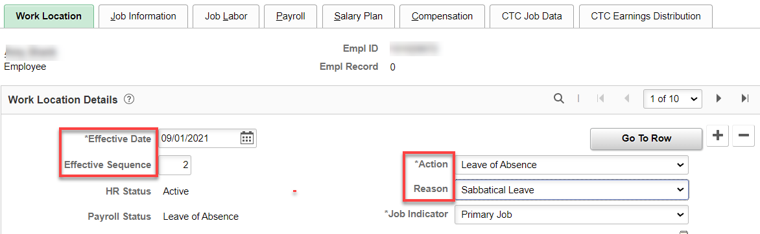

Payroll tab: At WVC, faculty do not accrue leave during a sabbatical. Change Absence System to Other (don’t forget to change back at the end of the sabbatical).

Compensation tab: nothing to do since they are on leave of absence.

That’s it!

