Approving a Name Change – also see Name - Adding/Updating

PRIMARY NAME CHANGES CAN ONLY BE DONE IN MODIFY A PERSON

Nav>Workforce Administration>Self Service Transactions>Employee Name Change Requests

Approving a Name Change and Adding /Updating Additional Names (including preferred)

Purpose: Use this document as a reference for how to approve a name change in ctcLink.

IMPORTANT: Before you begin this process, be sure to run the query

QHC_HR_SS_APPROVALS_PNDG_RPT to retrieve the list of employees requesting a name change.

- On the Name Change search page, enter the Empl ID.
- Select Search.
- The Name Change page displays. On this page review the Current Name and the New Name change information.
- Select one of the three options listed in the Administrator Actions section. Once complete, select Save.
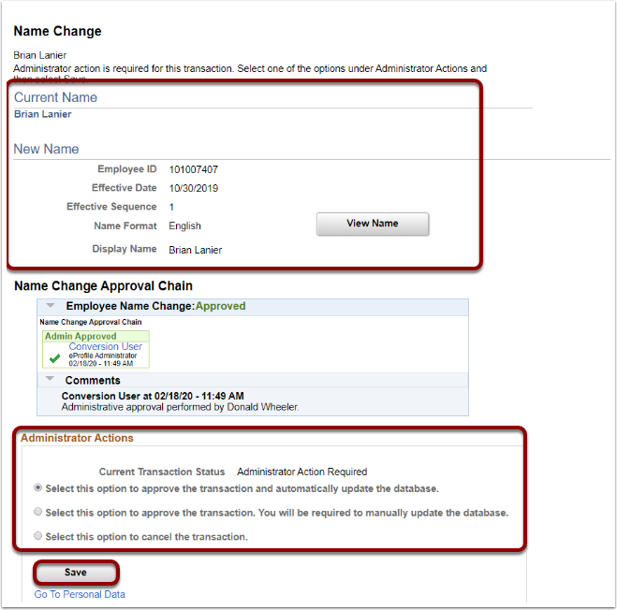
Adding/Updating Additional Names

When adding a Preferred Name in the Modifying a Person transaction, continue with this procedure to enter the Preferred Name to the Additional Name pages. By doing so, the Preferred Name will display in the CS Pillar.

Nav>Workforce Administration>Personal Information>Biographical>Additional Names

- The Additional Names search page displays.
- Enter the Empl ID.
- Select the Search button.

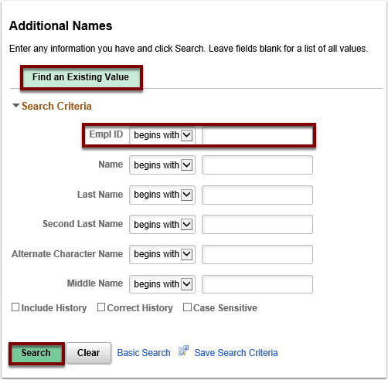

- The Additional Names page displays.
- The first record displayed will be the Primary Name.
- Select the plus sign [+] to add a new row.

NOTE: When viewing the Type of Name options, the Primary name type is not available. Updates to the Primary Name of an individual should be done in the personal data in the Modify a Person component.
The First Name and Last Name are the Legal Name(s) for the employee as verified by their driver’s license, government issued ID, or birth certificate. The Legal Name(s) will show on legal documents/screens such as Payroll and Tax information.
Select the View Name History link in the Primary row to view any historical name data for this person.

- Select the appropriate Type of Name from the drop-down menu.
- Select the Add Name Data link.

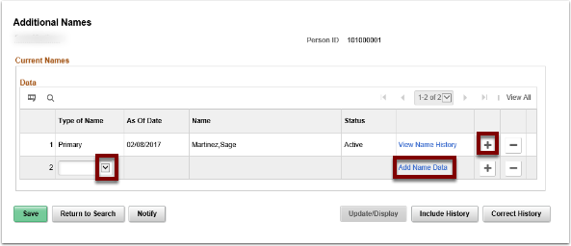

- The Name History page displays.
- Enter the appropriate Effective Date.
- The Status will default to Active, change if needed.
- Select the appropriate Name Format from the drop-down menu.
- Select the Edit Name link to enter the new name.

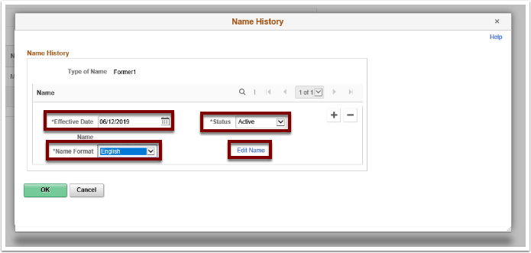

- Enter/Select the Name Prefix, if applicable.
- Enter the First Name, required (even if there is no change to the first name).
This needs to be the same as the Preferred First Name in order to show in the CS Pillar.
If you enter the legal name in the First and Last Name fields, even though the Name Type is Preferred, it will be what shows in the CS Pillar.
- Enter the Middle Name, if applicable.
- Enter the Last Name, required (even if there is no change to the last name).
This needs to be the same as the Preferred Last Name in order to show in the CS Pillar.
- Enter/Select the Name Suffix, if applicable.
- Enter the Preferred First Name. (This should be the same as First Name.)
- Enter the Preferred Last Name. (This should be the same as Last Name.)
- Select the Refresh Name button to populate the Display Name, Formal Name, and Name fields.
- Select the OK button to return.

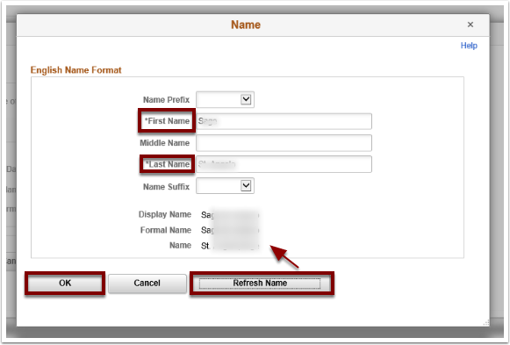
- The Name History page displays.
- Select OK to exit.

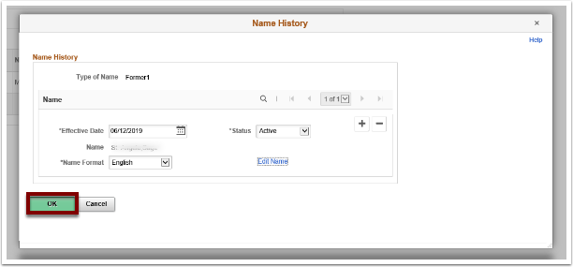

- The Additional Names page displays.
- Verify that all the data is accurate.
- Select the Save button.

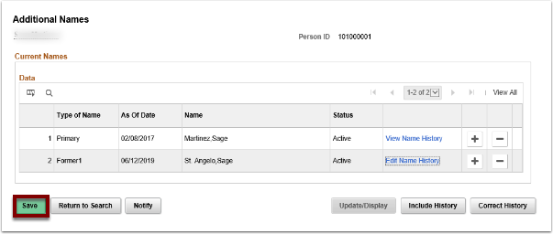

That’s it!

