Checking/Adding Direct Deposit Information The QRG is GREAT.

Nav>Payroll for North America>Employee Pay Data USA>Request Direct Deposit

We ALWAYS encourage employees to set up their own direct deposit but we can if we want to.

- The Request Direct Deposit page displays.
- Enter valid value into the Empl ID field.
- Select the Search button.
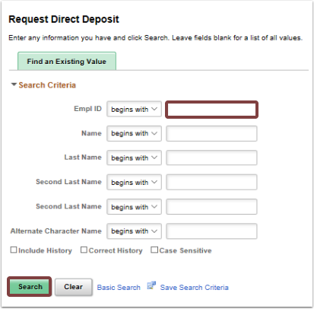
- The Request Direct Deposit page displays.
- Select Active from the Status drop-down menu.
- Select the check box Suppress DDP Advice Print option.
- If part of an employee's check is direct deposited and part is issued in a live check, the live check would also show the direct deposit information.
- Select a valid value from the Bank ID field.
- Enter the Account Type from the drop-down menu. Choices are:
  - Checking
  - Issue Check
  - Savings
- Select the Deposit Type from the drop-down menu. Choices are:
  - Amount if the employee wants a fixed dollar amount to be deposited in this account type.
  - Balance of Net Pay if the balance of an employee's pay is to be deposited in this account type.
  - Percent if the employee wants a specific percentage of their net pay to be deposited in this account type.
- Enter a valid value into the Account Number field.
- Enter a valid value into the Priority field. Use the Priority field to enter a priority number for this distribution. During direct deposit processing, distributions are made to accounts in order of their priority number: the lower the priority number, the higher the priority. Priority becomes important when an employee's net pay isn't enough to cover all direct deposits.
- Select the Save button.
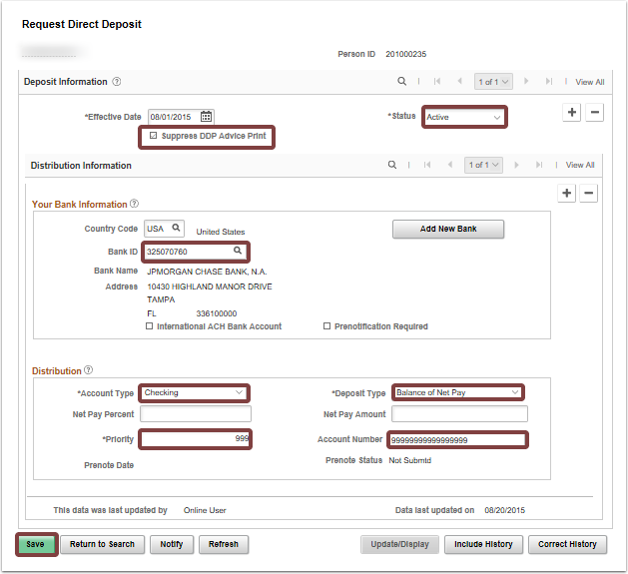
- The process to add direct deposit information to employee record is now complete.
- End of procedure.

The following is the bank info for a person that did not put in information for direct deposit, therefore, the system set them up a Focus card through US Bank.

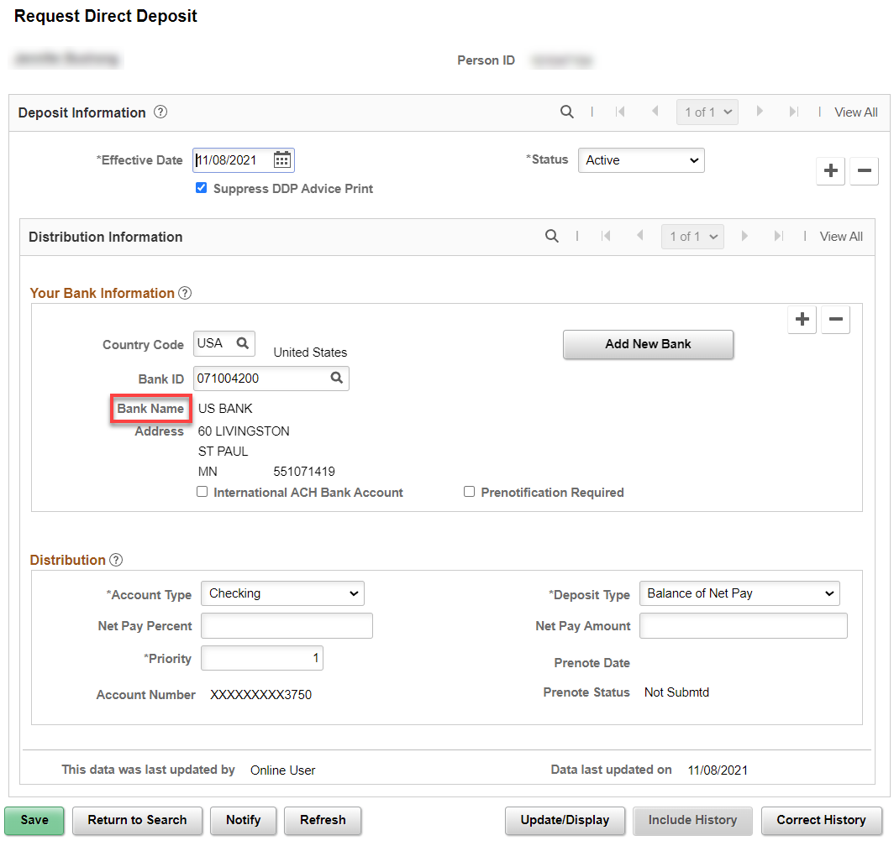

That’s it!

