Payroll-Error generated by T&L; closing the Rejected by Payroll Box

From time to time payroll will receive an error message likely generated by the Time and Labor Load process. Work with HR/Payroll team to determine if a payable time for the error should be paid or not. If payable, the hours may need to be manually entered in the payline and T&L adjusted accordingly.

Error Example: It includes a lot of info that, for the most part, doesn’t make a lot of sense.

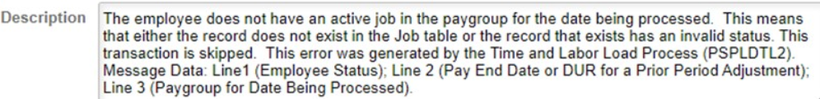

What the error message does include, however, is the EE name and Empl ID.

So, check it out since we know it is coming from Time and Labor.

Workforce Administrator Tile>Time & Labor Admin tile>Enroll/Maintain TL Data>Employee Timesheet

This EE has HOL generated for 7/5/21, which is in Rejected by Payroll status.

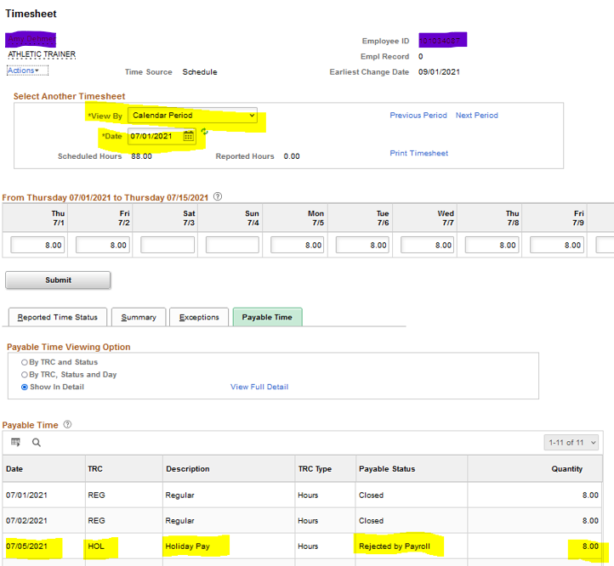
To clear the error:

Nav>Time and Labor>Report Time>Adjust Paid Time
OR
Nav>Workforce Administrator Tile>Time & Labor Admin Tile>Adjust Paid Time

Select the box Close? for HOL and Save.

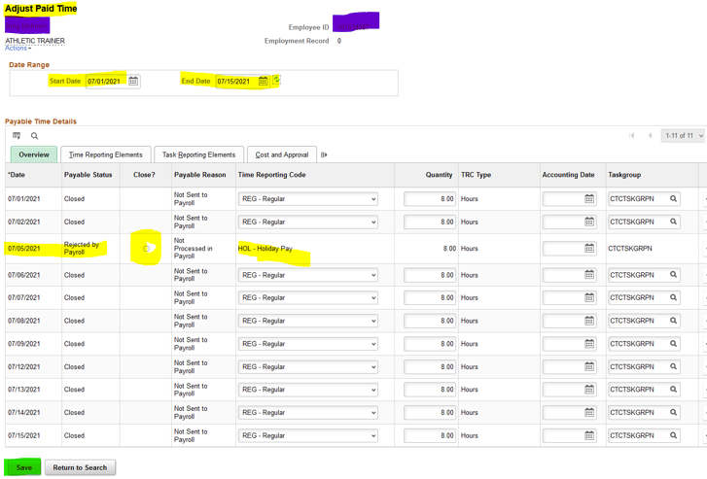

Here’s another example. Select the box Close? for Shift Differential and Save.

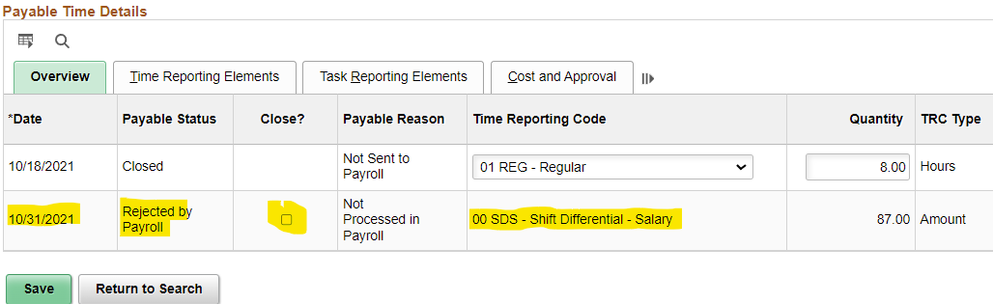

Here’s another example of an hourly employee that switched to full time so the hours were backed out. Select each box to Close. Save.

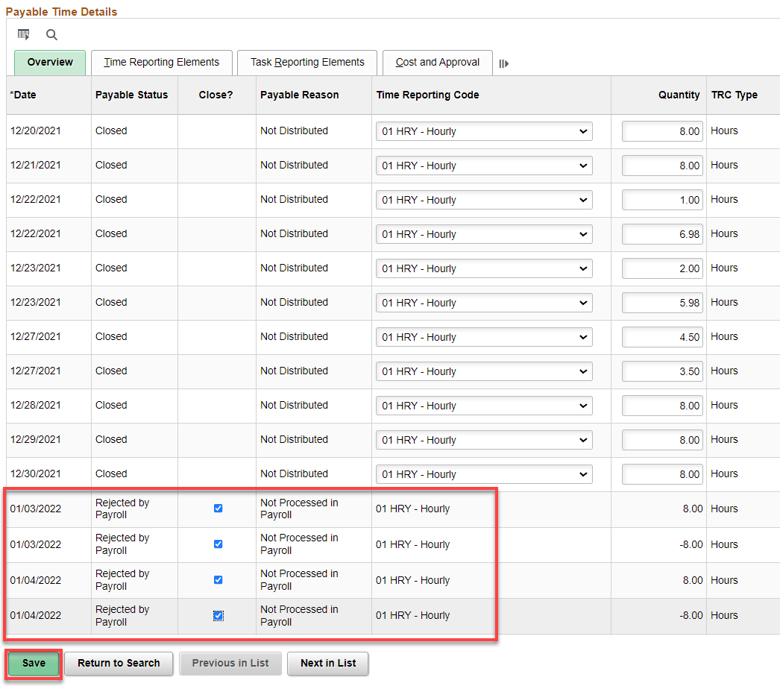

That’s it!

