SPECIAL ASSIGNMENT Employment Agreement
Instruction Form

This form is used for part-time and full-time faculty appointments that are not on the class schedule, and other special assignments where there is generally not a timesheet turned in (PT- & ML –hourly assignments are exceptions).

- Be sure to fill out the entire employment agreement including the budget information and description of duties.
- The administrator and/or supervisor need to sign the form before it is sent to human resources for the director’s signature.
- Please be sure to send the employment application packet and I.D. to HR with the employment agreement (if new employee).
- The HR office will mail the employment agreement to the employee for their signature.
_________________________________________

Below is a special assignment employment agreement form with the window for the type of appointment/position “popped up.” This is done by either clicking on the appointment category box with the mouse or by using the tab key to tab into the “cell” and then activating the pop up window by clicking on the box. Once the pop up window appears, choose the proper appointment category and continue.

NOTE: PT appointment categories are for part time faculty employees*
ML appointment categories are for full-time WVC faculty*
* There will be some exceptions to these (e.g., guest speakers, etc.)
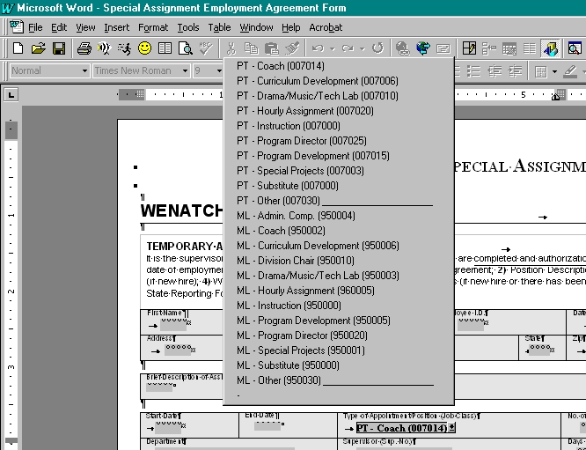
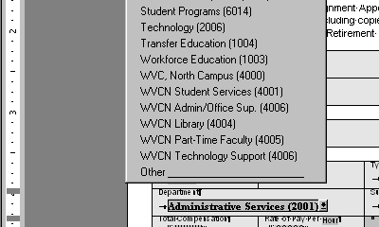

As you can see to the left, the next pop-up window is for the department. Once you activate this pop-up window, choose the proper department and continue. If the proper department is not listed, choose “Other” and write in the department name after you print the form out.

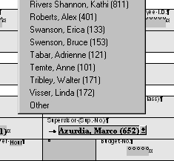

The next pop-up window is for the supervisor (pictured to the right). Activate this pop-up and choose the supervisor. If the supervisor is not one of the choices listed, choose “Other” and write in the supervisor’s name after you print the form out. If you notice that the list needs updating or you feel there is a supervisor’s name that should be added, please contact human resources.

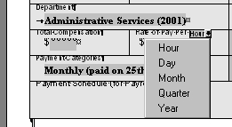

Pictured left is the “Rate of Pay” pop-down window. This window is often overlooked. If one of the choices apply to the rate of pay, please choose the correct one.

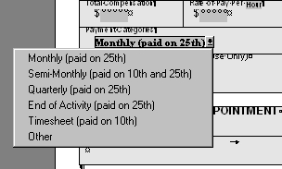

Pictured right is the “Payment Category” pop-down window. Again, just choose the appropriate category and continue.

If you have any questions about which choice to make regarding any of the menus, please contact the human resources office.

