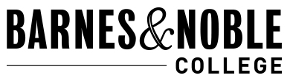
How to Return your Rentals Via-Mail

- Go to Http://wvc.bncollege.com
- Select Textbook Rentals

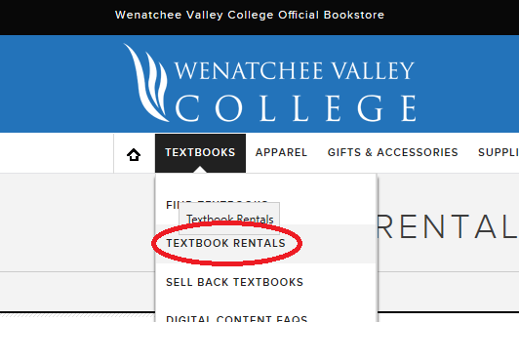

3. Click the Rental Return Link in the lower right-hand corner
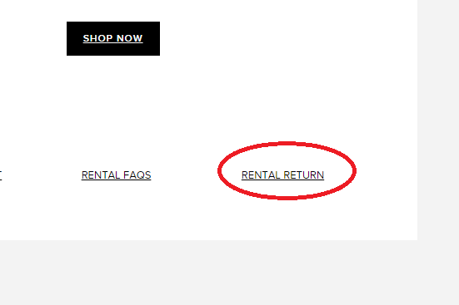

3a. Enter Order ID and Email address then submit.
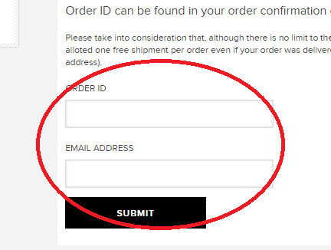
3b. The system will ask you for your address if you do not have an address on file with us or if you do it will go right to the next two screens:
