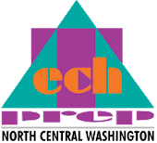
DUAL CREDIT
TEACHER VERIFICATION FORM
2016-2017

(Please use ink and print clearly)

Teacher Name:
(last) (First)

High School: District:

Address

Phone: Fax:

E-mail:

I certify that in 2016-2017 I will teach high school courses to meet 100% of the competencies outlined in the following articulation agreements:

Articulation Title | Required High School  Course 1 Title | Required High School  Course 2 Title
1.

2.

3.

4.
5.

Teacher Signature Date

Career & Technical Education Director Signature Date

Return form to: Wenatchee Valley College/Tech Prep
ATTN: Riva Morgan
1300 Fifth St.
Wenatchee, WA 98801
(509) 682-6847 / Fax (509) 682-6601

