Add A New Employee Instance

Nav>Workforce Administration>Job Information>Add Employment Instance

Classified Staff

Work Location tab: Put start date as effective date, put in position number them select “Override Position Data” and it will change to “Use Position Data” Add Company and Department, press tab and the rest will autofill.

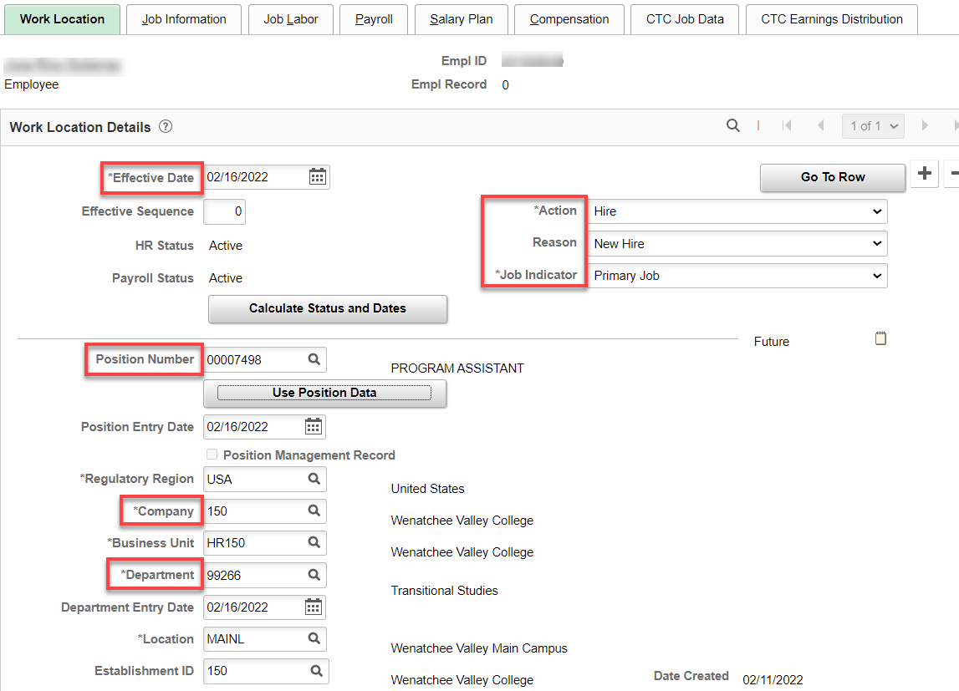

Job Information tab: Put in Supervisor, Empl Class, Work Period should be W522, FTE. If Work Period is W, the Position Data Work Period and/or Class Code needs updated. For now, you can put in W522 in Job Data and adjust the FTE back to 1.00. IF ELIGIBLE FOR SHIFT DIFF, put Evening in Regular Shift.

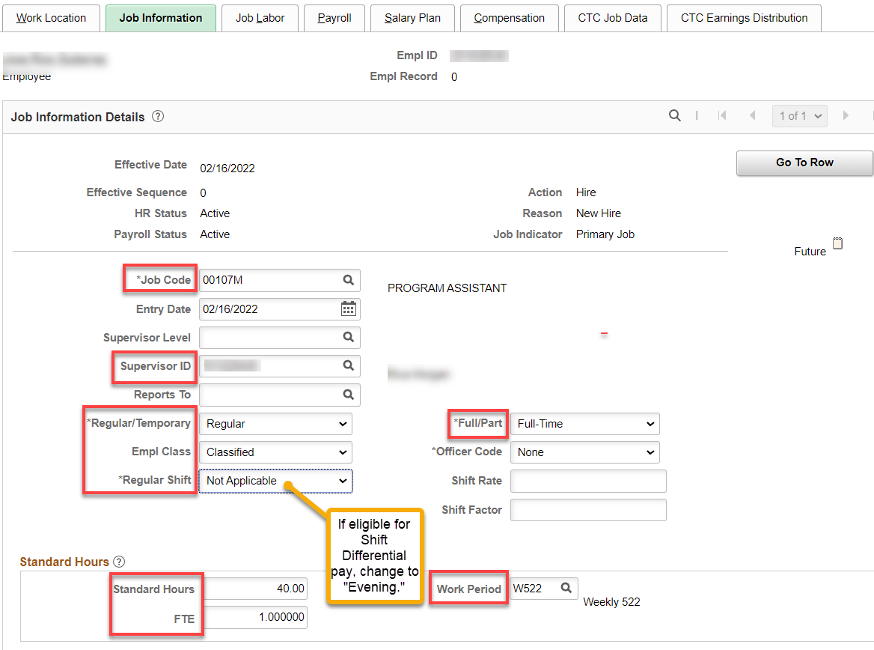

Job Labor tab: The union code should already be applied (pulls from the job class), change if needed and add Union Seniority Date (start date unless needs adjustment for prior service).

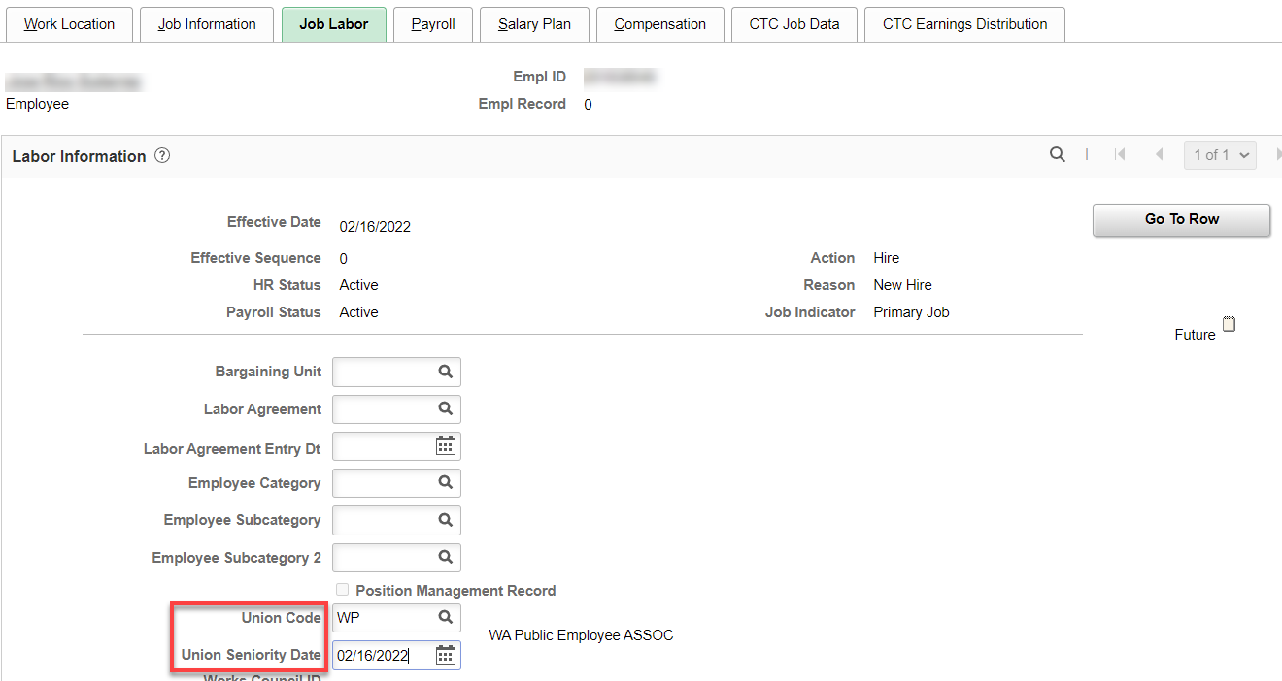

Payroll tab: Add Absence System (Absence Management) and Pay Group – everything else will autofill.

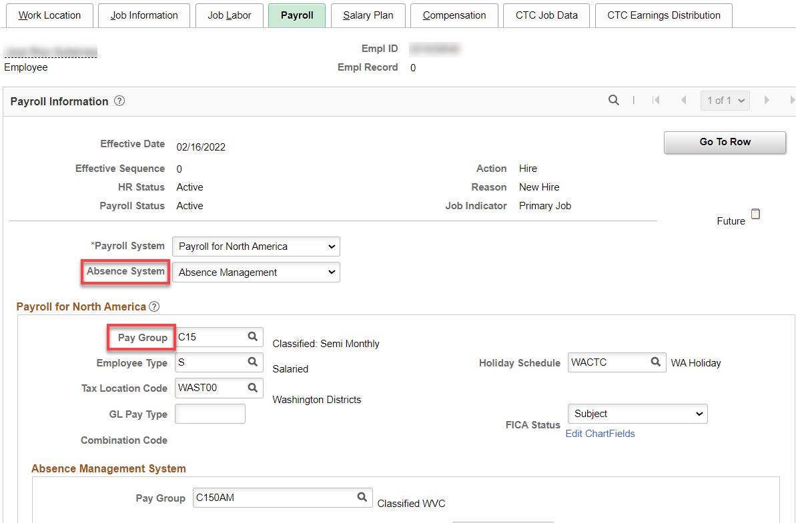

Salary Plan tab: Add Step and Step Entry Date (for 1-15 put the beginning of the month and 16-end of month, the 1st of the following month). Even if the employee starts above step 1 or even at the top step, put in the dates above. The system knows to move them up 6 months, a year or six years.

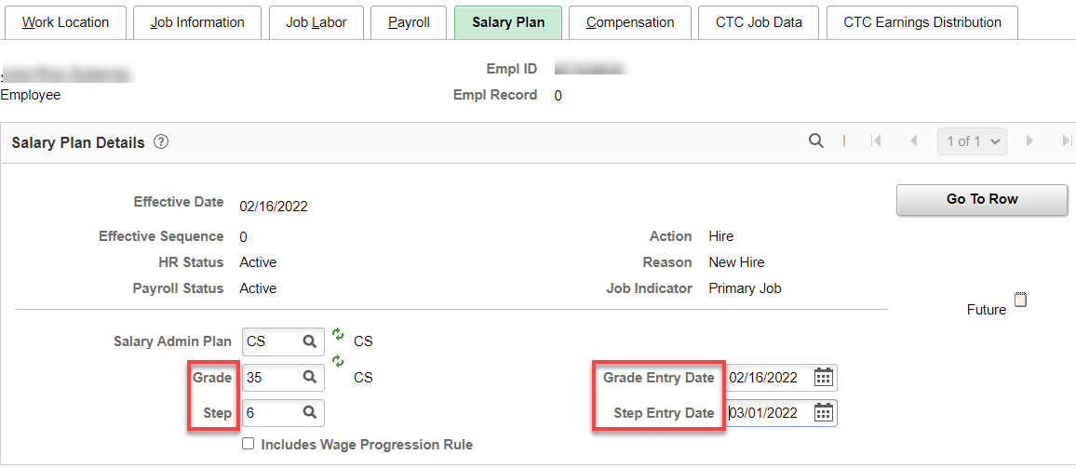

Compensation tab: Add Rate Code, Comp Rate (annual salary), Frequency should already be “S” and hit Calculate Compensation. If you click the down arrow on Pay Rates, you will see all the different rates.

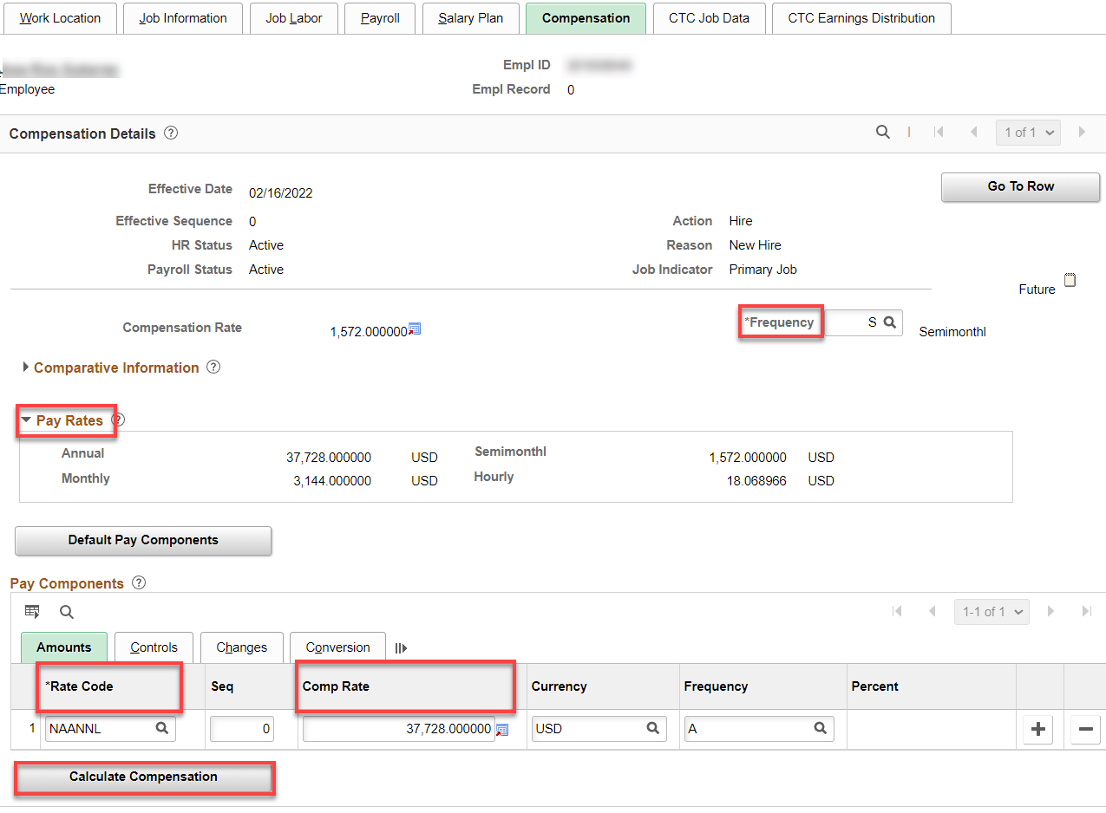

CTC Job Data tab: Add Leave Accrual Date (the first of the current month if the start date is 1-15, first of the next month if start date is after the 15th), Leave Max Month (always the month hired), Job Term, Job Emp Type, Probation End Date or Trial Service Date, DRS Calendar not needed, check Union Member, if applicable (has nothing to do with union dues…BUT, it’s important for other union-related things like MOUs and union reporting) and OFM Bargaining Unit (if applicable).

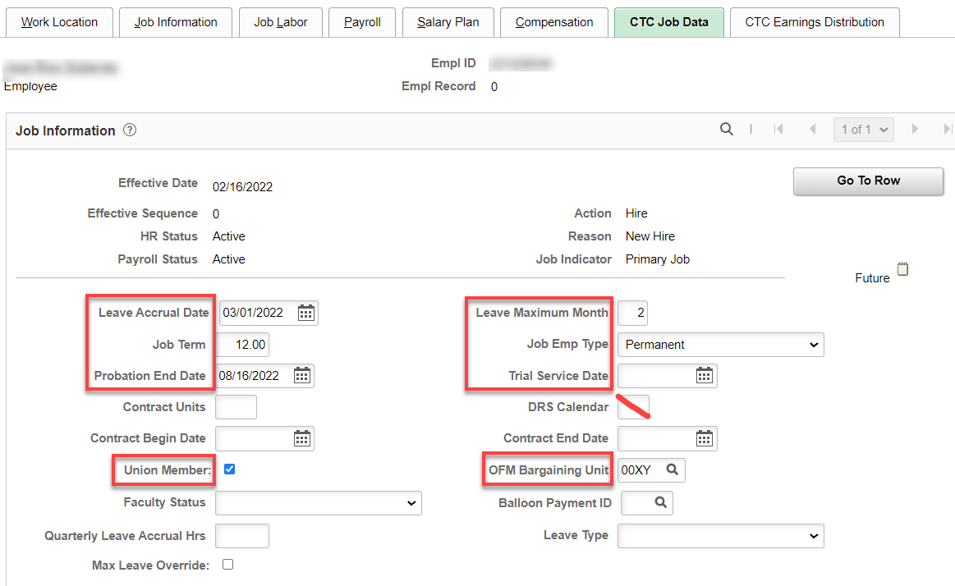

CTC Earnings Distribution tab: Add Earnings Code, Percent of Distribution, check Primary on all codes (if more than one), click on Edit ChartFields to add Combination Code(s).

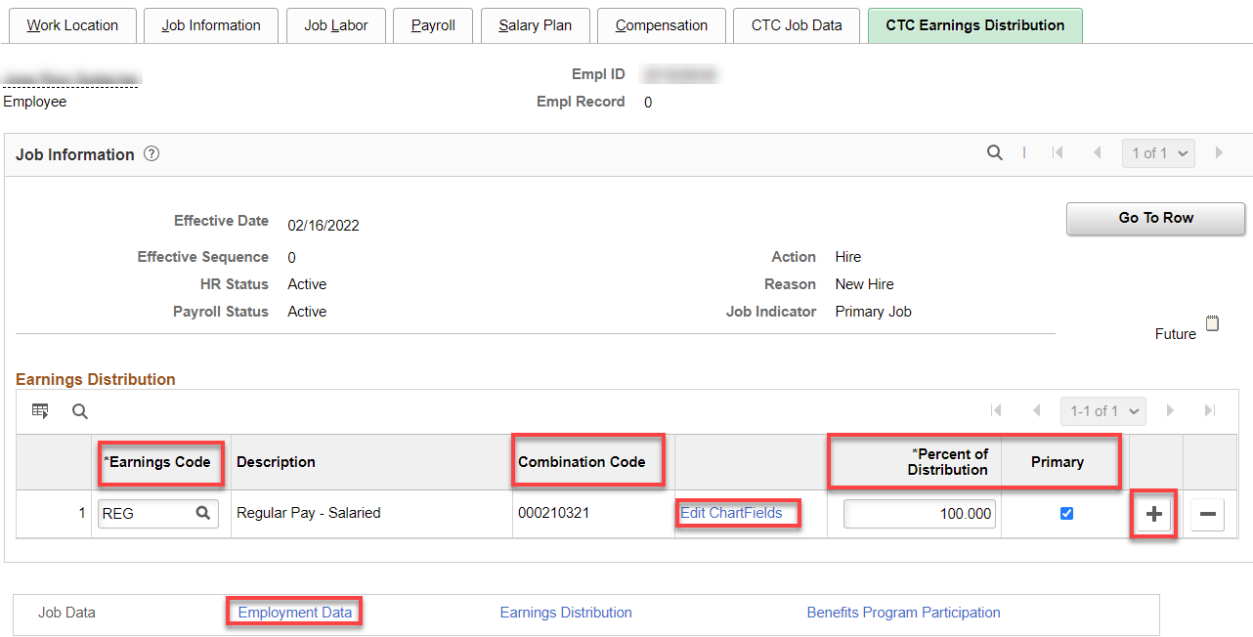

After entering the Combo Code, hit enter and the ChartField Detail will populate; check budget to see if it matches what you need, click OK.

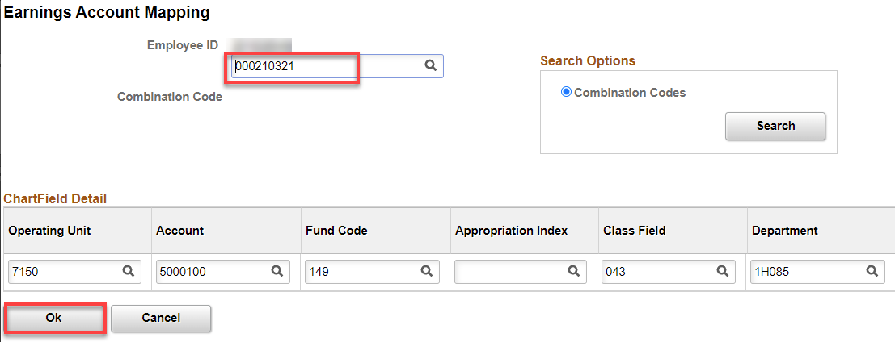

Click on Employment Data Hyperlink (Employment Information will autofill after filling out the Time Reporter Data).

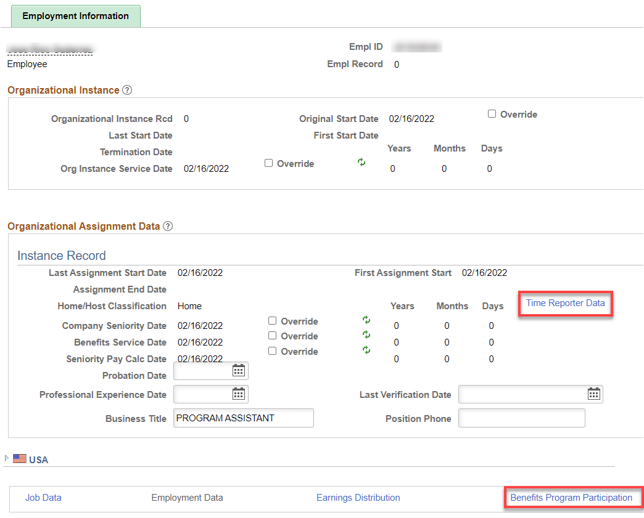

Click on Time Reporter Data First, change the effective date to the hire date, Time Reporter should already be Elapsed Time Reporter, Add Elapsed Time Template, appropriate Workgroup, Taskgroup, click OK. Employment Information should have filled in like above (You have to look after the final save).

Note: save yourself a lot of time by putting in the first digits (e.g., 15) in Workgroup, to bring up only the workgroups associated with our college).

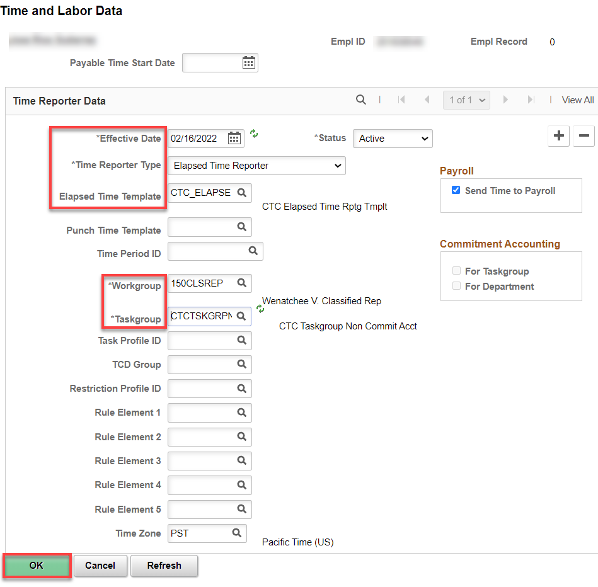

Click on the Benefit Program Participation hyperlink
Add Benefit Record. Effective date is the start date. If a rehire and the old Benefit Participation Details are present, add + a row and put the updated info in.

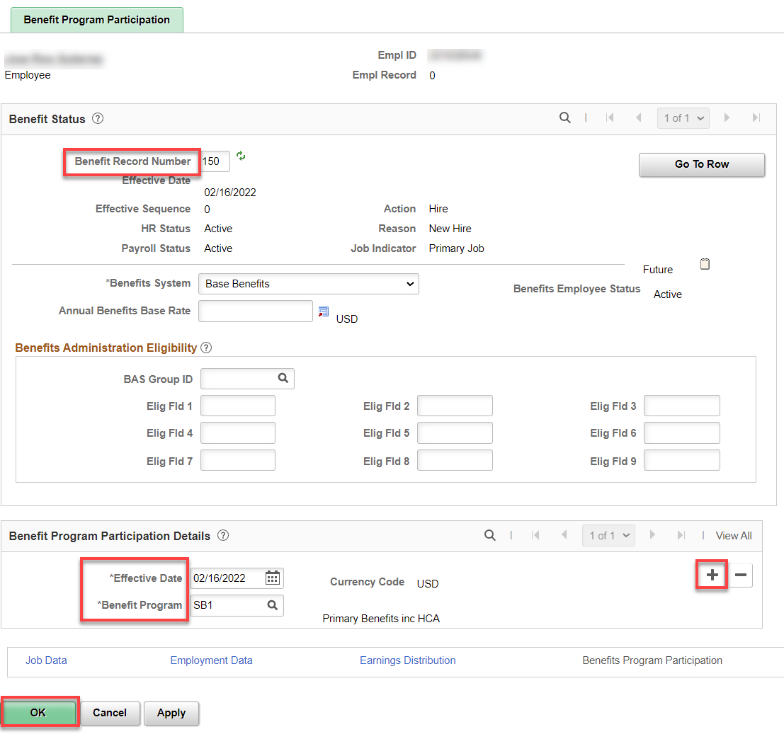
After you click save, you will see a couple of warnings, just read and click ok.

Assign ACA Status – Nav>Benefits>CTC Custom>Assign ACA Status

If they work more than 130 hours, use the 1st of the current month, otherwise, use the 1st of the next month. Add a Row if this is a change. Save.

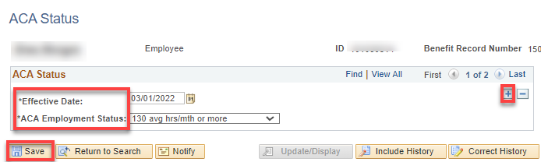

AFTER START DATE
Assign Work Schedule - Nav>Time and Labor>Enroll Time Reporters>Assign Work Schedule OR Workforce Administrator, Time & Labor Admin Tile, Enroll/Maintain TL Data>Assign Work Schedule

In order for leave to accrue and holidays to work correctly, a work schedule must be assigned from Use Default Schedule to Select Predefined Schedule.

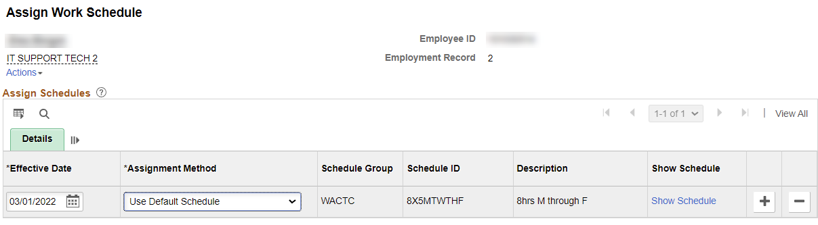

Add Effective Date (Start Date), Assignment method (change from Use Default Schedule to Select Predefined Schedule, Schedule Group (WACTC) and the schedule ID (choose from a long list or if it is 5 8s M-F, put in 8X5 to narrow the search). You can see the schedule by clicking on Show Schedule or add a new schedule (in the future) by adding a row.

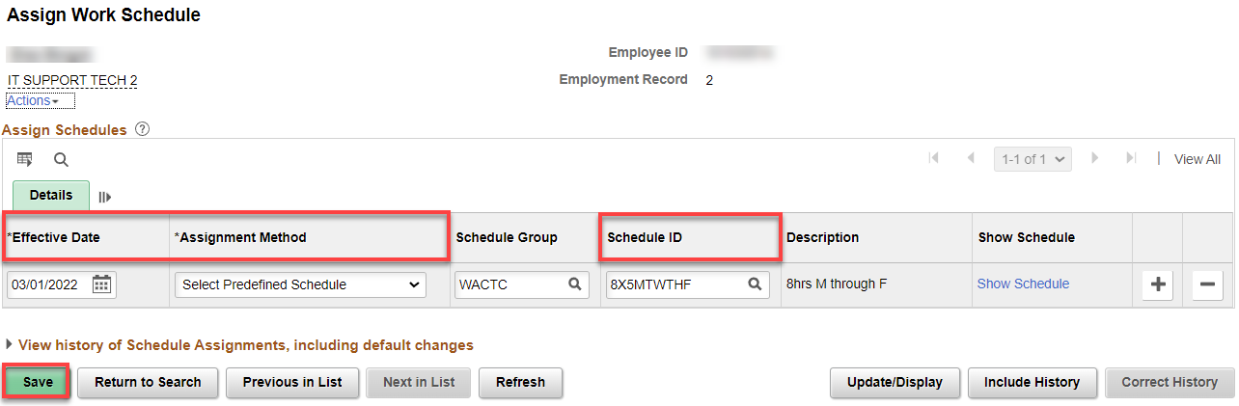
That’s it .

