Add A New Employee Instance

Nav>Workforce Administration>Job Information>Add Employment Instance

PT Faculty

The effective date is the current date or a date before the quarter starts (very important to do this so FWL runs properly)

Work Location tab: dd Effective Date (must be prior to the quarter start date), Reason, Company, Department, Department Entry Date (start of quarter)The Department Entry Date (first day of the quarter).

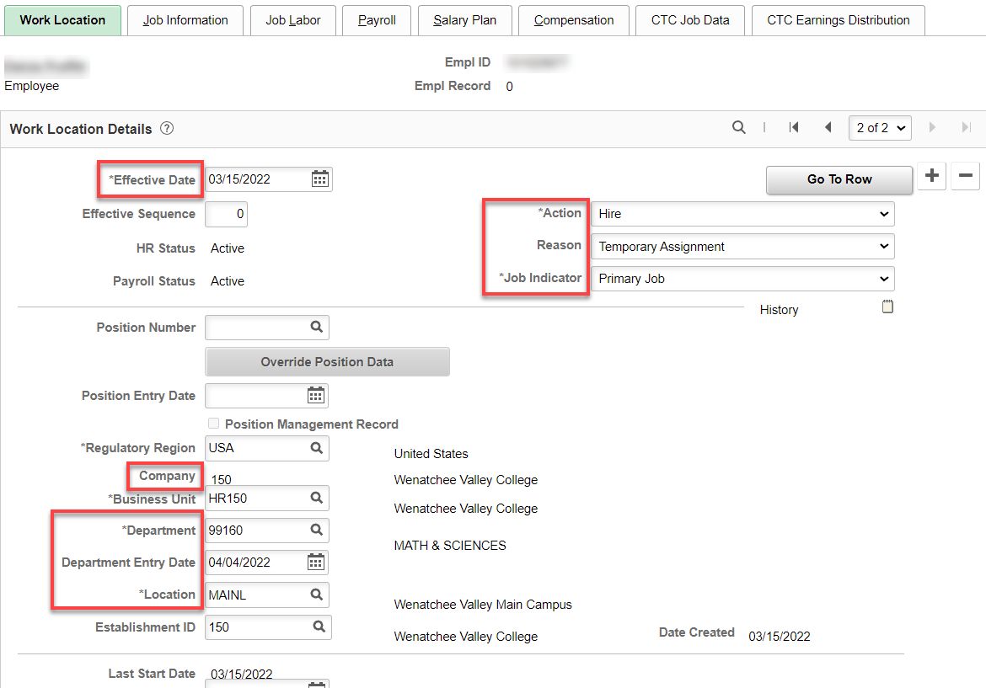

Job Information tab: Add Job Code, Supervisor ID, Regular/Temporary, Full/Part, Empl Class.

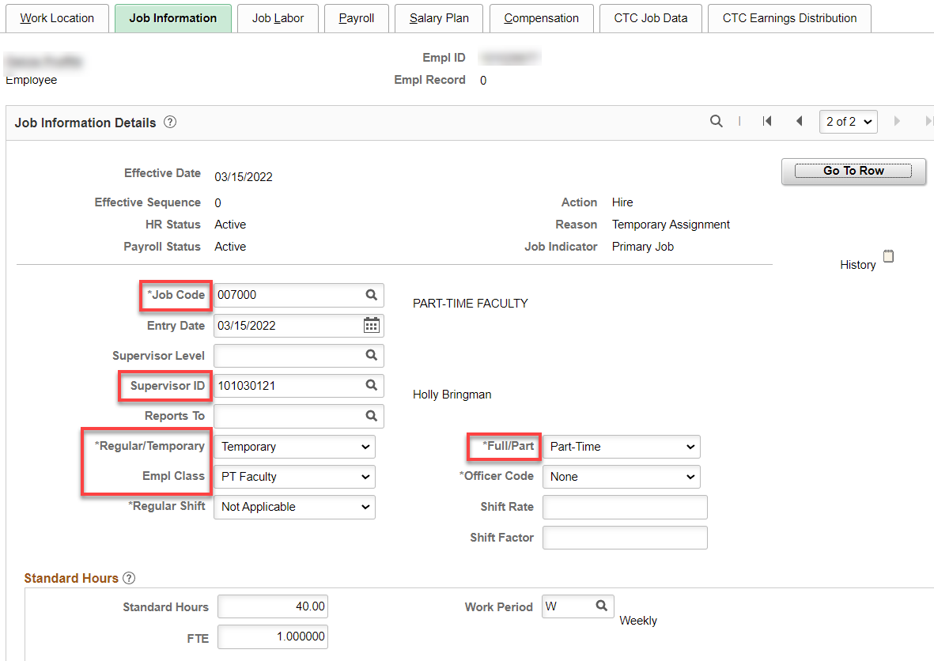

Job Labor tab: Union code auto fills

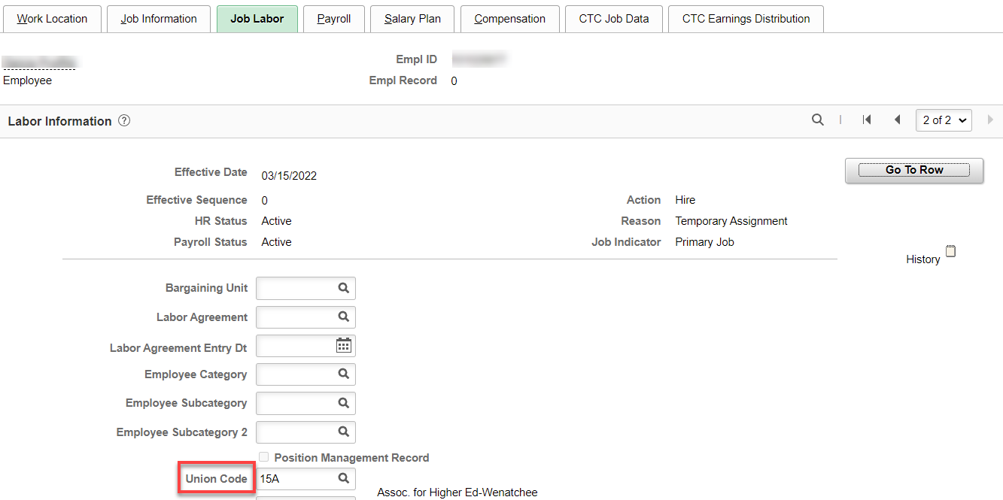

Payroll tab: Add Absence System (Absence Management-ONLY ADD AN ABSENCE SYSTEM TO ONE JOB TYPE – don’t add Absence Management if they already have one); Add Pay Group (P15), everything else autofills.

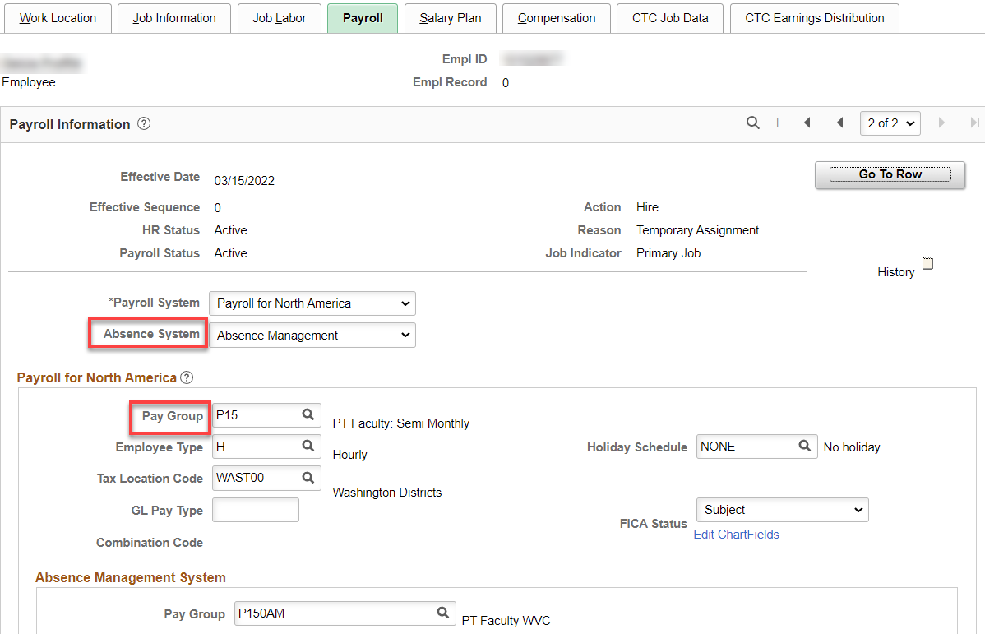

Salary Plan tab: Leave blank.

Compensation tab:- Leave blank (FWL will populate).

CTC Job Data tab: Add Leave Accrual Date (first of the contract begin date month), Job Employment Type (Temporary) and DRS Calendar. I like to add the Job Term, Contract Begin and End Dates because they help distinguish between other jobs (but they are not necessary).

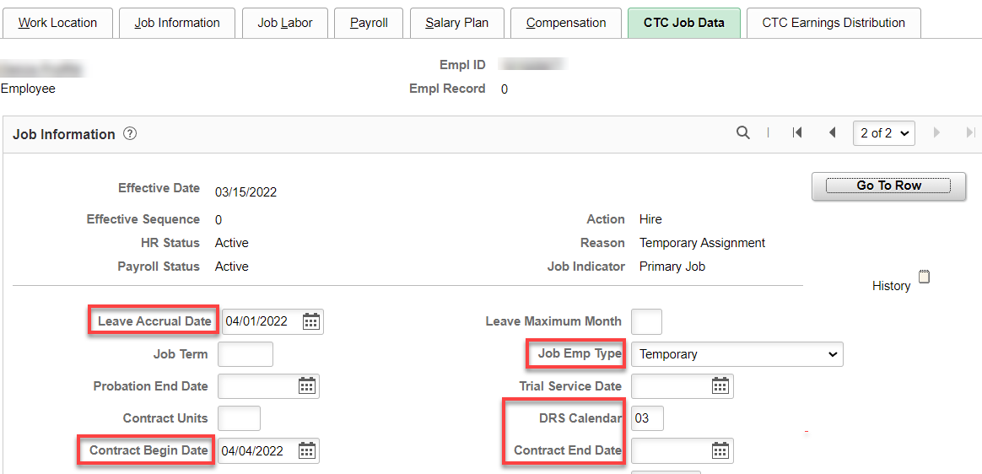

CTC Earnings Distribution tab: Add Earnings Code (PTF), Percent(s) of Distribution and set all to Primary. Click on Edit ChartFields to enter Combo Code(s).

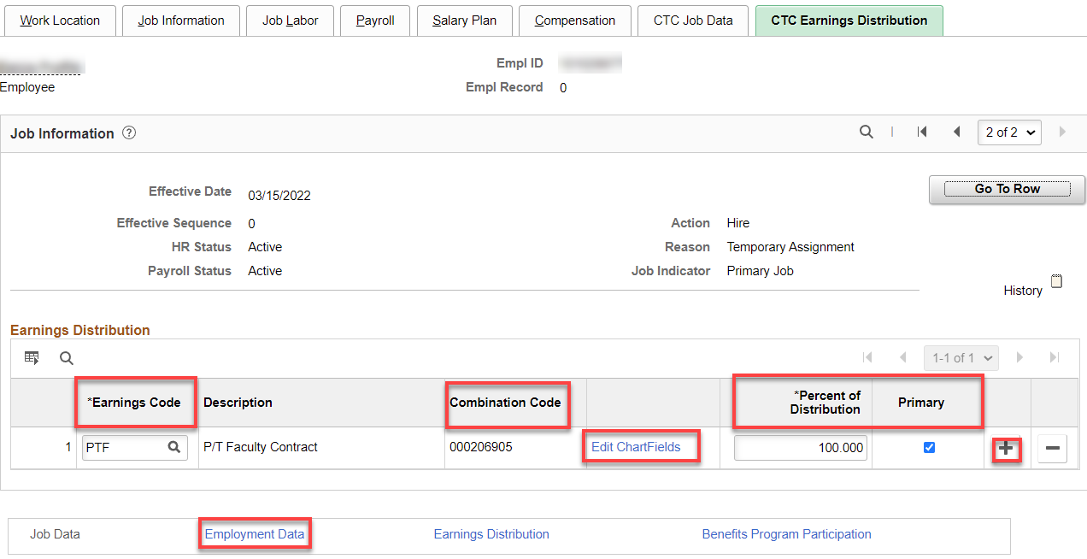

Enter Combo Code, click OK. If you don’t have a combo code but you have all other chart fields, you can enter the chart fields and click Search (better to have the combo code though).

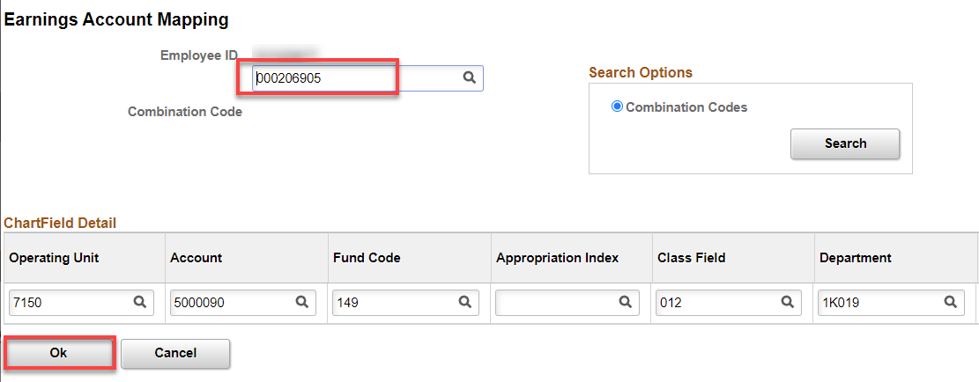

Click on Employment Data link.

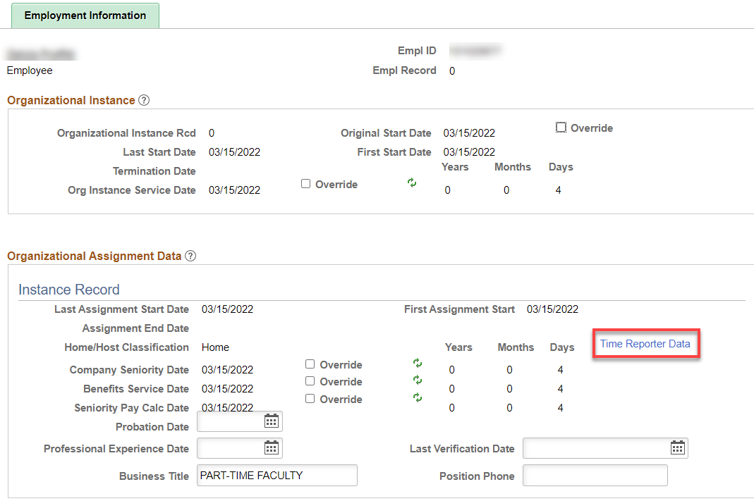

Click on Time Reporter Data First, change the effective date to the quarter start date, Time Reporter should already be Elapsed Time Reporter, Add Elapsed Time Template. Workgroup, Taskgroup, click OK. Employment Information should have filled in like above. Yes, the dates are not the actual start dates and you can override them if you choose.

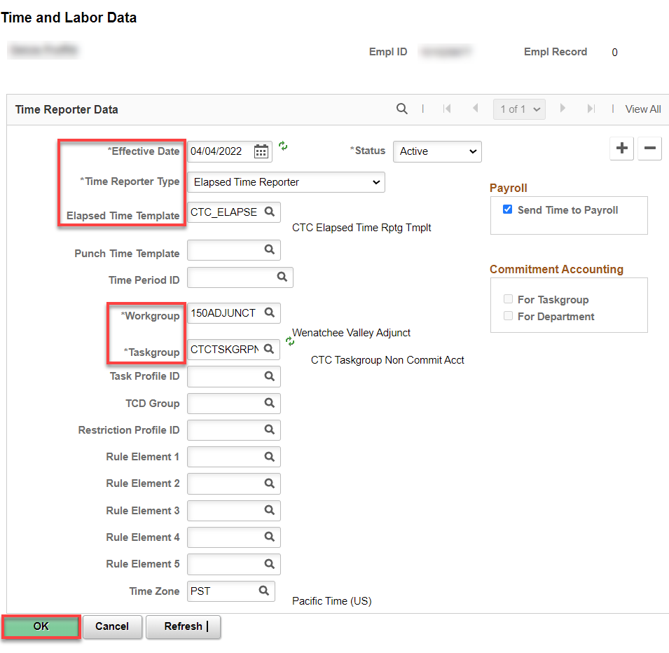

Benefit Program Participation - Since this is a primary job with no benefits, just make sure the Benefit Record Number is 150. If this is the primary job for a new PT faculty, the Benefit program will be autofill to SB0. If secondary job for benefit eligible, Benefit Program will already be SB1. Click Refresh. Again, the effective Date for Benefit Program will not be the actual start date but that’s ok.

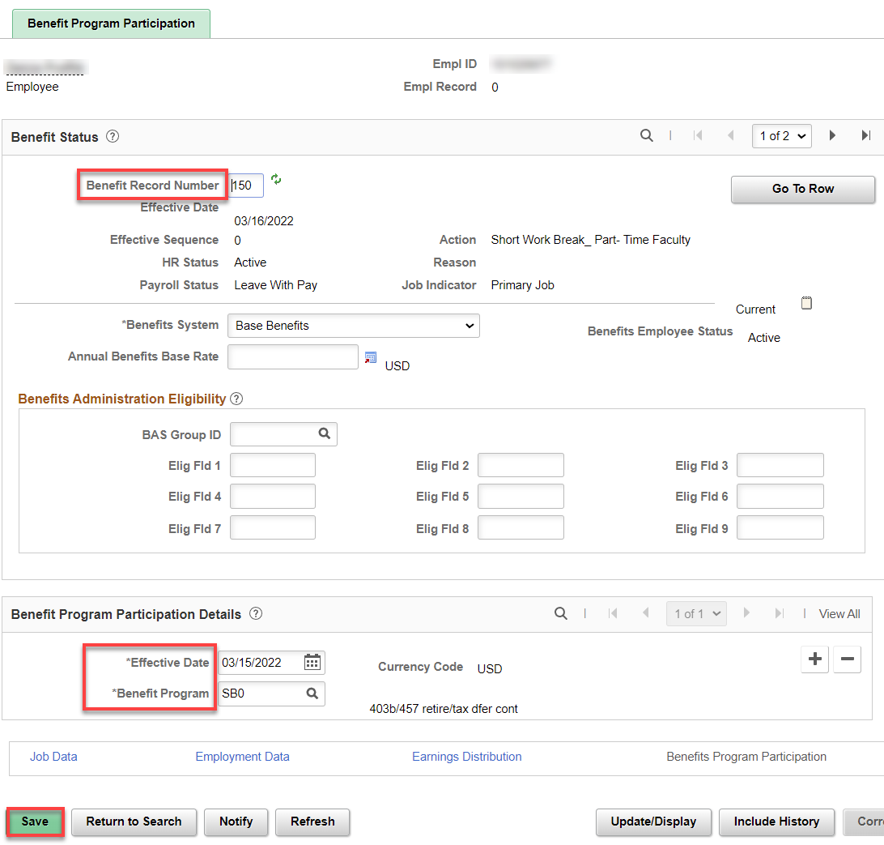

Assign ACA Status – Nav>Benefits>CTC Custom>Assign ACA Status

Add Effective Date (probably quarter start date). If new employee, set to less than 130 hours per month, Save.

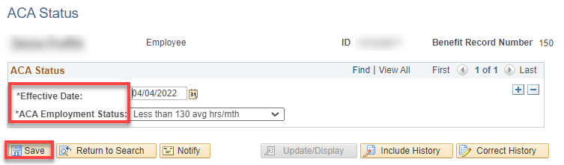

That’s It!

