Adding a Person There are three good QRGs that are basically the same: Add a New Employee Person and Job Instance, Adding a Person and Hiring a New Employee

Nav>Workforce Administration>Personal Information>Add a Person

IMPORTANT: Before you begin this process, be sure to perform the Search Match process to verify if the person has an existing Employee ID.
Refer to the QRG titled Performing a Search Match.
After performing a Search/Match and you indeed find an Empl Id, go to Add Employment Instance and try to add an Employment instance.

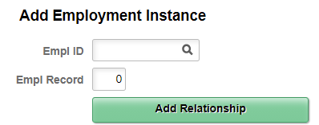

If you had problems with Adding a Person or Modify a Person but were able to add an employment instance, be sure to go to Modify a Person and make sure the information is correct.

If you cannot Add a Job Instance, go to Add a Person

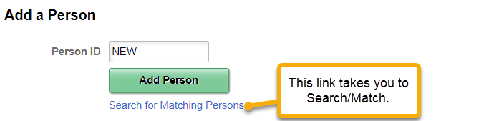

IF YOU HAVE AN EMPL ID, instead of clicking on Add Person (NEW), put in the Empl ID and click Add Person.

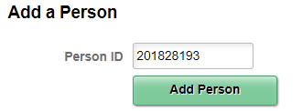

- Change Effective Date, if necessary, select Add Name.

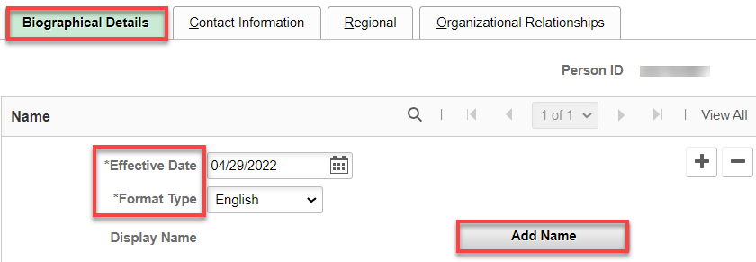

- Enter First Name, Last Name, Click Refresh Name, click OK.

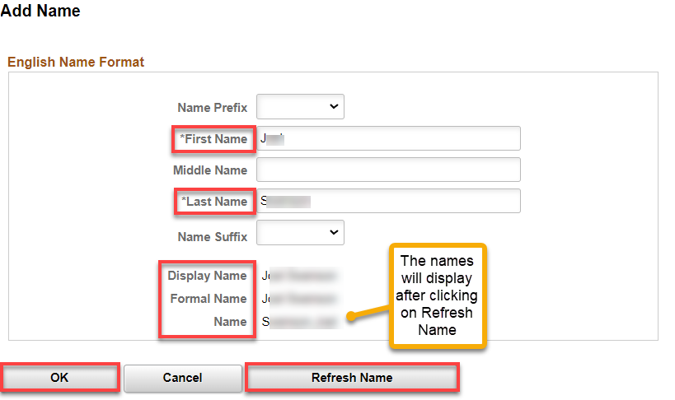

- The Biographical Details tab displays from the Modify a Person page.
- Enter the Date of Birth.
- The Birth Country will default to USA on the user profile preferences of the employee doing the data entry. If needed, it can be changed to another country.
- Birth State and Birth Location are not required but can be entered if desired.
- In the Biographical History subsection, select Sex from drop-down menu. (To review Legal Definition of Sex, select the link to review a pop up window).
- Highest Education Level defaults to A-Not Indicated. If known, the real value can be selected from the drop-down menu. This is information only and does not drive anything. More education data can be stored in profile management.
- Marital Status defaults to 'Unknown'. If known it should be selected from the drop-down menu. This field does not drive taxes. That data is stored in PY.
- Language Code is the employees preferred language. This is information only and only one value can be selected. More information about languages can be stored in profile management.
- The 'Country' field under National ID subsection defaults to USA. If needed it can be changed if the employee is not a US citizen.
- The National ID Type value defaults to social security number for USA.
- Enter the National ID value. There has to be at least one primary National ID.

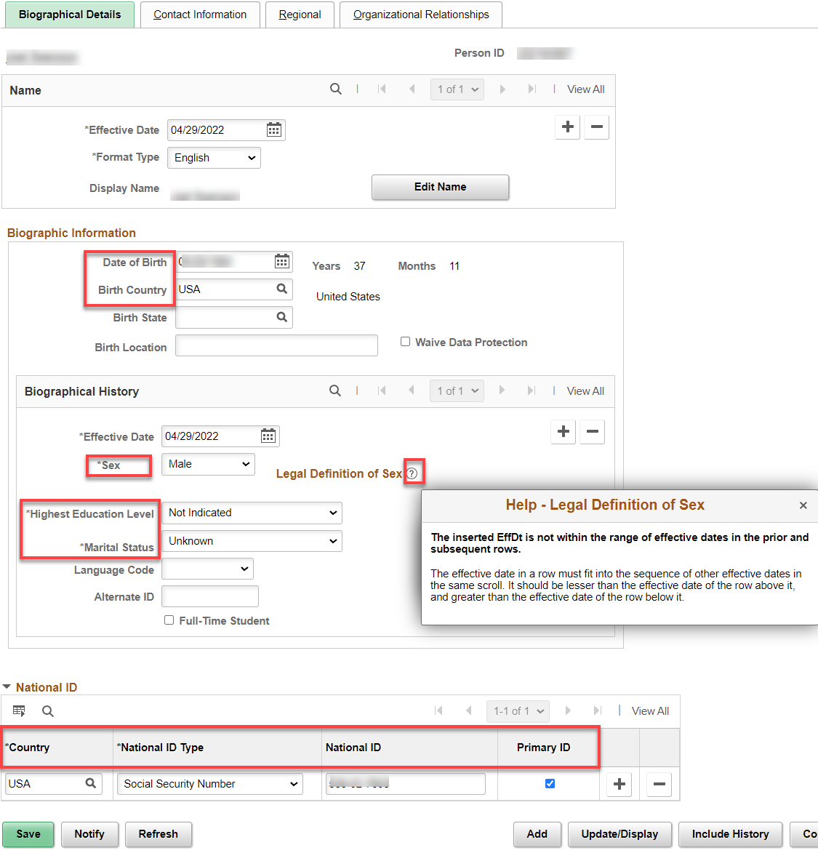

- Select the Contact Information tab.
- Select the Add Address Detail link.

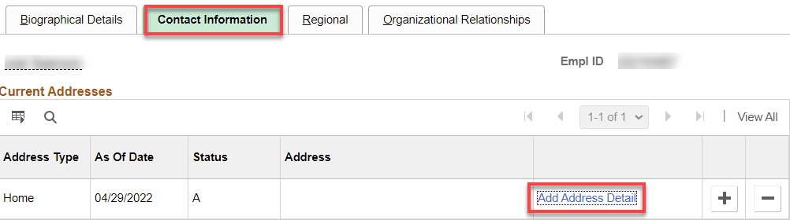

- Select the Add Address link.

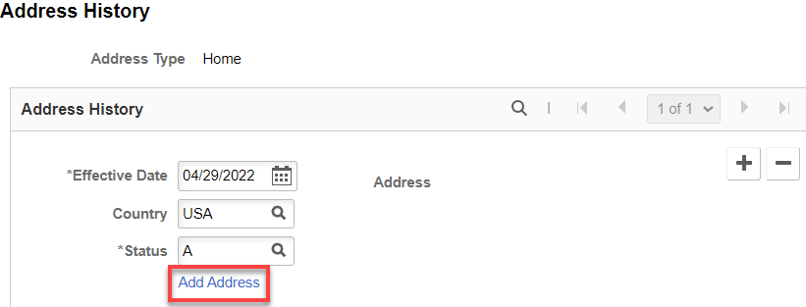

- Enter the Street Address in the Address 1 field.
- If there is a P.O. Box you can enter it in Address 2 field.
- Enter the City and State.
- Once you enter the State the 'Address Validation' functionality (third party tool) will fill in the rest of the fields if that is a valid address. If not, it will show you valid addresses based on what you have entered.
- Enter the Postal (Zip) code, County (optional), if needed, select the OK button.

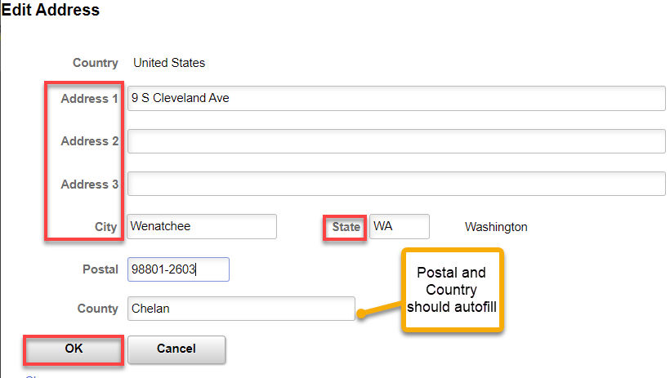

- This time the address you entered will display on the page.
- Select the OK button.

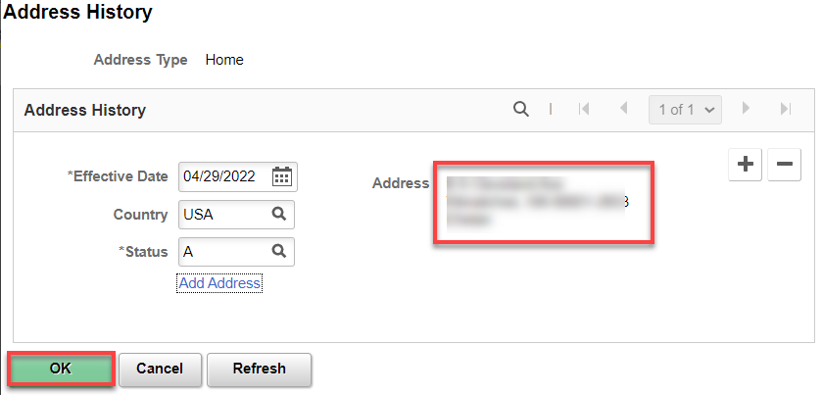

- The Contract Information tab displays.
- Enter the Phone and Email Information
- Select the Preferred checkbox.
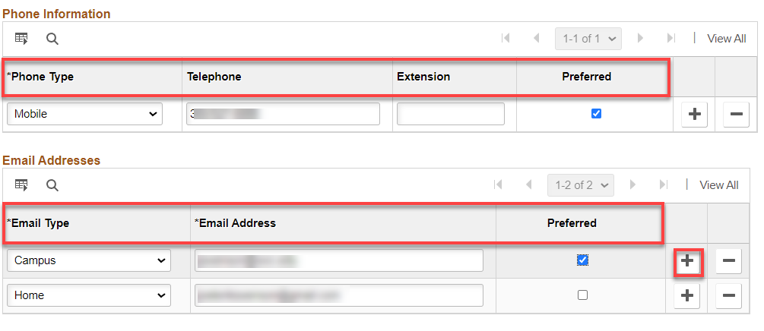

- Select the Regional tab.
- Select an Ethnic Group from the lookup icon.
- Select the Primary checkbox if applicable.
- Use the fields in the History section to track your I-9 information.
- In the Veterans section:
  - Select a Military Status from the drop-down menu.
  - If you select a discharge related option, the system will require the Military Discharge Date.
- The option selected in the Smoker History gets displayed on the Additional Information page of Employee Self Service (ESS > Personal Details > Additional Information).
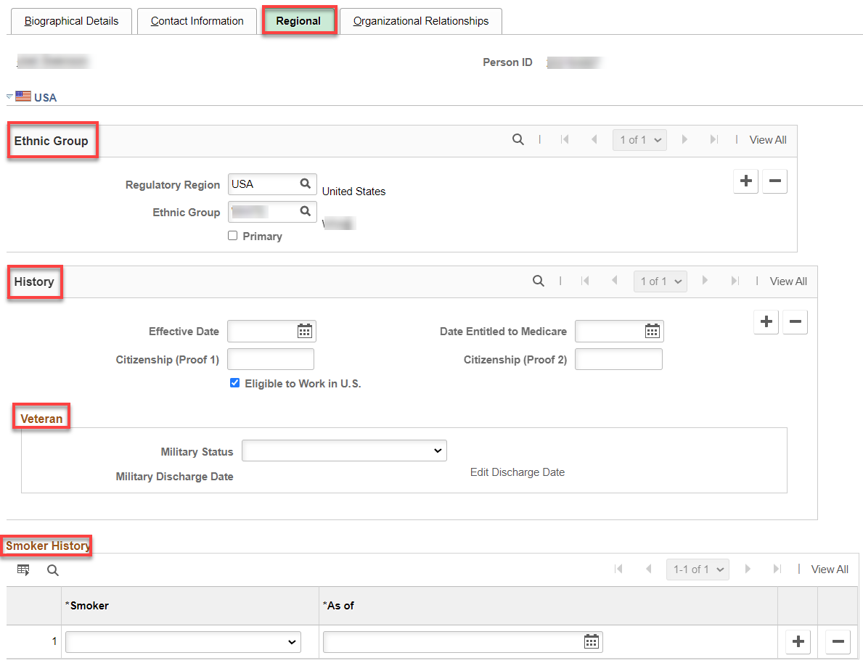

- Select the Organizational Relationships tab.
- There are three options on this page when hiring a person. For the most part you will always choose 'Employee'. SBCTC does not use 'Contingent Worker'. 'Person of Interest' is only used for Volunteers that need access to PSFT.
- Select the Employee option.
- Select the Add Relationship button. The system will check the personal data and make sure it meets any checks and balances the system has. The system checks the person you are entering against both HCM and CS to see if they already exist based on key fields. (Name, SSN, Birthdate etc.)
- Select the OK button.
- Select the Save button.
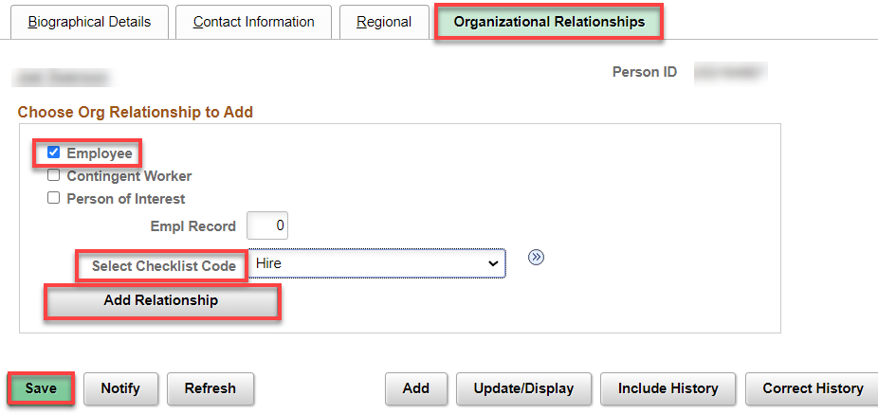

In this case, the system is saying that there may be a person already in the system. We already know this because we started with an Empl ID, click Return
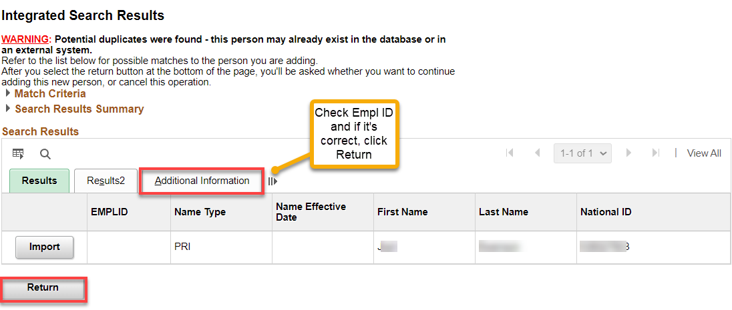

- A Message box will appear.
- Select the OK button.

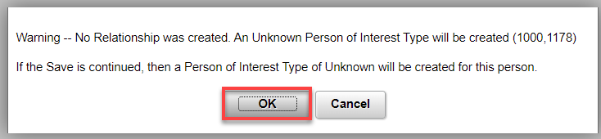

- The Organizational Relationships tab displays.
- The system will save the record and generate a Person ID (Empl ID).

That’s It!

