Changing Retirement Plans

Nav>Benefits>Enroll in Benefits>Retirement Plans

- If you’re going from PERS 2 to PERS 3, you don’t need to term PERS 2 – you can just add row and start up PERS 3 on the date the EE chose that plan. The new contribution will collect the pay period that the new plan choice is effective.
- If you’re going from a DRS plan to SBRP (or vice versa) – you must term the old plan and start the new plan or both will collect.

TERMINATE OLD PLAN: Add + a row to Coverage

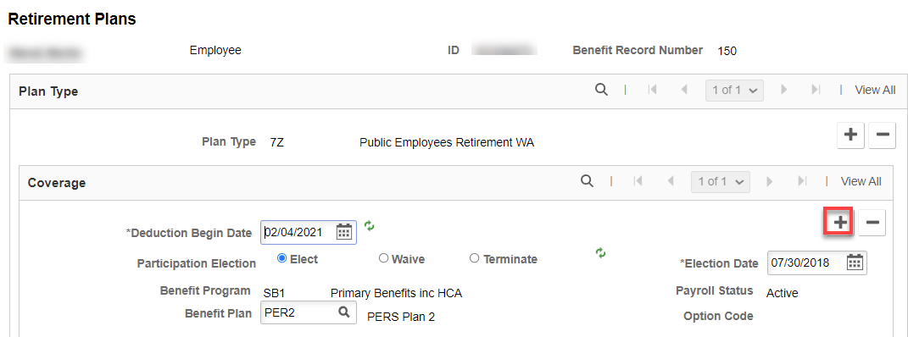

Check Terminate, add the end date in Deduction Begin Date and make the Election Date the same, save

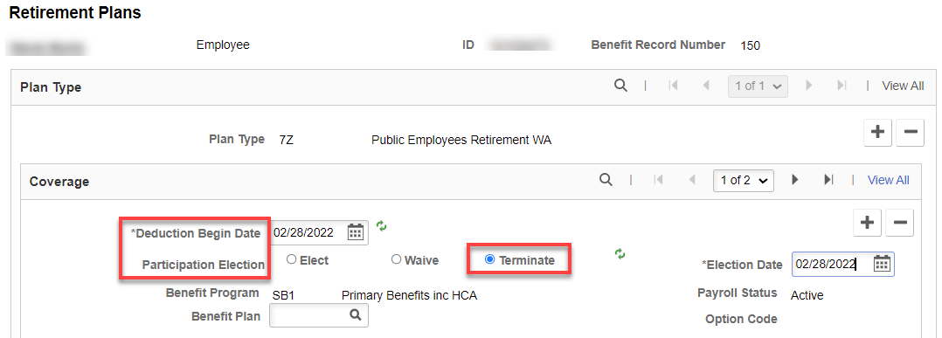

ADD NEW PLAN: Add + a row to Plan Type, add Plan Type, save.

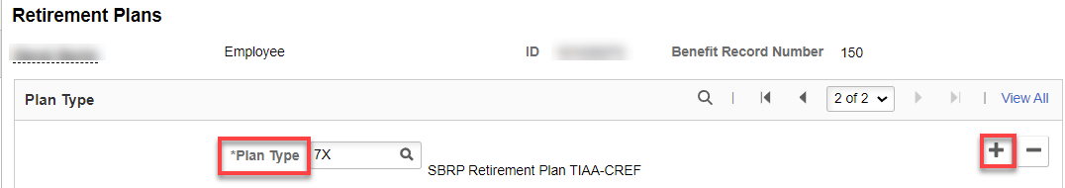
Add a row + to Coverage to add new plan (or just fill out if already added), add Deduction Begin Date, Election Date (must be the same), Benefit Plan, save.

Note: NEVER CHANGE THE ELECTION DATE IF THERE IS A PRIOR DRS PLAN DATE…DRS wants only one Election Date).

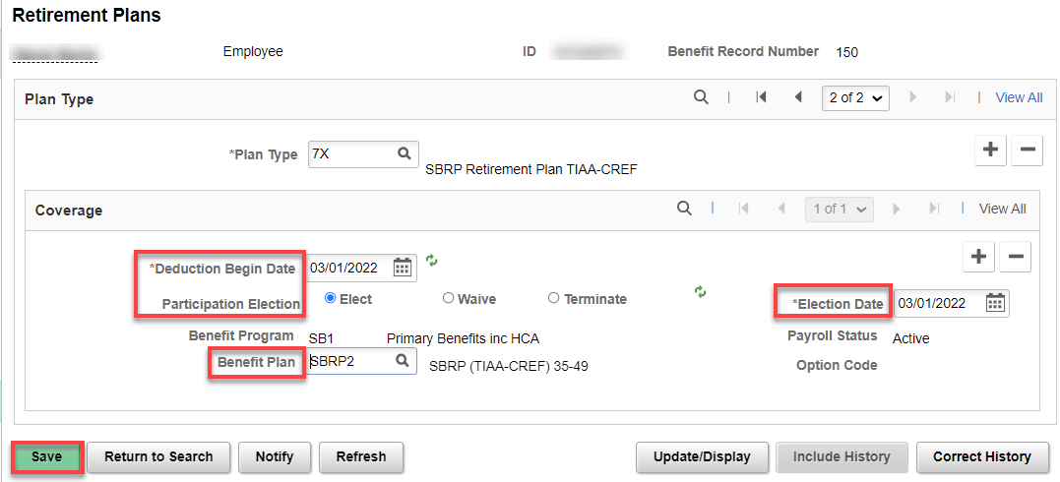

If the plan change is to a DRS plan, you must add the information in Retirement Fields

Retirement Fields

Nav>Benefits/CTC Custom/Retirement Fields

Add the Effective Date, DRS Option, DRS Option Date, and Retirement Plan Effective Date, Save.
Prior RET Plan is only for a Retiree Returning to Work (so unless this is the case and we know it, this field should be blank).

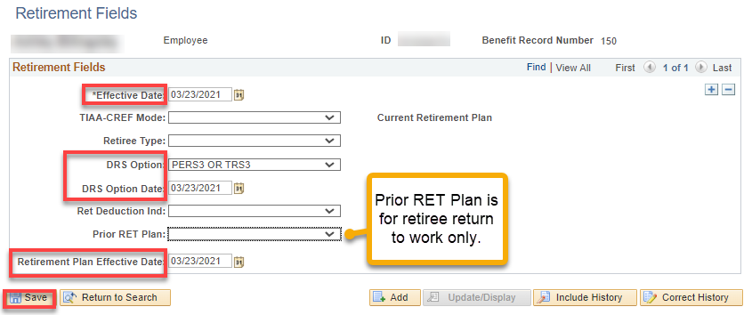

If the plan changes from a DRS plan to the SBRP, nothing needed to be done with Retirement Fields.

Dates are very important and must be the same on both the Retirement Plan and Retirement Fields pages. See QRG Dates on Retirement Plan Pages.

DRS Transaction
Nav>Benefits>CTC Custom>DRS Transaction

Payroll takes care of this page…thank goodness.

How do the retirement plans get updated for the different ages? It’s an automatic process, E-188, that is run by Central Payroll each pay cycle.

That’s it!

