Running the Age 50 SRA Extension Process (QRG is GREAT I just modified it a bit)

Purpose: Use this document as a reference for how to run the Age 50 Extensions for 403b and 457 savings plans in ctcLink. Run this process separately for each limit type, i.e.: 457 and 402(g).

The Identify Age-50 Extensions process identifies the employees who are age 50 or more and it creates Age-50 limit extension records that increase the 402(g) Savings Plan limits, the 457 Savings Plan limits, or both for elective deferrals as authorized by IRS regulations.

This process identifies and allows for those employees eligible for the 457 15 year catch-up, and the 402(g) age 50 extensions, to have the additional deduction limit of $xxxx added to their 457 and 403(b) plan - Verify limit amounts with IRS. The 402(g) is the limit type for the 403(b) plan.

This process should be ran prior to payroll processing.

NOTE: Run this process separately for each limit type, i.e., 402(g) and 457.

Running the Age 50 Extensions

NAV>Workforce Administrator>Benefits tile>Identify Age-50 Extensions OR Nav>Benefits>Monitor Savings Pln Extensions>Identify Age-50 Extensions

- The Identify Age-50 Extensions run control ID search page displays.
- Enter the Run Control ID or select Add a New Value.
- Select the Search button.

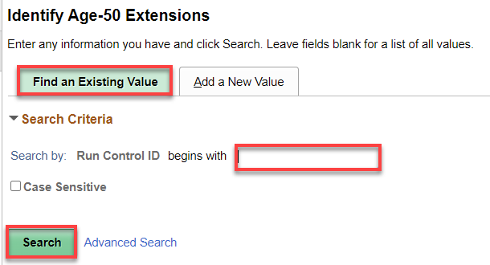

- The Identify Age-50 Extensions page displays.
- Enter the As of Date (pay period end date, i.e. the 15th/Last of the month, which is also the day the process should be run, ideally).
- Enter the Company or select from the search icon.
- Enter the catch-up contribution amount specified by IRS in the Annl Cap Expsn field. (For 2022 it is $6500). This amount may differ year to year. DO NOT LEAVE FIELD BLANK!
- Select the Run button.

NOTE: You can run this on individual employees if needed but typically you will run it for the entire company.
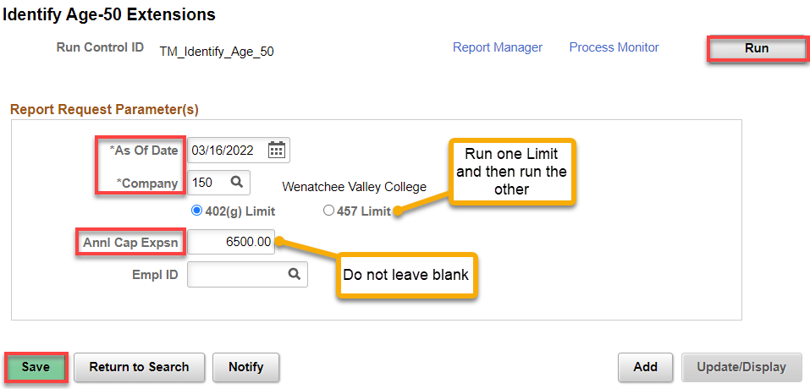

- The Process Scheduler Request page displays.
- Select the OK button.

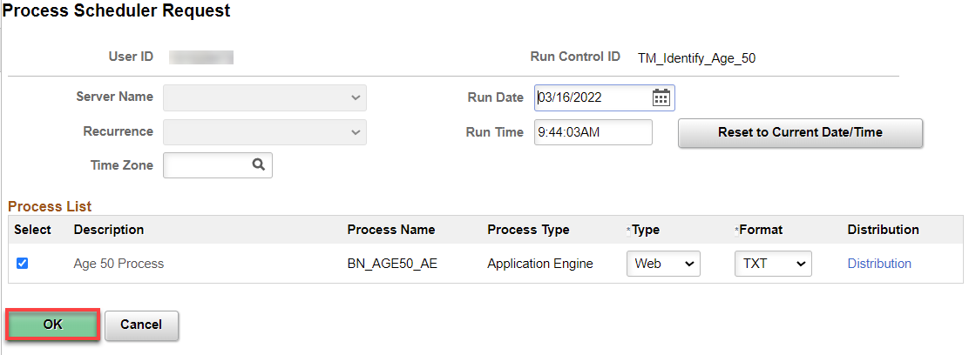

- The Identify Age-50 Extensions page displays.
- Make note of the Process Instance number.
- Select the Process Monitor link.
- The Process Monitor page displays.
- From the Process List tab, select the Refresh button until the Run Status = Success.

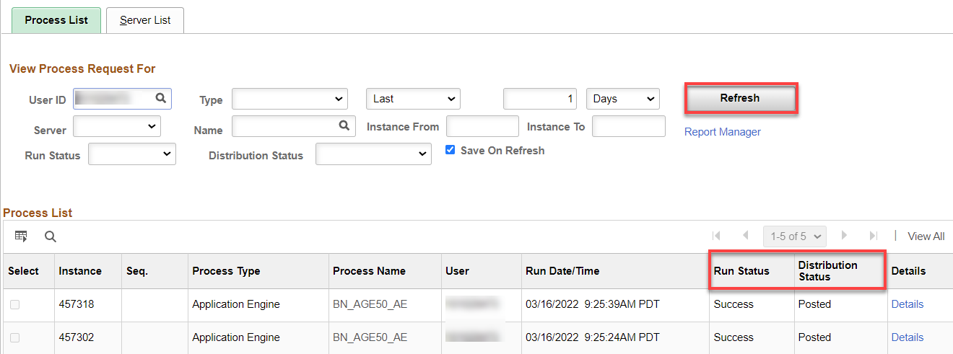

- The process to run the Identify Age 50 Extensions is now complete.

Don’t forget to rerun it for the other Limit Type (402(g) or 457).

If you forget to run this process and someone reaches the under 50 limit, you HAVE TO go to Nav>Benefits>Savings Management and manually add the extra deferral amount allowed (for 2022 it’s $6500). Add the Adjustment Amount and Save. See below for an example:

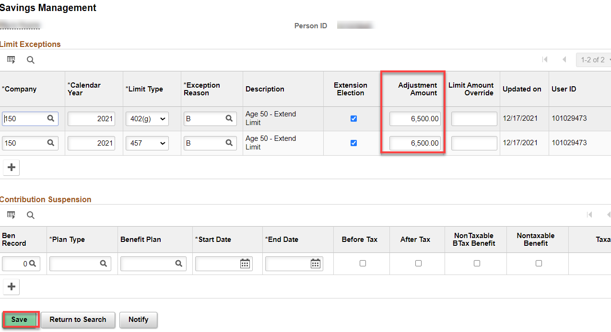

That’s it!

