IPEDS Reporting

The QRG only lists the IPEDS Reporting link that takes you to the IPEDS Reporting page at the State Board. For HCM, we only have to do the Spring Collection where you will find the HCM IPEDS Reporting Procedures (below).

Below are the steps and details to validate the data prior the SBCTC submission to IPEDS.

1. Log into QARS and review each IPEDS report o The QARS system requires a user name and password. To establish an account, contact DataServices@sbctc.edu.

2. Review the “Missing or N IPEDSSCODE” report under the category of “IPEDS Prelim Reports” that provides a listing of Job Codes assigned an IPEDSSCODE value of “N” which is excluded from IPEDS reporting. See the IPEDSSCODE section for more details.

3. Review the preliminary reports under the category of “IPEDS Prelim Reports”. ▪ The reports contain the aggregate data on the first page representing what will be reported to IPEDS.

a. Each report contains a detailed list of staff who are included in the aggregate counts starting on page two to assist in data validation.

b. The Datalink data source for these Preliminary reports is the view SBMD.IPEDS_DATA_VW.

4. Correct any data issues found in the preliminary reports in ctcLink to finalize your data before the system upload deadline specified above.

- SBCTC will upload the data into the IPEDS data collection system for all PeopleSoft colleges in batch and notify you that it is time to edit and lock.

- To view prior years’ data submitted to IPEDS, the same QARS reports are available under the category of “IPEDS Final Reports”.

- IPEDSSCODE
- The IPEDSSCODE found in the JOBCODE_TBL is a primary data element used for reporting the number of staff per the IPEDS Occupational Categories.

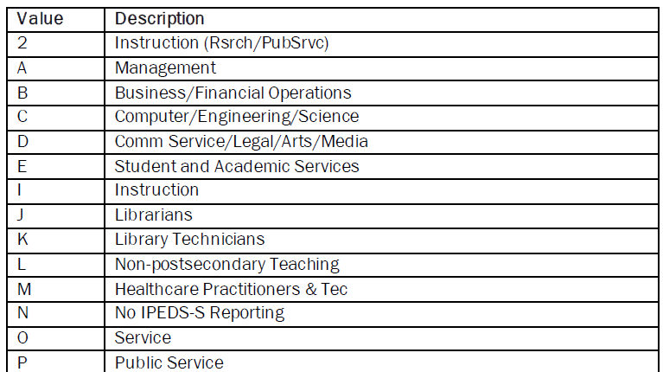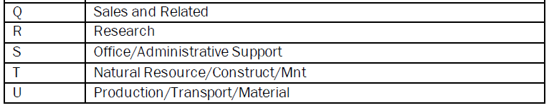

Login to QARS (if you don’t have access, email the State Board. Click on My Reports.

Filter by IPEDS HR Prelim Reports and check all.

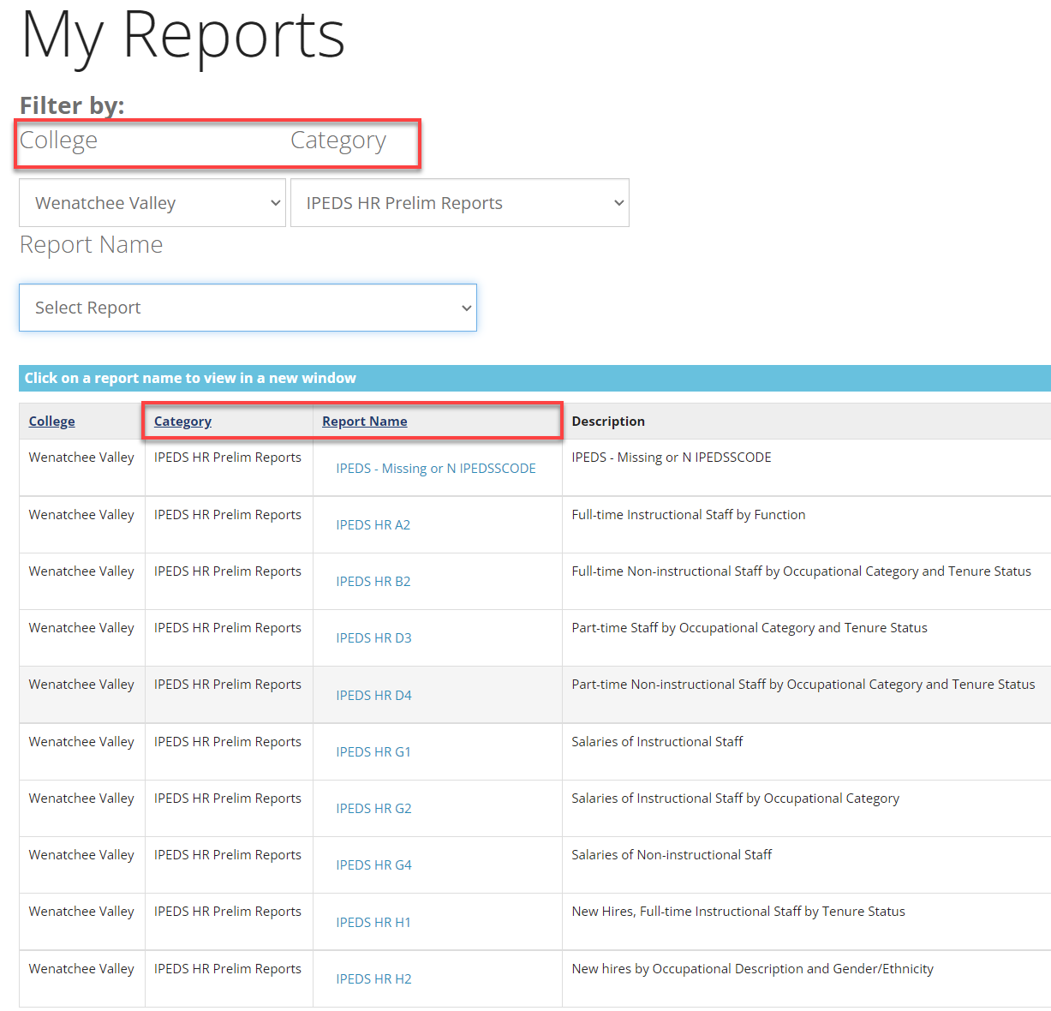

There is an edit check report available in QARS under the category of “IPEDS Prelim Reports” that provides a listing of Job Codes assigned an IPEDSSCODE value of “N” or those missing an IPEDSSCODE.

Please verify using this report that the Job Codes should be excluded from IPEDS reporting. If the Job should be reported to IPEDS, please update the IPEDSSCODE for that job in the Job Code Table in ctcLink.

To access this table, please navigate as follows: HCM>Set Up HCM>Foundation Tables>Job Attributes>Job Code Table. Once there, enter correct SET ID and the job code needing to be updated and click search. Job Code Profile detail will display for the requested job code.

To view IPEDSSCODE on this screen, scroll down and expand the area directly below union code field by clicking the arrow next to USA Flag icon.

For additional information on how to update job codes, please refer to the following QRG: Creating and Updating Job Codes.

Check all Preliminary Reports.

HR PART G1 - Salaries of Instructional Staff. Because ctcLink doesn’t allow FT salaries (at this time) for those faculty that have a different than an annual salary, you must:

- Go to Job Data
- Select the Effective Dated row that has the wrong salary (it will be before or equal to 11/1/YY)
- Click on Correct History
- Print a page to show the old figures
- Change the salary to the annual rate (do this right before the SBCTC uploads into IPEDS)
- After data is uploaded into IPEDS, go back and put the old figures into JOB Data.

After making all necessary corrections and SBCTC has uploaded the data, go to the IPEDS Data Collection System website and login (Institutional Effectiveness should have sent the login info).

Check all pages and fix edits.

One quirky thing is that all PT faculty are uploaded as credit/noncredit. This is because ctcLink doesn’t have a field to distinguish the two so the SBCTC went with credit/noncredit.

That’s it!

