Promotion or Transfer from Exempt to Exempt (the QRG sucks and isn’t correct regarding salary for prorated year so this document should be much better)

Job Data

Work Location tab: Change the Effective Date to the new job date, put in “Transfer” for Action and “Promotion” or “InterCollege Transfer” for Reason, Position Number, click on “Override Position Data” to “Use Position Data,” change Department and Location, if needed. If there is an overlap in the person leaving and the new person starting the job, you will get a warning. Just click OK (it is alright to overlap people with the same position number).

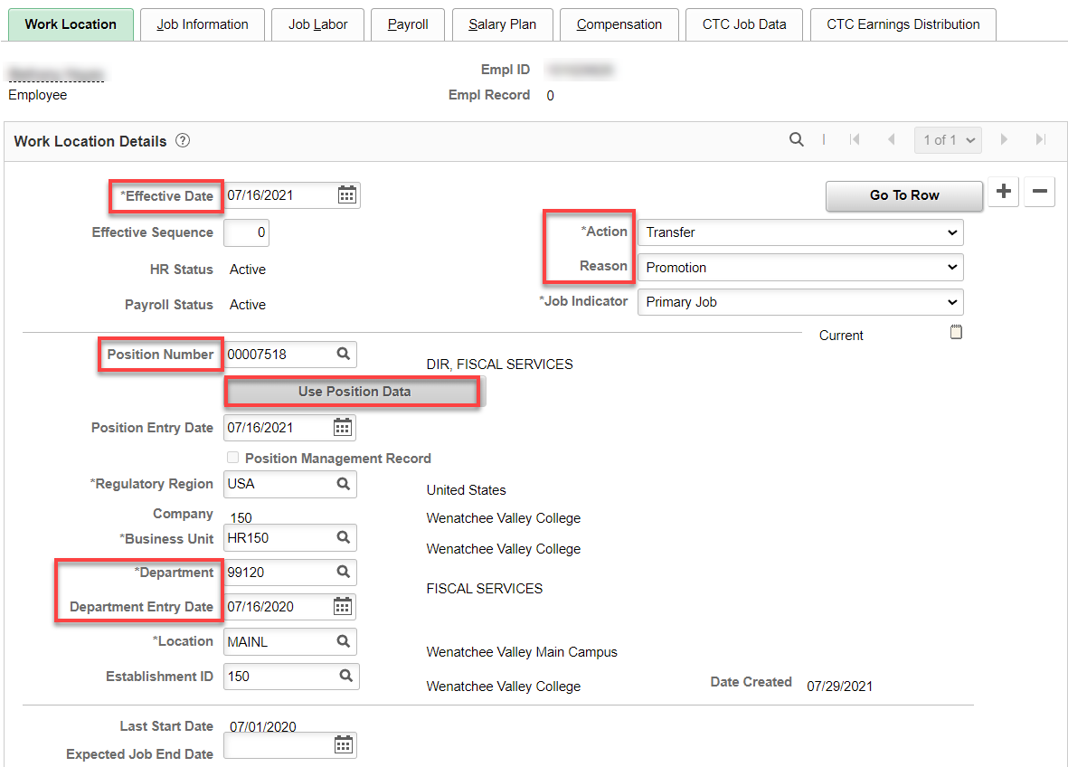

Job Information tab: Make sure Job Code, Supervisor, Regular/Temporary, Full/Part, and check anything else to be sure it is correct, change Work Period to W522 and correct the FTE (W522 changes the FTE).

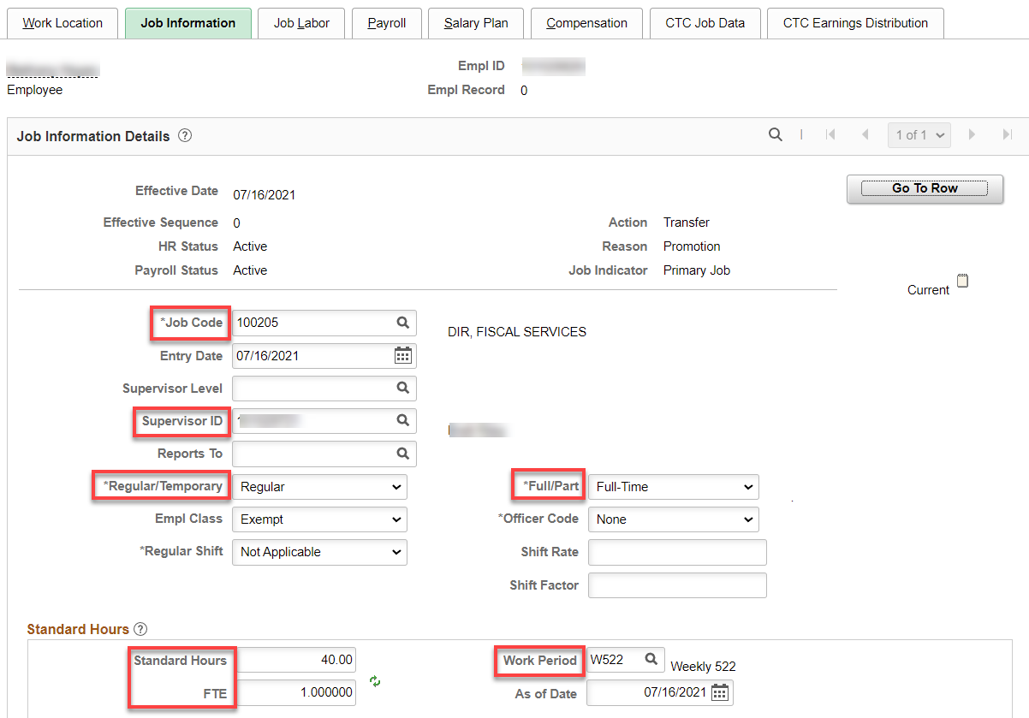

Job Labor tab: Make sure the union code is out, if applicable.

Payroll tab” Shouldn’t be any changes from one job to the other.

Nothing for Salary Plan

Compensation tab: Enter annual salary if FT 12 month, leave the Frequency at S and hit Calculate Compensation.

If less than full year, salary must be calculated by daily rate. Calculate salary for the days worked until the change in salary, then check salary already paid. If there is a difference, it must be added or subtracted with a PSHUP file. In this example, the rate already paid was $126.434 short of what was owed so it needs to be paid through PSHUP. Calculate the salary for the rest of the appointment period, enter prorated salary and change the Frequency from “S” to the number of payments left in the appointment period.

Example in this case: $60,009/261= $254.908045 x 44 days = $11,127.95376 (amount earned) minus $11,001.52 (amount paid) = $126.434 difference. New rate: $72,000/261x 217 days left in appointment period = $59,862.069 with the number of pay periods left = 20 (C20).

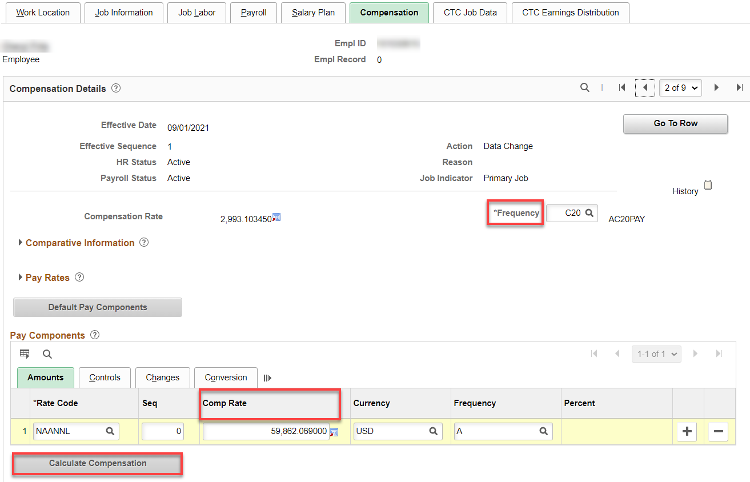

CTC Job Data tab: Leave accrual date should not need to change, change contract units if less than 261, correct any other fields that need it. Leave max month is always 8 for exempt.

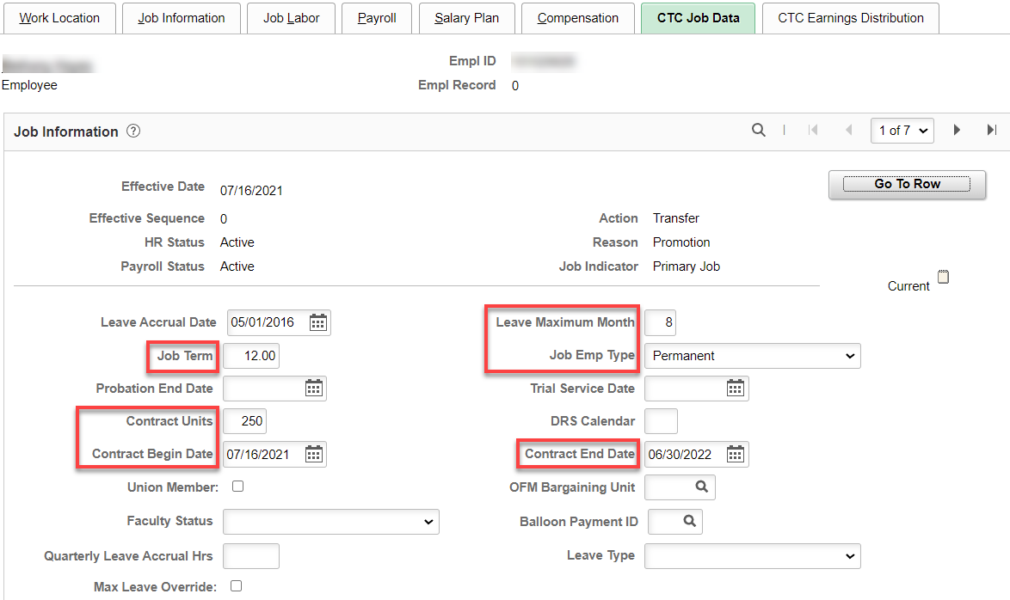

CTC Earnings Distribution tab: Enter new information.

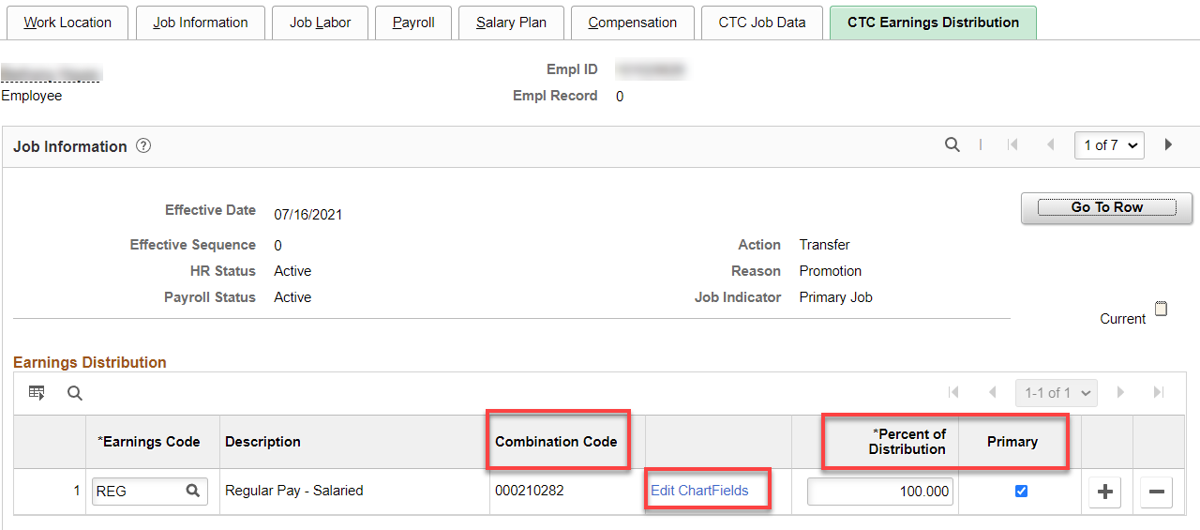

Employment Information should be correct but take a look at it.
Time Reporter Data should already be correct but check it out.

Benefit Program Participation – no changes should be made if it is exempt to exempt

Check Compensatory Plan Enrollment to see if EE is enrolled in the correct compensatory time off plan.

Nav>Time and Labor>Enroll Time Reporters>Comp Plan Enrollment OR Time & Labor tile

Add a Row if necessary, Effective Date, Compensatory Time Off Plan. Save.

Key:
Exempt – no comp time plan
Exempt Overtime Eligible – WACOMP1
Classified – WPEACMP

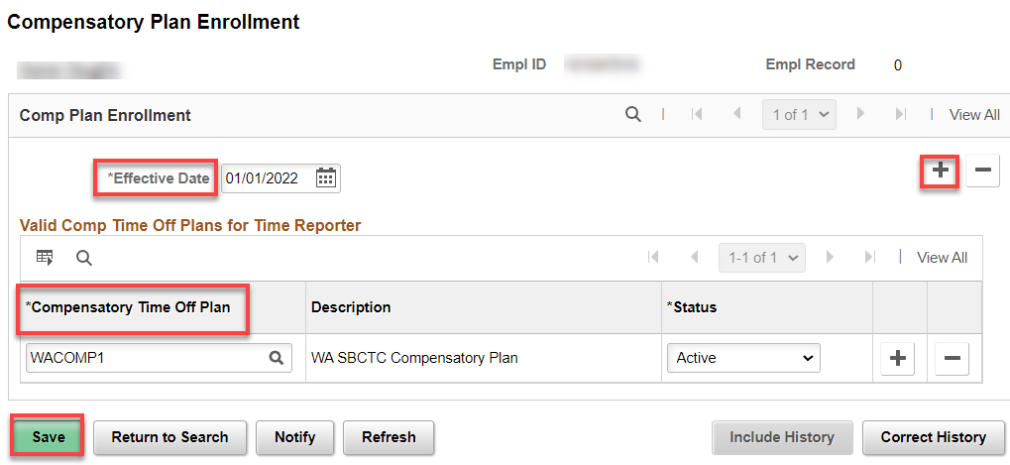

That’s it!

