Position Management – Position Management QRG
Nav>Workforce Administrator page>Position Management Tile>Manage Position Tile

For editing a current position, add + a row, make the change needed and Submit.

Changing a Current Position to a Different Position Number (see documentation Position Management – New Position adding a new position)

Make sure the Effective Date is on or before the Effective Date of the new position. Follow steps below Change/Edit a Current Position. See Reclassifying a Position with New Job Code QRG and documentation, Reallocation-Classified.

Enter Position Number – Hit Search
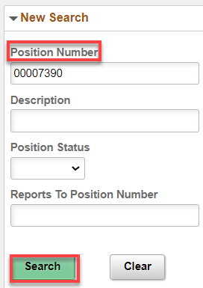

Click anywhere in box (white)

Add + Row

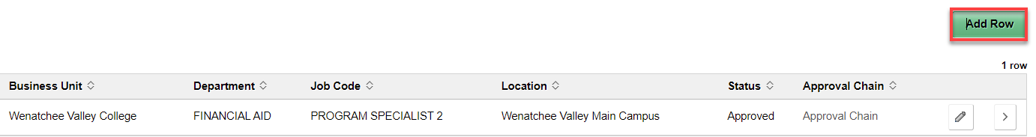

Under Request Details, change effective date (if needed) and add Reason Code (in this case I’m changing Job Code so I chose Re-Org). Continue.

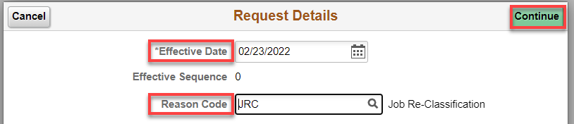

Position Data: Add Action Date, new Job Code (search if necessary), – the rest of job information will autofill (BE SURE JOB CODE INFO IS CORRECT because it pulls the info from it) – Change if necessary (double check Department and Work Period (W522 for classified and exempt) (Classified must have Salary Admin Plan and Grade)
Next

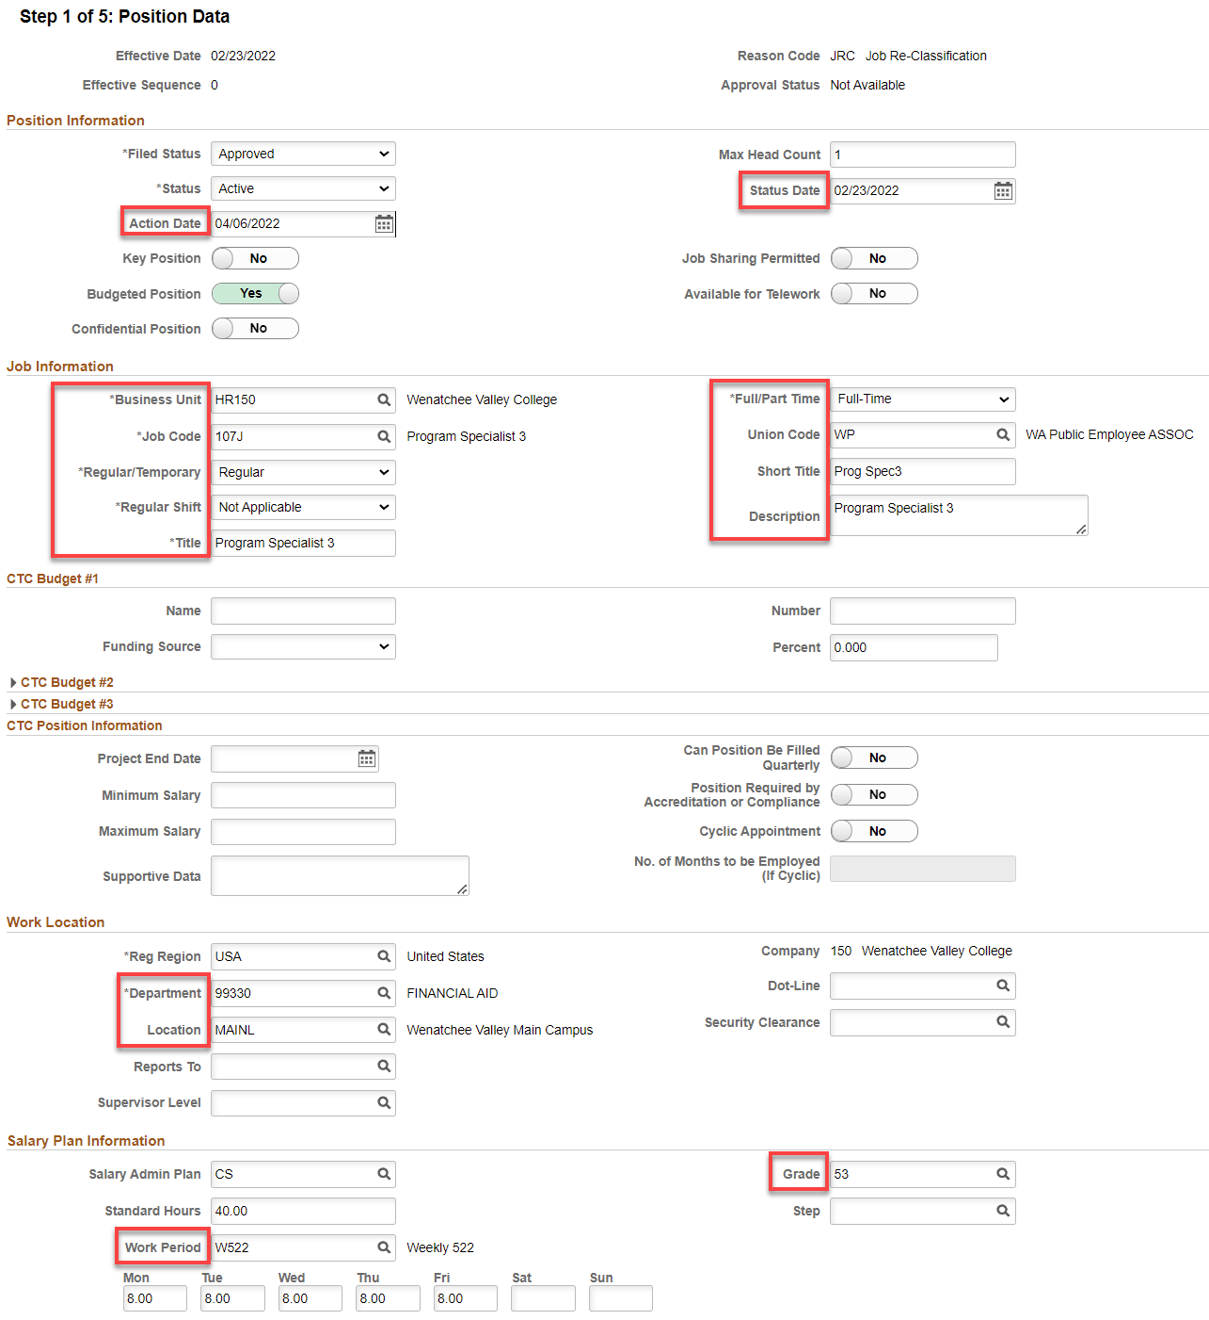

Step 2: Specific Information
Leave FTE at 0.00 or change to 1.00 (I like 1.00 so it autofill’s the New Employment Instance).
Next

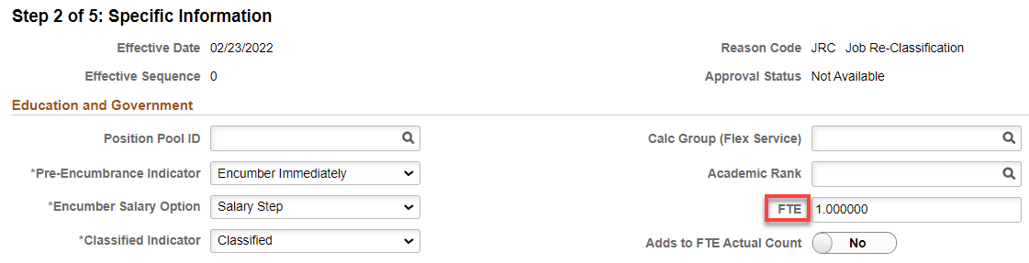

Step 3: Attachments: nothing for this step.
Next

Step 4: Budget Incumbents: nothing for this step.
Next

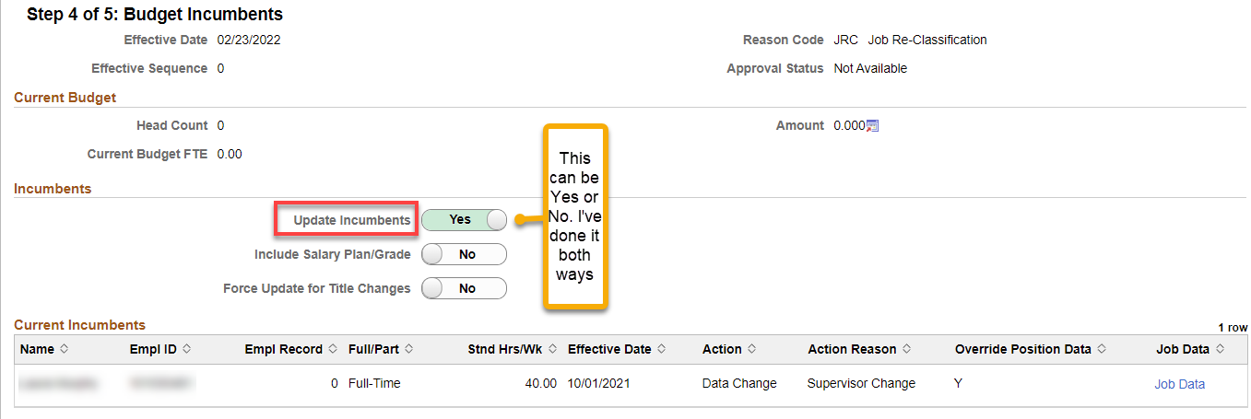

Step 5: Review and submit: you can view the current to proposed values.
Submit.

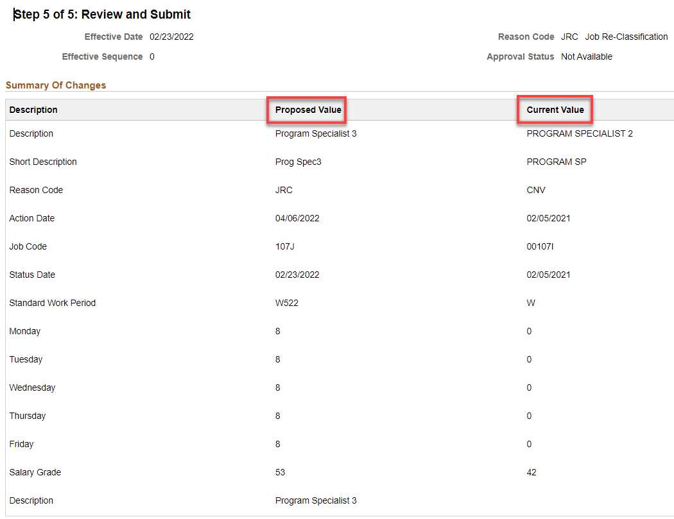

Warnings
This warning is telling me to update my Job Codes Work Period to W522. Click OK

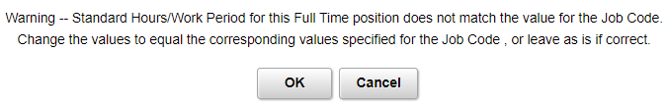

This warning means that this change can be put in Job Data Empl Record for position number 0007374 automatically.

If you click Yes, a row with the new information will automatically be placed in Job Data for the position number. If you do this, make sure to check what any future dated rows and what changes were made because they won’t be updated. Especially check the Compensation Frequency to make sure it didn’t change a balloon payment or other issues.

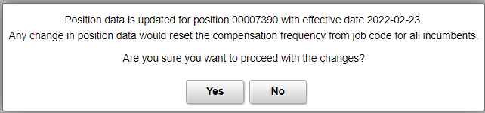

If you click No, a row will not be added and you will need to make the change manually. I’ve done it both ways and it’s pretty cool.

No matter what you choose, go to Job Data and update. See documentation, Reallocation-Classified.

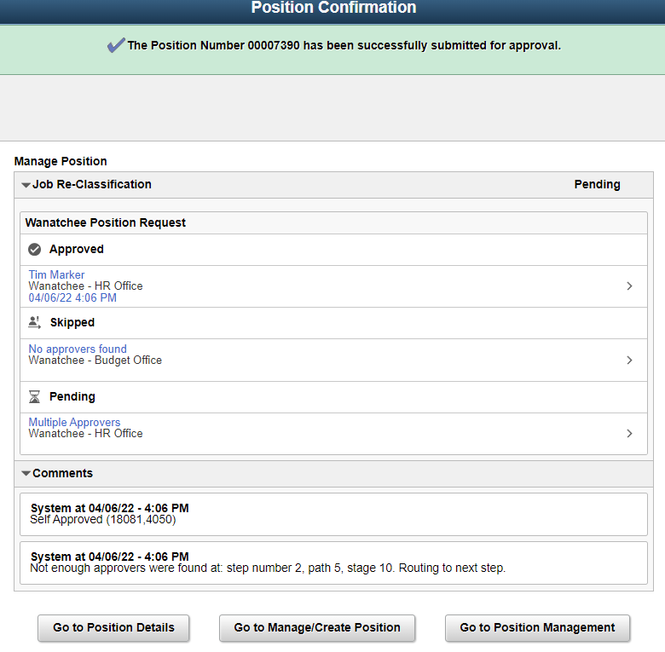

Position Confirmation
WVC has no approvers except Reagan or Tim
Click on Multiple Approvers to see who can approve

Check notifications (flag) for an alert or action to approve (if you are the approver).

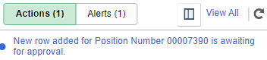

Now you can go Job Data and see if the information has changed (retroactive only – future dated will not be overridden until the future date.

That’s it!

