Running Request Time Administration

Workforce Administration>Time & Labor Tile>

Add a New Value if this is the first time running. After you set a value, you can reuse it in the future.

Click Search and the Run Control ID you want.

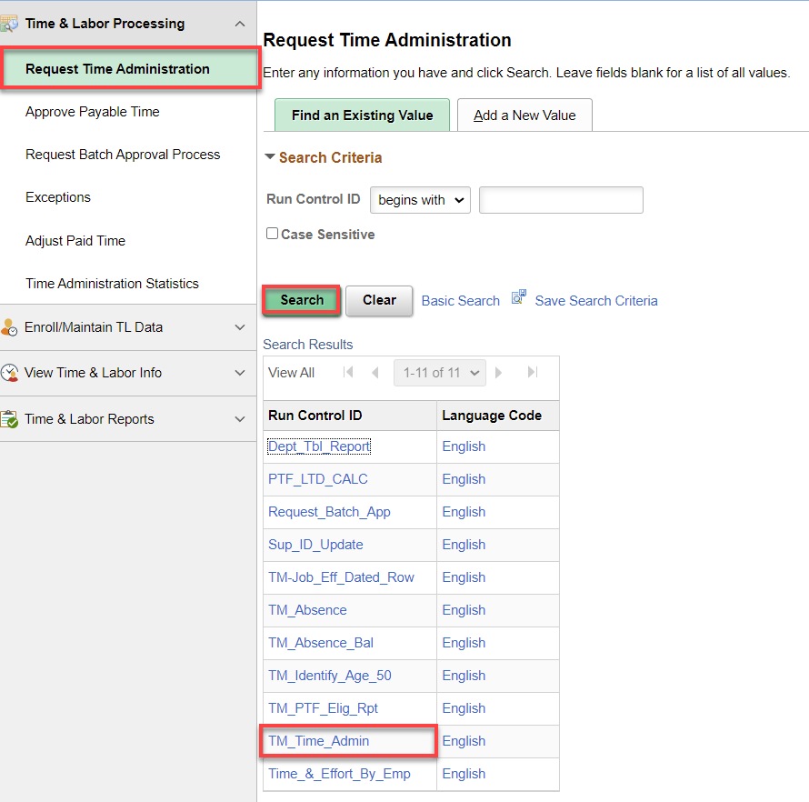

Change the Process Through Date as needed, Employees to Process (All, one or a few), Save and Run. I you need to change a saved process from ALL to an individual, click on the minus – and remove the row.

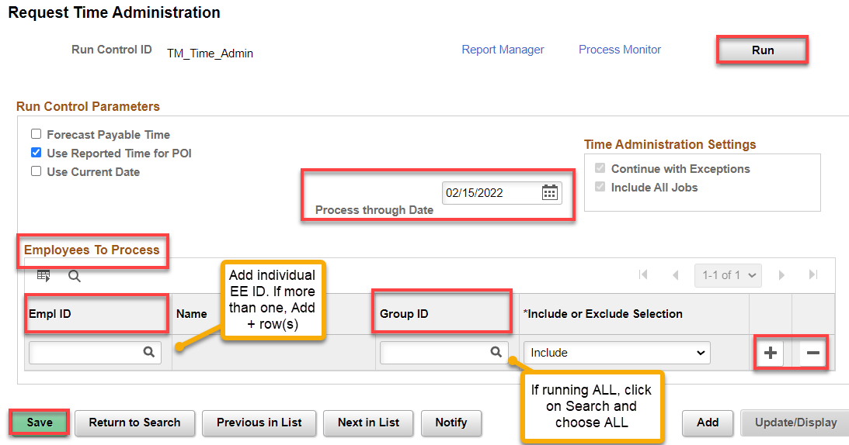

You can also run ALL but Exclude some by putting in the Empl ID(s) to exclude, adding + a row and choosing ALL under Group ID.

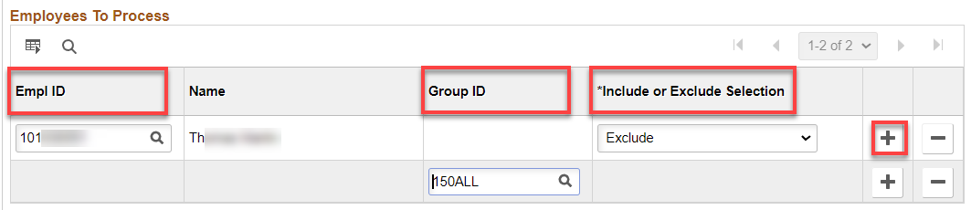

After clicking on Run, change Run Date or Run Time, if needed, and click OK.

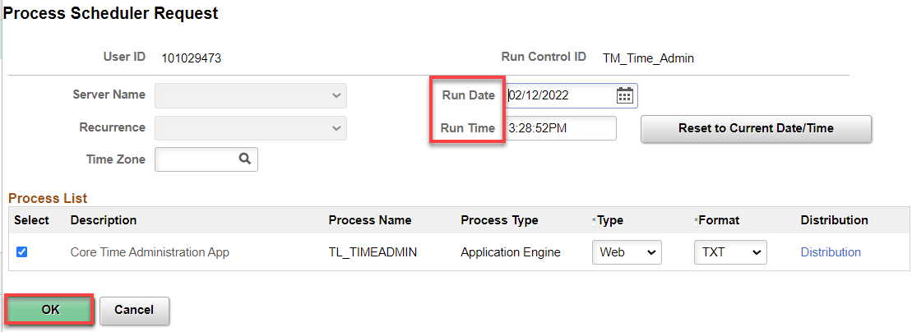

Click on Process Monitor to see how the process is running. Refresh as necessary until you see the Run Status as Success and Distribution Status as Posted. Click on Go back to Request Time Administration to set up another run or exit.

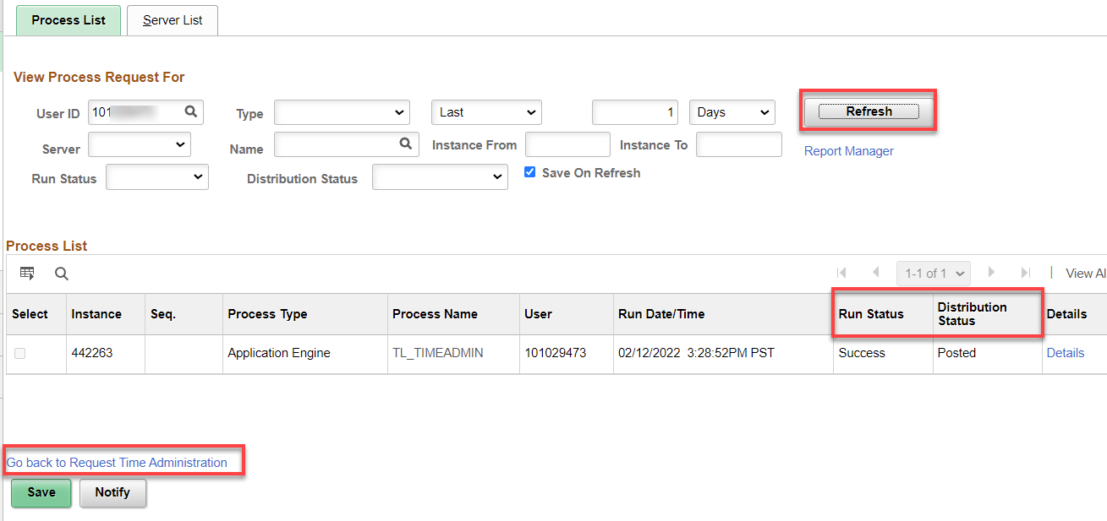

By clicking on the Details link and View Log/Trace link and the.log file, you can check to see if the process ended normally.

That’s it!

