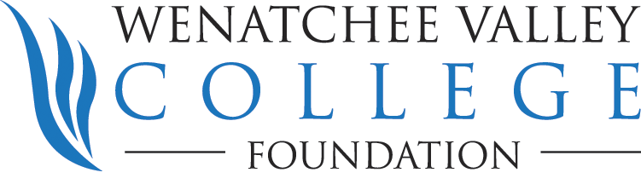

WENATCHEE VALLEY COLLEGE FOUNDATION
GENERAL FORM FOR GIFT BY WILL

Gifts to the Wenatchee Valley College Foundation to support our area’s future leaders may be made through your will. They may indicate a specific dollar amount, a percentage of the total estate or the residue remaining after all debts, taxes, expenses and other bequests have been paid. A specific bequest of property such as art objects, rare books, equipment or real estate may also be made.

A particular purpose for your gift may be designated in your will, but the functions and needs of Wenatchee Valley College do change in time, so an unrestricted bequest is especially appreciated. Your gift will be applied where the need is greatest whenever your will becomes effective.

Official name: Wenatchee Valley College Foundation, Inc.
Tax I.D.: 23-7319272

*****
Suggested verbiage for:
GENERAL FORM FOR OUTRIGHT BEQUEST

"I hereby give, devise and bequeath to Wenatchee Valley College Foundation, Inc. (hereinafter called "Foundation"), a Washington nonprofit corporation, the following described property: ____________________________________(insert dollar amount or description of property)."

"This gift may, for investment purposes, be merged with the general investment assets of the Foundation, and shall be entered on the books and records as the _________________________ Fund and shall always be so designated. The income and, at the discretion of the Board of Directors ("Board") of the Foundation, a part or all of the principal shall be used to: ______________________________________________________________________________(insert description of specific use for which the bequest is intended.)"
For example:
* to further the objects and purposes of Wenatchee Valley College.
* to support the Department of ______________________ at Wenatchee Valley College.
* to provide scholarships for deserving Wenatchee Valley College students.
* to support an endowed chair in ____________________________ ($1 million gift).

"If, in the judgment of the Board, the purpose for which this bequest is made is no longer appropriate, then the Board shall use the income, appreciation and/or principal to further the objectives and purposes of Wenatchee Valley College, giving due consideration to my special interest as evidenced by the purpose described above."
Suggested verbiage for:
GENERAL FORM FOR REMAINDER BEQUEST

"I hereby give, devise and bequeath all of the rest, residue and remainder of my estate to Wenatchee Valley College Foundation, Inc., a Washington non profit corporation, to be used for (its general corporate purposes) OR (the following restricted purpose_____________________)"

OR

"I hereby give, devise and bequeath all of the rest, residue and remainder of my estate to Wenatchee Valley College Foundation, Inc., a Washington nonprofit corporation, to create an endowment fund to be known as the ______________________ Fund. Such fund shall be kept, administered and invested by the Foundation Board of Directors for the benefit of Wenatchee Valley College in such manner as the Board of Directors may direct the following restricted purposes: ____________________________ (insert restricted purpose)."

Suggested verbiage for:
GENERAL FORM FOR CONTINGENT BEQUEST

"If all of the above-named beneficiaries should fail to survive me, then I hereby give, devise and bequeath to Wenatchee Valley College Foundation, Inc., a Washington non profit corporation, such property of my estate as was given to such persons.

"The property comprising this gift may, for investment purposes, be merged with the general investment assets of the said Foundation, and shall be entered on the books and records as the _______________________________ Fund and shall always be so designated. The fund shall be used to further the objectives and purposes of Wenatchee Valley College."

TAX STATUS OF THE WENATCHEE VALLEY COLLEGE FOUNDATION

The Wenatchee Valley College Foundation, Inc. is a tax-exempt organization as described in subsection 501(c)(3) of the Internal Revenue Code. It qualifies as a public charitable organization under Subsection 170 (b)(1)(A)(vi) of the Internal Revenue Code (and is not a private foundation as described by the Tax Reform Act of 1969). Contributions to the WVC Foundation are deductible according to the schedules established under income tax and estate tax regulations. The WVC Foundation is officially designated by the Washington State Board of Higher Education as qualified to receive and administer gifts for Wenatchee Valley College.

