PART TIME Hourly Employment Agreement Instruction Form

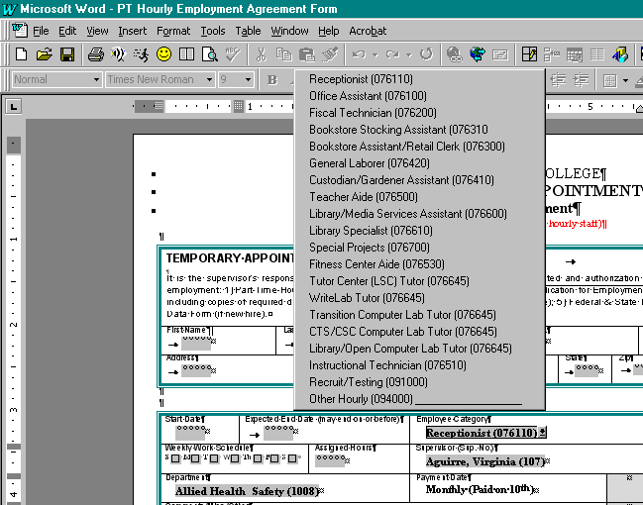Below is a part time hourly agreement form with the window for the employment category “popped up.” This is done by either clicking on the employment category box with the mouse or by using the tab key to tab into the “cell” and then activating the pop up window by clicking on the box. Once the pop-up window appears, choose the proper employment category and continue. There are similar pop-up windows for the supervisor and department.

NOTE:
- Use the part time hourly employment agreement anytime the employee is filling out a timesheet and is being paid from the Cabinet approved list of part time jobs (list is available on the HR web page or by contacting the HR office).
- Be sure to fill out the entire employment agreement including the budget information and description of duties.
- The administrator and/or supervisor needs to sign the form before it is sent to human resources for final approval.
- Please be sure to send the employment application packet and I.D. to HR with the employment agreement (if new employee).
- The HR office will mail the employment agreement to the employee for their signature.

Contact human resources if you have any questions.

